**PROJECT REPORT**

**ON**

**AGROCARE**

**Agriculture Management App**

|  |  |
| --- | --- |
| **Chapter** | **Page No.** |
| **1. Introduction**   * 1. College Profile   2. Project description   3. Project Profile   **2. Environment Description**   * 1. Hardware and Software Requirements   2.2 Technologies Used  **3. System Analysis and Planning**   * 1. Existing System and its Drawbacks   2. Feasibility Study   3. Requirement Gathering and Analysis   **4. Proposed System**  4.1 Scope  4.2 Project modules (Module-wise objectives/functionalities Constraints)  4.3 Expected Advantages  **5. Detail Planning**  5.1 Data Flow Diagram  5.2 Process Specification  5.3 Data Dictionary  5.4 Entity-Relationship Diagram  **6. System Design**  6.1 Database Design  6.2 Directory Structure  6.3 Input Layouts  **7. System Testing [Test Cases]**  **8. Limitations and Future Scope of Enhancements**  **References** |  |

**1.Introduction**

1.1 College Profile

1.2 Projectdescription

1.3 ProjectProfile

**1.1 College Profile**

Prof. V. B. Shah Institute of Management, R. V. Patel College of Commerce (English Medium), V. L. Shah College of Commerce (Gujarati Medium) & **Sutex Bank College of Computer Applications & Science** are Self - Financed colleges affiliated to the Veer Narmad South Gujarat University, Surat. Prof. V. B. Shah Institute was started in the year 1998 with a view to churn out management professionals. A progressive academic record has been maintained in this regard. The R. V. Patel College of Commerce which was started in the year 2001 offers the B.Com. degree programme in English Medium whereas the V. L. Shah college of Commerce started in the year 2006 offers the B.Com. degree programme in Gujarati Medium. **Sutex Bank College of Computer Applications & Science** started in the year 2000 offers the B.C.A. degree programme, with the onset of the 21st century, there has been tremendous advancement in science and technology.

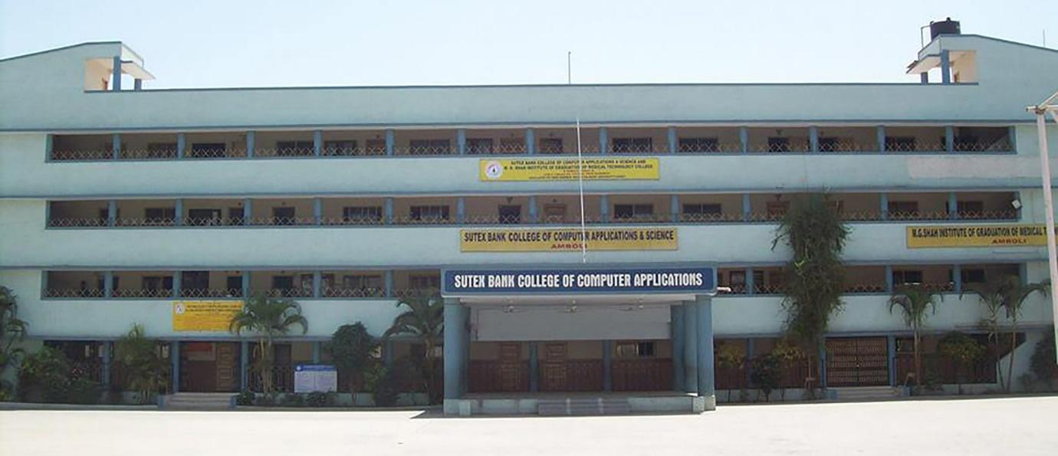

The entire academic year is replete with academic, extra & co-curricular activities, sporting events, guest lectures, Industrial Visit, Educational tour, seminars and workshops. A significant goodwill has been created by the institute among its stakeholders.

The institute is proud to have a qualified, competent and an industrious staff. They assist the students in unleashing their talents and exhibiting their skills. The perspective institutional plan is collectively chalked out by the I/c Principal, members of the managing trust (Jivan Jyot Trust, Amroli), the faculty members as well as the administrative staff. Industrial visits and practical tasks help the students a great deal in supplementing their learning. Students are also given ample of scope to sharpen their entrepreneurial skills. The institute takes pride in stating that it focuses on the optimal use of resources available and takes all the measures for quality enhancement and quality sustenance.

**1.2 Project description**

Welcome to AgroCare, the groundbreaking Android application designed to revolutionize farming practices and empower farmers across rural India. AgroCare encompasses a wide array of features tailored to meet the diverse needs of the agricultural community, providing a comprehensive platform for networking, resource access, and knowledge sharing.

At its core, AgroCare fosters a vibrant community of farmers through its networking capabilities. Users can post updates, seek advice, and engage with fellow members, facilitating collaboration and collective problem-solving. With features such as likes, comments, shares, and saves, users can interact with posts in a dynamic and meaningful way, enriching the agricultural discourse.

In addressing the crucial aspect of labor management, AgroCare allows farmers to publish vacancies for agricultural work, connecting them with potential laborers seeking employment opportunities. Through direct contact via WhatsApp or phone calls, the platform streamlines the process of recruitment, ensuring efficient workforce allocation and task delegation.

Facilitating trade within the agricultural community, AgroCare serves as a marketplace for a variety of products and services. From domestic animals to cultivation products and tools, users can showcase their offerings and connect with interested buyers, facilitating seamless transactions and fostering economic growth.

Keeping users informed and empowered, AgroCare aggregates essential weather information based on the user's location. This feature equips farmers with timely insights into weather patterns, enabling them to make informed decisions regarding crop management and agricultural practices.

In addition to weather updates, AgroCare provides users with access to news and government schemes related to farming. Administrators regularly publish relevant information, ensuring that users stay informed about the latest developments in agriculture and have access to beneficial government initiatives.

AgroCare also harnesses the power of artificial intelligence to provide personalized consulting services to farmers. Whether it's disease management, farming techniques, or crop optimization, our AI guide offers valuable insights and recommendations, empowering users to enhance their agricultural productivity and efficiency.

Recognizing the linguistic diversity of rural India, AgroCare is available in 12 regional languages, ensuring accessibility and inclusivity for all users. This multilingual approach enables farmers from diverse backgrounds to access the platform and benefit from its features seamlessly.

In addition to its core functionalities, AgroCare offers a streamlined marketplace for agricultural products. Administrators can publish a wide range of farming-related items such as seeds, plants, and pesticides directly within the app. Users can browse these products, add them to their cart, and place orders with the option for both cash on delivery and online payment methods. This seamless ordering process ensures convenience for farmers while facilitating access to essential supplies for their agricultural endeavors. Moreover, users have the ability to view their order history, enabling them to track past purchases and plan future procurement needs efficiently. Administrators also benefit from access to date-wise order records, providing them with valuable insights into user preferences and transaction trends for effective management and planning.

For administrators, AgroCare offers comprehensive oversight and management tools, including access to user data and visual statistics. Administrators can monitor platform performance, make informed decisions, and ensure the smooth operation of the application.

In essence, AgroCare is more than just an app; it's a transformative tool that empowers farmers, fosters collaboration, and drives sustainable growth in India's agricultural sector. Join us as we embark on this journey to revolutionize farming practices and improve livelihoods with AgroCare.

**1.3 Project Profile**

|  |  |
| --- | --- |
| Agriculture Management System | |
| Project title: | Agriculture Management System |
| Project Label: | AgroCare |
| Package Name: | com.project.agriculturemanagmentapp |
| Frontend: | Extensive Markup Language |
| Backend: | Java, Firebase |
| Operating system: | Android |
| Platform: | Android studio, firebase console |
| Documentation tool: | Microsoft word,Draw.io |
| APK Size: | 29.6 MB (3,10,74,014 bytes) |
| Target SDK Version: | 33 |
| Minimum SDK  Version: | 26 |
| Android Gradle Plugin Version: | 8.0.2 |
| Project Duration: | 4 months |
| Api Keys: | c19c16e82898cc7627f4e02e485861de |
| Api Providers: | Openweathermap.org |
| Internal Guide: | Asst. Prof. Ragini. B. Prasad |
| Submitted to: | Sutex Bank College of Computer Applications & Science. |

**2. Environment Description**

2.1 Hardware and Software Requirements

2.2 Technologies Used

**2.1 HARDWARE AND SOFTWARE REQUIREMENT**

* **SOFTWARE REQUIREMENT**

|  |  |
| --- | --- |
| OperatingSystem | Android OS |
| Software | Android Studio |
| FrontEnd | Extensive Markup Language |
| BackEnd | Java |
| Browser | GoogleChrome, Brave, Microsoft Edge |
| Database | Firebase Database |

* **HARDWAREREQUIREMENT**

|  |  |
| --- | --- |
| Processor | 2GhzProcessor. |
| RAM | 2GB |
| MemoryStorage | 512MB |

**2.2 Technology Used**

* **Introduction to Android**

Android, since its inception in 2008, has revolutionized the mobile landscape with its open-source nature, Linux kernel foundation, and focus on touchscreen interaction. Its popularity stems from a robust ecosystem fueled by collaboration and innovation among developers worldwide. Key features such as customizable UI, seamless Google integration, a vast app ecosystem via the Play Store, and adaptable hardware compatibility have contributed to its widespread adoption. Furthermore, Android prioritizes user security with features like app sandboxing and regular security updates, ensuring a safe and reliable user experience across devices.

* **Java in Android Development**

Java plays a pivotal role in Android development, serving as the primary language for building apps that interact with the Android SDK. Its object-oriented nature aligns well with Android's architecture, facilitating code organization and maintenance. Developers leverage Java for UI development, event handling, data management, concurrency, and multithreading, utilizing its extensive ecosystem of third-party libraries for additional functionality. Java's versatility empowers developers to create high-quality, feature-rich apps for the Android platform, driving innovation and user engagement.

* **Firebase Database in Android Development**

Firebase Database, a cloud-hosted NoSQL database, offers real-time data synchronization and offline capabilities, making it a preferred choice for Android developers. Its NoSQL structure allows for flexible data storage without predefined schemas, while offline persistence ensures a seamless user experience even without an internet connection. Security rules enable granular access control, while seamless integration with other Firebase services enhances app functionality. Scalability, performance, easy setup, and management further solidify Firebase Database as a valuable tool for Android app development.

* **XML in Android Development**

XML serves as the backbone of Android UI development, providing a declarative syntax for defining UI layouts and structures. With XML, developers can efficiently manage resources, customize UI elements, and support various screen sizes and orientations. Data binding enables seamless communication between the UI layer and application logic, while Android Studio's visual editor allows for real-time preview and visualization of XML layouts. Together, these features empower developers to design intuitive and visually appealing user interfaces for Android applications, driving user engagement and satisfaction.

**3. System Analysis and Planning**

3.1 Existing System and its Drawbacks

3.2 Feasibility Study

3.3 Requirement Gathering and Analysis

**3.1 EXISTING SYSTEM AND ITS DRAWBACKS**

* **Existing system**
* In the existing system customer has to use different application for different purpose, which makes it very complex to get different kind of services. Most of the existing systems are tailored to local community and those which are nation wide lack in providing services which farmers need as most of them will only provide networking facility. System which provides basic services lacks other functionality.
* Moreover, there are so limited platform which provides farming labour and wages management. In short, existing system provides only limited functionality so user have to keep multiple app installed in their mobile which is headache for them. Furthermore, due to this all the user looking for different service will log in to only specific system which devide community of farmers. But what if all this farmers come on single system?
* **Drawbacks**

1. Limited Networking Features: Some existing systems may lack comprehensive networking features, such as real-time chat functionality and interactive post engagement options, limiting user interaction and engagement within the farming community.
2. Ineffective Labor Management: Certain systems may offer limited capabilities for farmers to publish labor vacancies and for users to find and contact job listings efficiently, leading to challenges in workforce allocation and recruitment.
3. Absence of Payment Tracking: Many systems may not provide users with the ability to track payments to laborers, resulting in a lack of transparency and accountability in financial transactions within the agricultural sector.
4. Poor Product Visibility: Some platforms may not adequately showcase users' agricultural products, tools, and accessories for sale, hindering their ability to reach potential buyers and limiting market access.
5. Limited Product Catalog: Certain systems may have a restricted product catalog for farming-related products, with fewer options available for users to explore and purchase essential supplies and equipment.
6. Insufficient Information on News and Government Schemes: Some platforms may not offer comprehensive coverage of news and government schemes related to farming, leaving users uninformed about important developments and opportunities in the agricultural sector.
7. Inaccurate Weather Information: Existing systems may provide weather information that is not precise or tailored to the user's current location, leading to potential inaccuracies in agricultural planning and decision-making.
8. Lack of AI Guidance: Many systems may lack AI-powered guidance and consulting services for farmers, depriving users of valuable insights and recommendations on disease management and farming practices.
9. Limited Language Support: Some platforms may not offer multilingual support for users from diverse linguistic backgrounds, excluding non-English speaking users from accessing essential features and information.

**3.2 FEASIBILITY STUDY**

The measure of how beneficial or practicalthe development of the informant system will be to an organization. Along thistopic, feasibility is measured. So far taking the feasibility study and feasibility analysis during the development of the AgrocareSystem we havestudied the following four major categories of a feasibility study.

1) Operational Feasibility

2) Technical Feasibility

3) Schedule Feasibility

4) Economic Feasibility

**Operational Feasibility:**

AgroCare demonstrates high operational feasibility due to its user-friendly interface and seamless integration of features catering to the diverse needs of the agricultural community. The networking capabilities, labor management tools, marketplace functionality, and access to essential information all contribute to enhancing the operational efficiency of farmers. Additionally, the multilingual support ensures accessibility for users from various linguistic backgrounds, further enhancing the operational feasibility of the app.

**Technical Feasibility:**

The technical feasibility of AgroCare is robust, supported by its utilization of Java programming language, Firebase for backend infrastructure, and integration of free AI services. These technologies enable the smooth functioning of the app, facilitating features such as real-time networking, payment tracking, weather aggregation, and personalized consulting through AI. Furthermore, leveraging GitHub ensures version control and collaborative development, enhancing the technical viability of the project.

**Schedule Feasibility:**

AgroCare demonstrates strong schedule feasibility, as evidenced by the successful integration of its diverse features within a reasonable development timeframe. The efficient utilization of Firebase and free AI services expedites development, while the use of Java ensures compatibility with Android devices. Moreover, leveraging GitHub for version control streamlines the development process, allowing for timely updates and enhancements to meet project milestones and deadlines effectively.

**Economic Feasibility:**

From an economic standpoint, AgroCare offers significant value to its users while maintaining cost-effectiveness in its development and operation. Utilizing free AI services and open-source technologies such as Firebase and GitHub helps minimize development costs. Furthermore, the potential for revenue generation through marketplace transactions and premium features ensures long-term sustainability and profitability.

**3.3 Requirement Gathering and Analysis**

The choice of method is influenced by the data collection strategy, the type of variable, the accuracy required, the collection point, and the skill of the enumerator. Links between a variable, its source, and practical methods for its collection can help in choosing appropriate methods. The choice of the many methods for collecting data will depend on the variable to be measured, the source, and the resources available. In many cases, there is a natural way to collect particular variables.

✓ Conduct a brainstorming session

✓ Work in the target environment

✓ Document Analysis

✓ Interview

✓ Registration

✓ Observation

✓ Survey/Questionnaire etc.

For our system, we use observation and an Interview technique for requirement gathering to design system functionalities and made it easy to develop the system and achieved the desired goal.

✓ We visit many online Farming apps like Krishify, Agrostar, etc, and we see the functionality as a user of those apps and how they provide facilities to the customer for providing farming help and assistant online.

✓ For Manage Farming, we visit the different apps and talk with the app’s owner, and know the functionalities regarding managing data and making app with much more efficient in data handling ,widespread community support, wide range of products and information etc…

✓ Using this requirement, we analyse data and decide to follow the modules used.

1) User (Farmer)

2) Admin

**4. Proposed System**

4.1 Scope

4.2 Project modules

4.3 Expected Advantages

**4.1 Scope**

The main objective of Agrocare is to enable farmer with one stop solution for their needs. The system allows farmers to fulfil their need of any goods, labours, information online. farmers can sell their product online without need of personalized store. Moreover, networking is in the heart of this system which allow farmers to build their own nation-wide community.

**The Scope For the system can be as follow:**

* itcontainsauser-friendlylayout&easytounderstandforeveryuser and admin.
* Provide all need of networking which involves feed, response to feed, real-time chatting, followers concept for priority of feed.
* Enable Recruiter farmer to post vacancy and job-seeker labour to find work.
* Allow user to maintain their payment of wages to labours , eliminating the need of keeping records in diaries.
* Farmers can sell their cultivation products, domestic animal,cultivation tools-products to all over nation without need of setting personalized store.
* Ecommerce store allow farmer to buy all their need of farming like pesticides,seed,fertilizer and so on online.
* Information about weather animation allow farmers to take decision about farming.
* News and government data makes farmers politically active and allow farmer to take benefit from every scheme.
* Queries related to farming will be solved quickly with the A.I. assistant.
* Allow admin to manage user data and publish data.

**4.2 Project Module**

* Therearethreesystemcomponentsinoursystem.

1. User
2. Admin
3. User

* User can post feed,response to other user’s feed, chat with other users feed and follow another user.
* User can post vacancies and also view other vacancies of co-user, one can contact to recruiter by WhatsApp or direct call.
* User can publish their cultivation product, domestic animal and other tools and accessories for sell. Moreover, user can also contact other user through WhatsApp and call if he/she is interested in his/her item.
* User can maintain payment of wages to labour.
* User can buy all needed products from ecommerce store.
* User can obtain information related to weather based on their location.
* User can watch out latest news and government scheme.
* User can consult A.I. chat bot for all their queries.

1. Admin

* Admin will manage data of all user; admin has power to remove any data of any user.
* Admin can publish news and government scheme which then shown to user.
* Admin manages ecommerce store by listing new products and processing all the orders.
* Existing admin can add new admin of system.
* **Module Wise Objective**
* **User**
  + Login
  + OTP Verification
  + Manage Feed
  + Manage Vacancy
  + Manage Resell data
  + Manage labour data
  + Chat with users
  + Ecommerce Order
  + Online Payment
  + Chat with A.I.
  + View Weather Data
  + View News
  + Get government scheme
  + Update/Complete Profile
* **Admin**
* Login
* OTP verification
* Manage User Data
* Publish News
* Publish Government Scheme
* List Ecommerce Product
* Add Admin
* View Orders
* View Statistics

**4.3 Expected Advantages**

* **Ease of Communication:** Users can easily connect and communicate with fellow farmers, share insights, and seek advice through the networking feature. The real-time chat functionality enhances collaboration and knowledge sharing among users, irrespective of language barriers.
* **Efficient Labor Management: Farmers** can quickly publish labor vacancies, enabling seamless recruitment processes. Users seeking employment opportunities can easily browse and contact publishers, facilitating efficient workforce allocation and task delegation.
* **Transparent Payment Tracking:** The ability to track payments for labor ensures transparency and accountability in financial transactions. With instant SMS notifications upon wage payment, users have peace of mind knowing that their payments are accurately recorded and promptly communicated.
* **Convenient Trade Opportunities**: Users can effortlessly showcase and trade domestic animals, cultivation products, and tools, expanding market reach and facilitating transactions within the agricultural community. Direct contact options via WhatsApp or phone calls enhance convenience for buyers and sellers.
* **Access to Essential Products and Information:** With the admin's publication of farming-related products, users gain access to a wide range of essential supplies and resources. Additionally, the availability of news and government schemes relevant to farming ensures users stay informed about industry developments and opportunities for growth.
* **Personalized Guidance and Support:** The AI guide provides personalized consulting services to farmers, offering valuable insights and recommendations on disease management, farming techniques, and more. This feature empowers users to make informed decisions and optimize their agricultural practices for improved productivity and efficiency.

**5. Detail Planning**

5.1 Data Flow Diagram

5.2 Process Specification

5.3 Data Dictionary

5.4 Entity-Relationship Diagram

**5.1 DATA FLOW DIAGRAM**

* 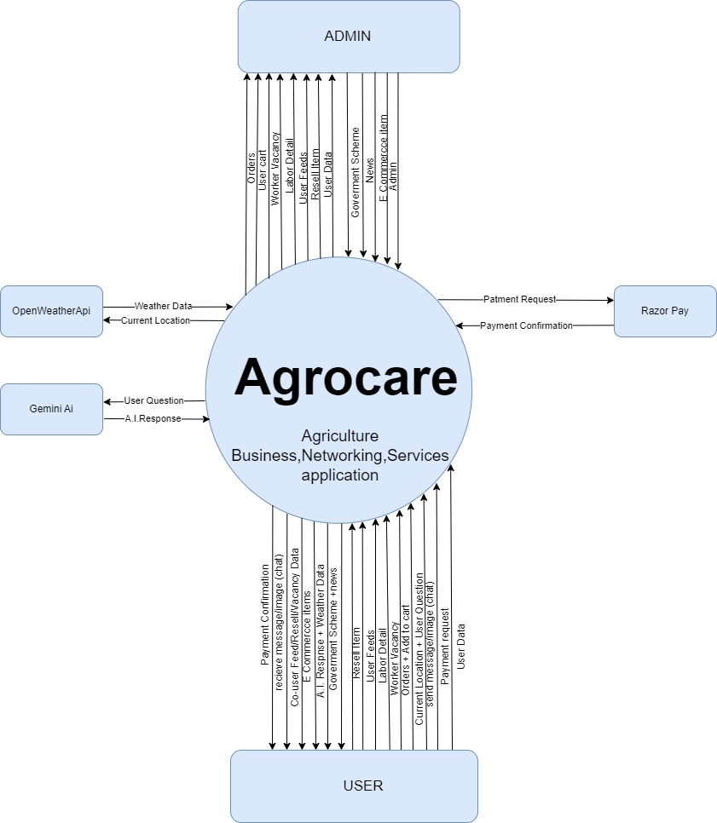**Context level diagram:**
* **1_level diagram:**
* **Admin:**

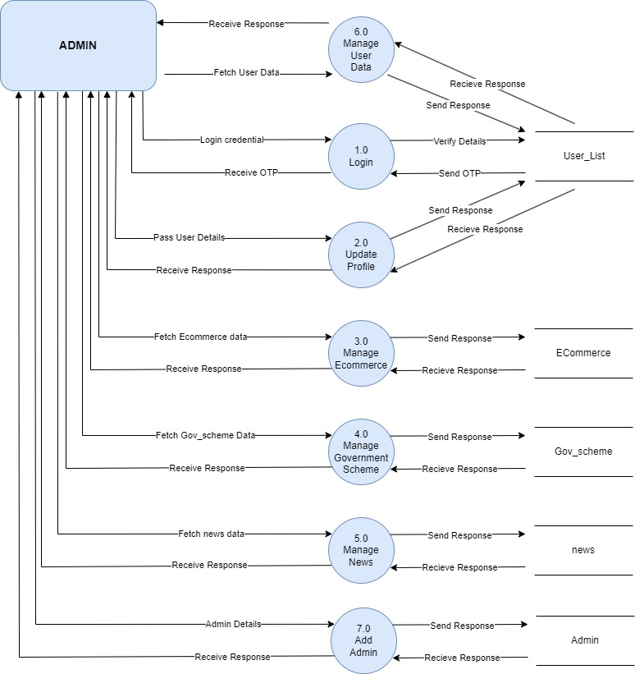

* 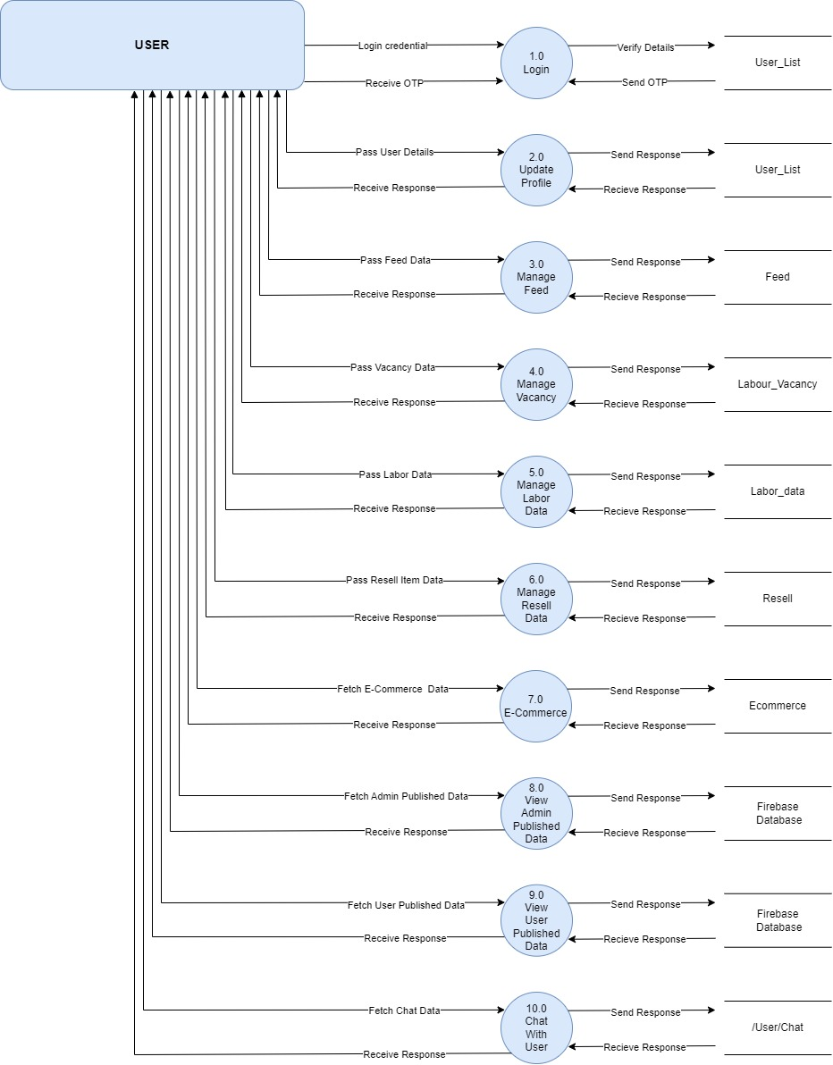**User:**
* **2_level diagram:**
* **Admin:**
* **3.0 ecommerce:**

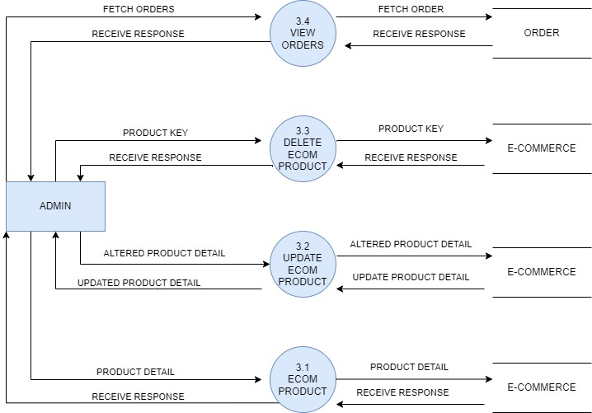

* **4.0 Manage Government scheme**

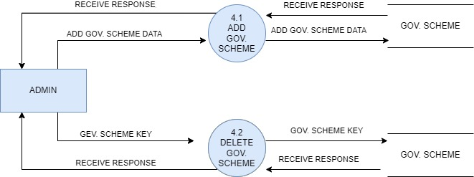

* **5.0 Admin manage news**

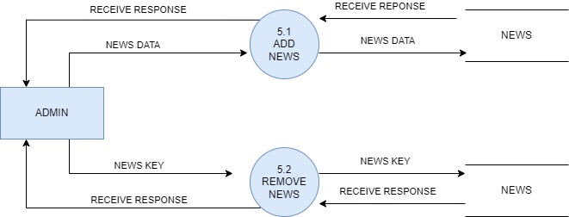

* **6.0 Admin view user data:**

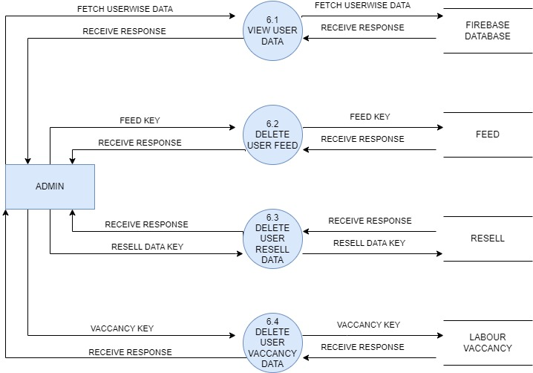

* **User:**
* 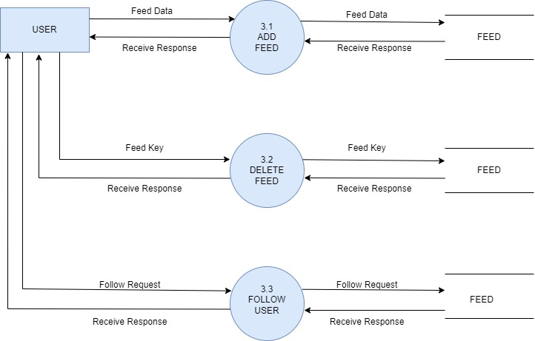**3.0 manage feed:**
* **4.0 manage vacancy:**

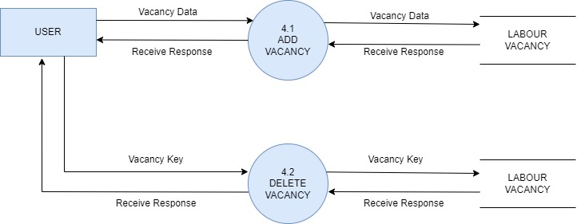

* **6.0 manage resell data:**

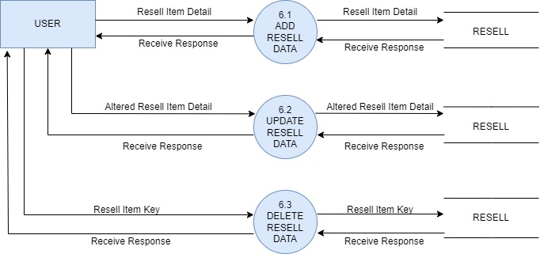

* **7.0 ecommerce User:**

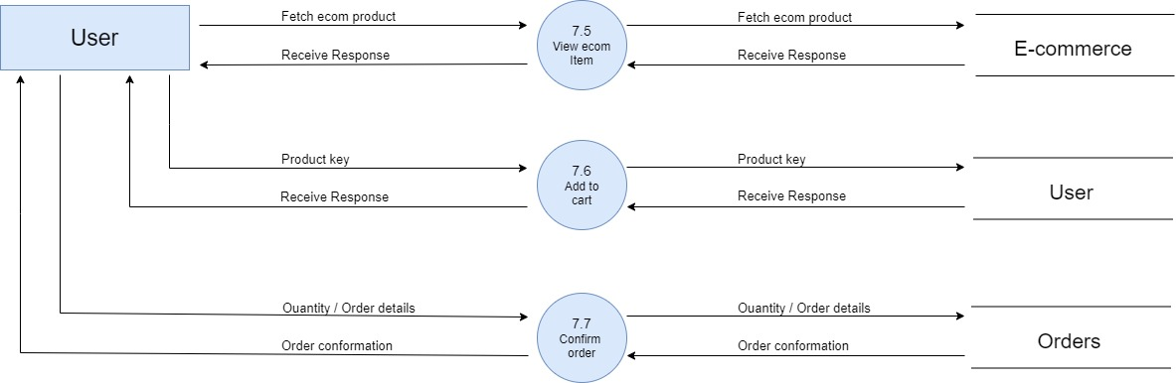

* **8.0 view admin published data:**

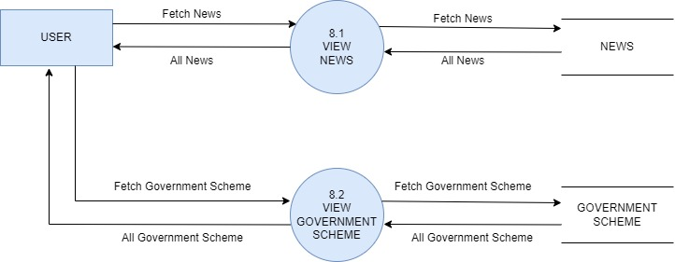

* **9.0 view user published data:**

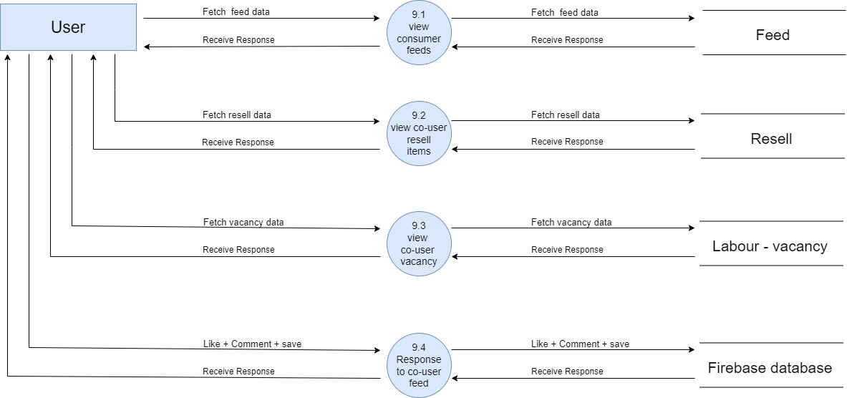

* **10.0 chat with user**

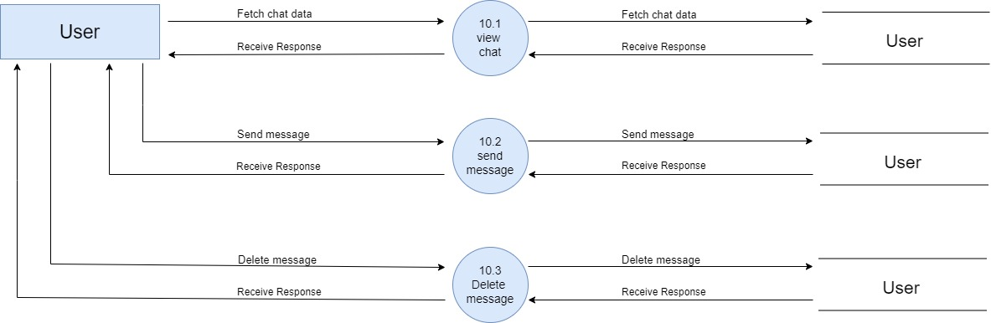

**5.2 PROCESS SPECIFICATION**

* **Admin:**
* **3.1 Admin add ecommerce product**

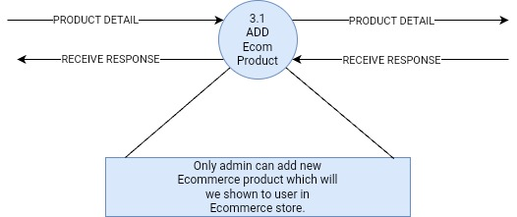

* **3.2 admin update ecommerce product**

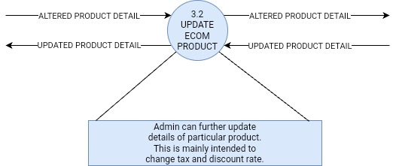

* **3.3 admin delete ecommerce product**

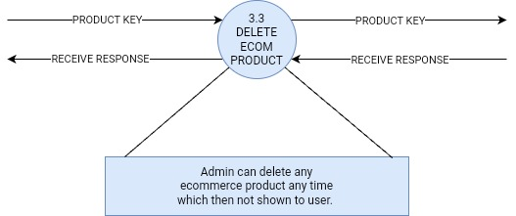

* **3.4 admin view orders:**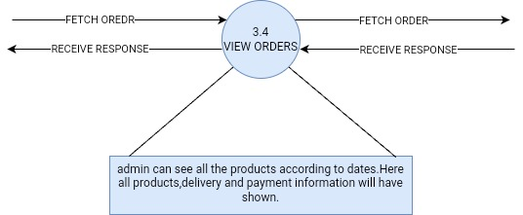
* **4.1 admin add government scheme:**

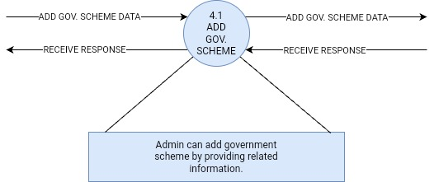

* **4.2 admin delete government scheme:**

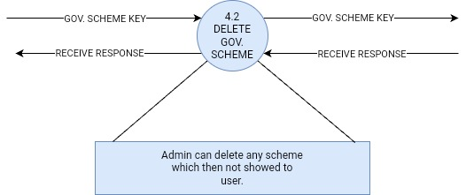

* **5.1 admin add news:**

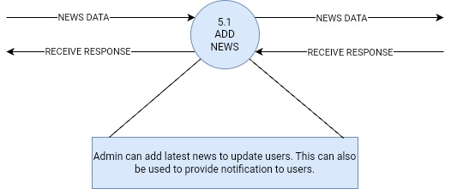

* **5.2 admin remove news:**

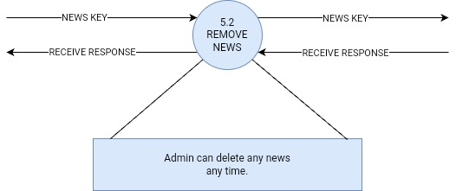

* **6.1 admin new user data:**

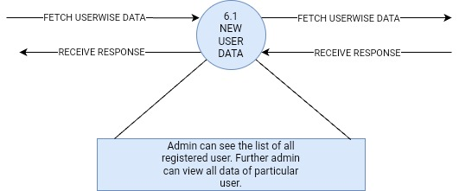

* **6.2 admin delete user feed:**

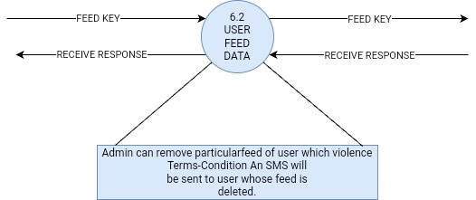

* **6.3 admin delete user resell data:**

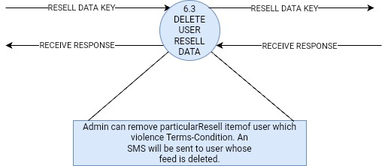

* **6.4 admin vacancy user resell data:**

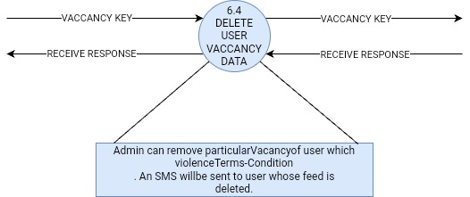

* **14.0 add admin:**

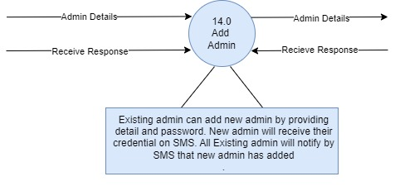

* **User:**
* **1.0 login:**

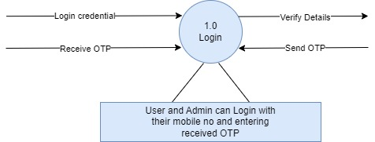

* **2.0 update profile:**

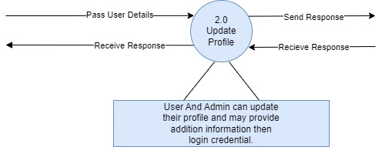

* **3.1 add feed:**

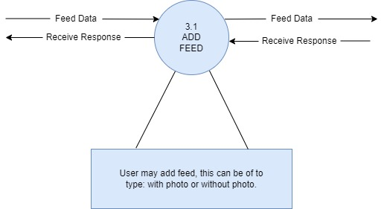

* **3.2 delete feed:**

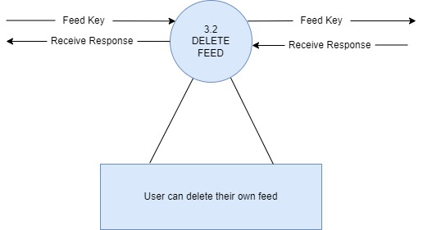

* **3.3 follow user:**

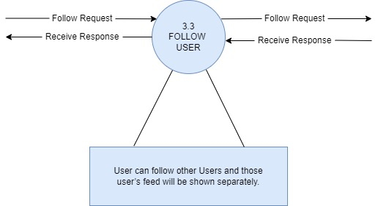

* **4.1 add vacancy:**

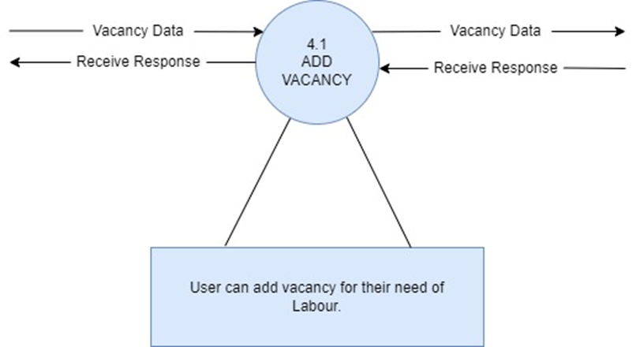

* **4.2 delete vacancy:**

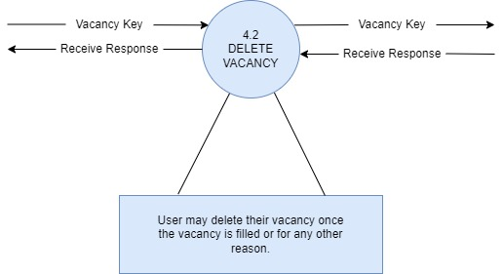

* **5.0 manage labor data:**

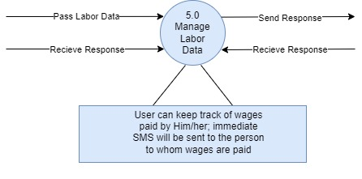

* **6.1 add resell data:**

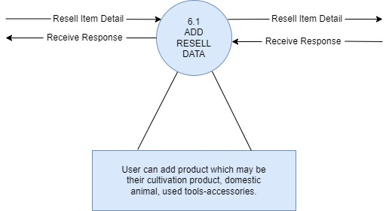

* **6.2 update resell data:**

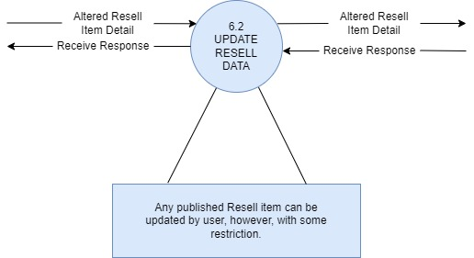

* **6.3 delete resell data:**

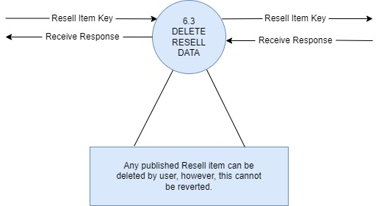

* **7.5 view ecommerce item**

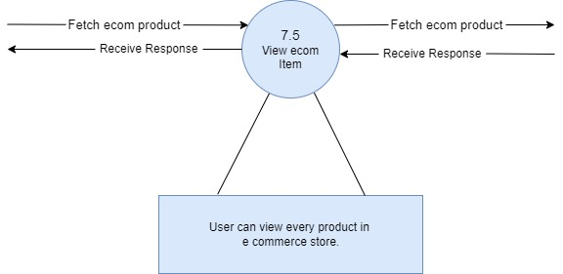

* 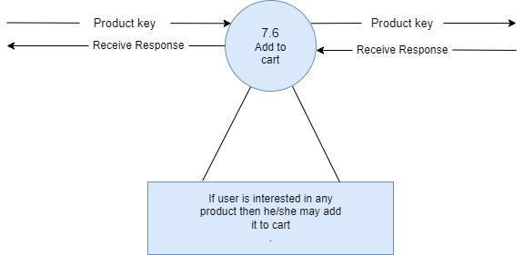**7.6 add to cart:**
* **7.7 confirm order:**

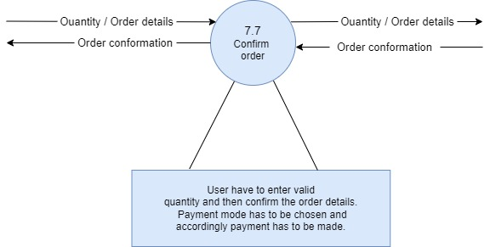

* **8.1 view news:**

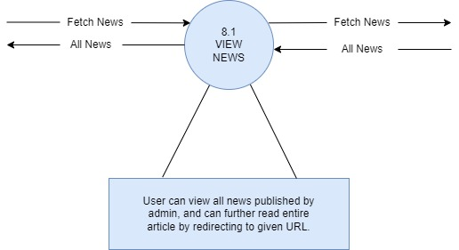

* **8.2 view government scheme:**

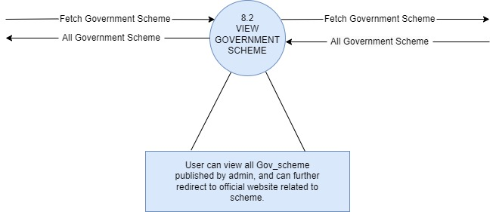

* **9.1 view customer feeds:**

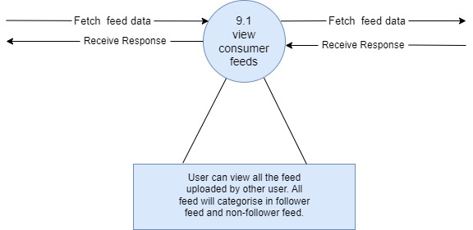

* **9.2 view customer resell item:**

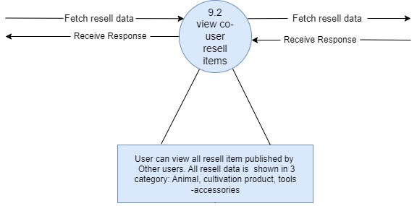

* **9.3 view customer user vacancy:**

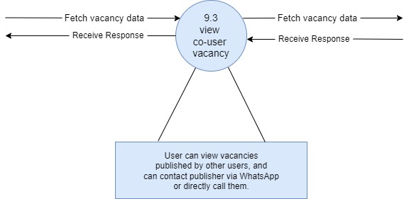

* **9.4 response between user**

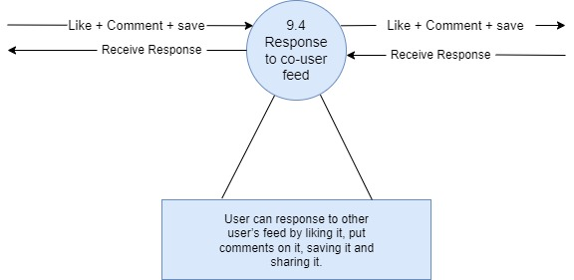

* 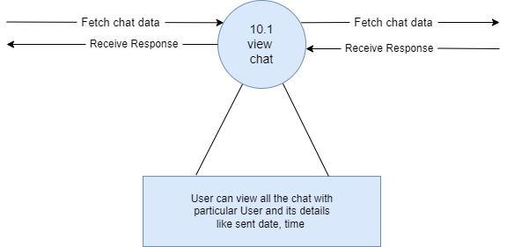**10.1 view chat:**
* **10.2 send message:**

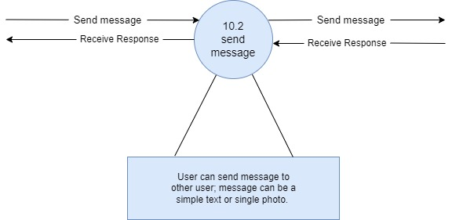

* **10.3 delete message:**

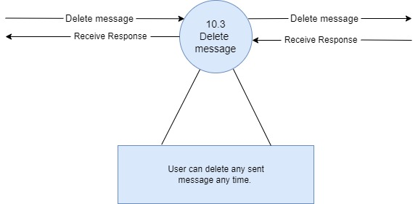

**5.3 DATA DICTIONARY**

|  |  |
| --- | --- |
| Name: | logindetail |
| Alias: | Null |
| Whereused?/How used? | User/Adminlogin(Input/Output) |
| ContentDescription: | uname+mo+url |

|  |  |
| --- | --- |
| Name: | Update/complete Profile Detail |
| Alias: | Null |
| Whereused?/How used? | User/AdminUpdate profile(Input/Output) |
| ContentDescription: | email+dob+gender+address+state+uname+mo+url |

|  |  |
| --- | --- |
| Name: | Feed Detail |
| Alias: | Null |
| Whereused?/How used? | Post Feed (Input/Output) |
| ContentDescription: | umo+date+post+key+des+mediatype |

|  |  |
| --- | --- |
| Name: | Chat Detail |
| Alias: | Null |
| Whereused?/How used? | Chat between Users (Input/Output) |
| ContentDescription: | key+msg+smo+rmo+date+time+img |

|  |  |
| --- | --- |
| Name: | Comment Detail |
| Alias: | Null |
| Whereused?/How used? | Comments of user on feed(Input/Output) |
| ContentDescription: | mo+comment+key |

|  |  |
| --- | --- |
| Name: | Like Detail |
| Alias: | Null |
| Whereused?/How used? | Like of user on feed(Input/Output) |
| ContentDescription: | mo |

|  |  |
| --- | --- |
| Name: | Save Feed Detail |
| Alias: | Null |
| Whereused?/How used? | Like of user on feed(Input/Output) |
| ContentDescription: | key |

|  |  |
| --- | --- |
| Name: | Vacancy Detail |
| Alias: | Null |
| Whereused?/How used? | User publish vacancy(Input/Output) |
| ContentDescription: | key+oname+ocan+twork+wtype+eamt+wdur+district+tehsil+village+  des+state+umoo+date |

|  |  |
| --- | --- |
| Name: | Labour Detail |
| Alias: | Null |
| Whereused?/How used? | User add labor detail(Input/Output) |
| ContentDescription: | lname+lmo+lloc+lwages+key+ldes+ladate |

|  |  |
| --- | --- |
| Name: | News Detail |
| Alias: | Null |
| Whereused?/How used? | Admin add news which can be view by user. (Input/Output) |
| ContentDescription: | headline+link+description+img+key |

|  |  |
| --- | --- |
| Name: | Government scheme Detail |
| Alias: | Null |
| Whereused?/How used? | Admin add Government scheme which can be view by user. (Input/Output) |
| ContentDescription: | name+state+url+des+key+lnk |

|  |  |
| --- | --- |
| Name: | Cultivation Product Detail |
| Alias: | Null |
| Whereused?/How used? | User add their cultivated product to sell. (Input/Output) |
| ContentDescription: | key+category+spiece+pname+qty+price+payment+state+mo+  district+tehsil+village+des+img+umo+date+sname |

|  |  |
| --- | --- |
| Name: | Animal Detail |
| Alias: | Null |
| Whereused?/How used? | User add their cultivated product to sell. (Input/Output) |
| ContentDescription: | key+type+spiece+ageyear+agemonth+mproduction+weight+state+mo+  price+district+tehsil+village+des+img+umo+date+sname. |

|  |  |
| --- | --- |
| Name: | Tools and Accessories Details |
| Alias: | Null |
| Whereused?/How used? | User add their Tools and Accessories to resell. (Input/Output) |
| ContentDescription: | key+type+spiece+ageyear+agemonth+mproduction+weight+state+mo+  price+district+tehsil+village+des+img+umo+date+sname. |

|  |  |
| --- | --- |
| Name: | Tools and Accessories Details |
| Alias: | Null |
| Whereused?/How used? | User add their Tools and Accessories to resell. (Input/Output) |
| ContentDescription: | Key+category+pname+Price+month+State+Mo+district+Tehsil+Village  Des+Img+umo+Date+Sname |

|  |  |
| --- | --- |
| Name: | Ecommerce Product Details |
| Alias: | Null |
| Whereused?/How used? | Admin add product for ecommerce store. (Input/Output) |
| ContentDescription: | Price+Img+Recomm+dpec+Key+Pname+Des+Cgst+Sgst+Discount |

|  |  |
| --- | --- |
| Name: | Ecommerce Product Details |
| Alias: | Null |
| Whereused?/How used? | Admin add product for ecommerce store. (Input/Output) |
| ContentDescription: | Price+Img+Recomm+dpec+Key+Pname+Des+Cgst+Sgst+Discount |

|  |  |
| --- | --- |
| Name: | Order Details |
| Alias: | Null |
| Whereused?/How used? | User enter quantity+ delivery details+ payment mode.  Product details are taken from system. (Input/Output) |
| ContentDescription: | Clsecommmodel+mo+address+qty+Key+Date+Name+time+  PaymentMode+PaymentId+PaymentStatus |

|  |  |
| --- | --- |
| Name: | AI Details |
| Alias: | Null |
| Whereused?/How used? | User prompts query or image to A.I.  Then A.I. generate output ans send response. (Input/Output) |
| ContentDescription: | uri+ query+ ai+ result |

|  |  |
| --- | --- |
| Name: | Weather Details |
| Alias: | Null |
| Whereused?/How used? | System sends latest latitude and longitude to server+  who accordingly sends weather data. |
| ContentDescription: | Latitude+longitude+ description+ humidity+ pressure+ temp+ temp_max+ temp_min+ speed+ icon. |

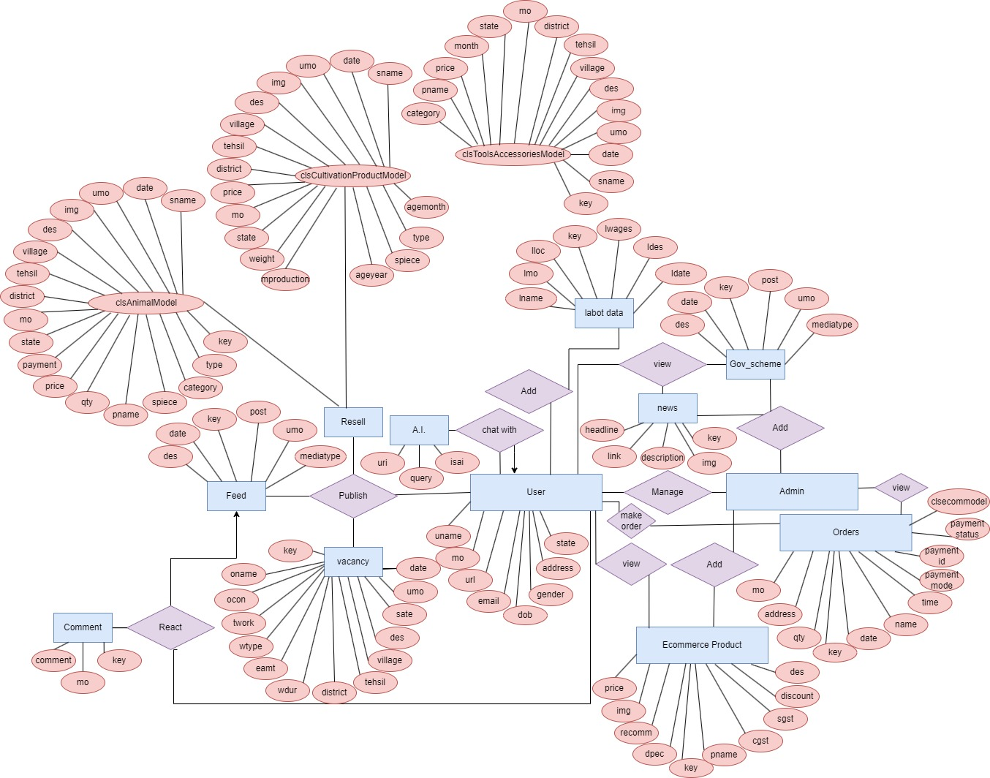

**5.4 Entity-Relationship Diagram**

**6. System Design**

6.1 Database Design

6.2 Directory Structure

6.3 Input Layouts

**6.1 DATABASE DESIGN**

**1.ClsUserModel**

|  |  |  |  |
| --- | --- | --- | --- |
| ClsUserModel | | | |
| No | Field Name | Data type | Description |
| 1 | uname | String | Username |
| 2 | mo | String | Mobile No. |
| 3 | url | String | Profile Picture URL |
| 4 | email | String | User Email |
| 5 | dob | String | Date Of Birth |
| 6 | gender | String | Gender |
| 7 | address | String | Address |
| 8 | state | String | State |

**2.ClsAnimalModel**

|  |  |  |  |
| --- | --- | --- | --- |
| ClsAnimalModel | | | |
| No | Field Name | Data type | Description |
| 1 | key | String | Unique key |
| 2 | type | String | Animal type |
| 3 | spiece | String | Spiece of Animal |
| 4 | ageyear | String | Animal Age year |
| 5 | agemonth | String | Animal Age month |
| 6 | mproduction | String | Production from Animal |
| 7 | weight | String | Weight of Animal |
| 8 | state | String | State of living |
| 9 | mo | String | Mobile number of owner |
| 10 | price | String | Price of Animal |
| 11 | district | String | District of living |
| 12 | tehsil | String | Tehsil of living |
| 13 | village | String | Village of living |
| 14 | des | String | Description about animal |
| 15 | img | String | One Image of animal |
| 16 | umo | String | Mobile No. of uploader |
| 17 | date | String | Date of Upload |
| 18 | sname | String | Name of Seller |

**3.ClsCommentModel**

|  |  |  |  |
| --- | --- | --- | --- |
| ClsCommentModel | | | |
| No | Field Name | Data type | Description |
| 1 | mo | String | Mobile No  of Commenter |
| 2 | comment | String | Comment text |
| 3 | key | String | Unique Key |

**4.ClscultivationProductionModel**

|  |  |  |  |
| --- | --- | --- | --- |
| ClscultivationProductionModel | | | |
| No | Field Name | Data type | Description |
| 1 | key | String | Unique Key |
| 2 | category | String | Category of product |
| 3 | spiece | String | Spiece of product |
| 4 | pname | String | Product name |
| 5 | qty | String | Quantity (In K.G.) |
| 6 | price | String | Price (Per K.G.) |
| 7 | payment | String | Total Payment |
| 8 | state | String | State of Origin |
| 9 | mo | String | Mobile number of Seller |
| 10 | district | String | District of Origin |
| 11 | tehsil | String | Tehsil of Origin |
| 12 | Village | String | Village of Origin |
| 13 | Des | String | Description of Product |
| 14 | img | String | One Image of Product |
| 15 | umo | String | Mobilw No of Uploader |
| 16 | date | String | Date of Upload |
| 17 | sname | String | SellerName |

**5.ClsEcommModel**

|  |  |  |  |
| --- | --- | --- | --- |
| ClsEcommModel | | | |
| No | Field Name | Data type | Description |
| 1 | price | String | Price of product |
| 2 | img | String | Image of Product |
| 3 | recomm | String | Recommendation about Product |
| 4 | dpec | String | Specification of  Product |
| 5 | key | String | Unique Key |
| 6 | pname | String | Product name |
| 7 | des | String | Description of Product |
| 8 | cgst | Float | Rate Of cgst |
| 9 | sgst | Float | Rate Of sgst |
| 10 | discount | Float | Rate Of discount |

**6.ClsFeedModel**

|  |  |  |  |
| --- | --- | --- | --- |
| ClsFeedModel | | | |
| No | Field Name | Data type | Description |
| 1 | umo | String | Mobile No of  Uploader |
| 2 | date | String | Date of upload |
| 3 | post | String | Post (Image) |
| 4 | key | String | Unique Key |
| 5 | des | String | Description about post |
| 6 | mediatype | String | Type of Media |

**7.ClsGovModel**

|  |  |  |  |
| --- | --- | --- | --- |
| ClsGovModel | | | |
| No | Field Name | Data type | Description |
| 1 | name | String | Title of Scheme |
| 2 | state | String | Applicable State |
| 3 | url | String | URL of image |
| 4 | des | String | Little Description About Scheme |
| 5 | key | String | Unique Key |
| 6 | lnk | String | URL of Official Website |

**8.ClsLaborModel**

|  |  |  |  |
| --- | --- | --- | --- |
| ClsLaborModel | | | |
| No | Field Name | Data type | Description |
| 1 | lname | String | Labor name |
| 2 | lmo | String | Labor Mobile No. |
| 3 | lloc | String | Labor location |
| 4 | lwages | String | Labor wages |
| 5 | key | String | Unique Key |
| 6 | ldes | String | Description About Work |
| 7 | ldate | String | Date of Work |

**9.ClsNewsModel**

|  |  |  |  |
| --- | --- | --- | --- |
| ClsNewsModel | | | |
| No | Field Name | Data type | Description |
| 1 | headline | String | Headline Of news |
| 2 | link | String | Link to news-site |
| 3 | description | String | Description about news |
| 4 | img | String | Tab Image of news |
| 5 | key | String | Unique Key |

**10.ClsOrderModel**

|  |  |  |  |
| --- | --- | --- | --- |
| ClsOrderModel | | | |
| No | Field Name | Data type | Description |
| 1 | clsEcommModel | object | Object of product that is ordered |
| 2 | mo | String | Mobile no of Buyer |
| 3 | address | String | Delivery Address |
| 4 | qty | String | Ordered Quantity |
| 5 | key | String | Unique Key |
| 6 | date | String | Date of order |
| 7 | name | String | Name of customer |
| 8 | time | String | Time of order |
| 9 | PaymentMode | String | (Online,COD) |
| 10 | PaymentId | String | Unique id of payment |
| 11 | PaymentStatus | String | Status of payment |

**11. ClsToolsAccessoriesModel**

|  |  |  |  |
| --- | --- | --- | --- |
| ClsToolsAccessoriesModel | | | |
| No | Field Name | Data type | Description |
| 1 | key | String | Key |
| 2 | category | String | Category of Product |
| 3 | pname | String | Product name |
| 4 | price | String | Price of Product |
| 5 | month | String | Usage of Product in month |
| 6 | state | String | State of Origin |
| 7 | mo | String | Mobile number Of seller |
| 8 | district | String | District of Origin |
| 9 | tehsil | String | Tehsil of Origin |
| 10 | village | String | Village of Origin |
| 11 | desc | String | Description About Product |
| 12 | img | String | Image Of product |
| 13 | umo | String | Mobile Of uploader |
| 14 | date | String | Date Of Upload |
| 15 | sname | String | Seller Name |

**12. ClsVacancyModel**

|  |  |  |  |
| --- | --- | --- | --- |
| ClsVacancyModel | | | |
| No | Field Name | Data type | Description |
| 1 | key | String | Unique Key |
| 2 | oname | String | Name of Recruiter (Owner) |
| 3 | ocan | String | Owner Contact Number |
| 4 | twork | String | Type of work |
| 5 | wtype | String | Wage type  (Fix, Partnership) |
| 6 | eamt | String | Expected Earning amount |
| 7 | wdur | String | Work duration |
| 8 | district | String | District of Origin |
| 9 | tehsil | String | Tehsil of Origin |
| 10 | village | String | Village of Origin |
| 11 | des | String | Description about work to do |
| 12 | state | String | State of Origin |
| 13 | umo | String | Mobile No  of Publisher |
| 14 | date | String | Publish Date |

**13. ClsChatModel**

|  |  |  |  |
| --- | --- | --- | --- |
| ClsChatModel | | | |
| No | Field Name | Data type | Description |
| 1 | key | String | Unique Key |
| 2 | msg | String | Chat Message |
| 3 | smo | String | Sender Contact Number |
| 4 | rmo | String | Reciever Contact Number |
| 5 | date | String | Send Date |
| 6 | time | String | Send TIme |
| 7 | img | String | Chat Image |

**14. clsaiconversation**

|  |  |  |  |
| --- | --- | --- | --- |
| clsaiconversation | | | |
| No | Field Name | Data type | Description |
| 1 | imguri | String | Image data |
| 2 | query | String | queryMessage |
| 3 | isai | Boolean | Sent By ai or not |

**6.2 DIRECTORY STRUCTURE**

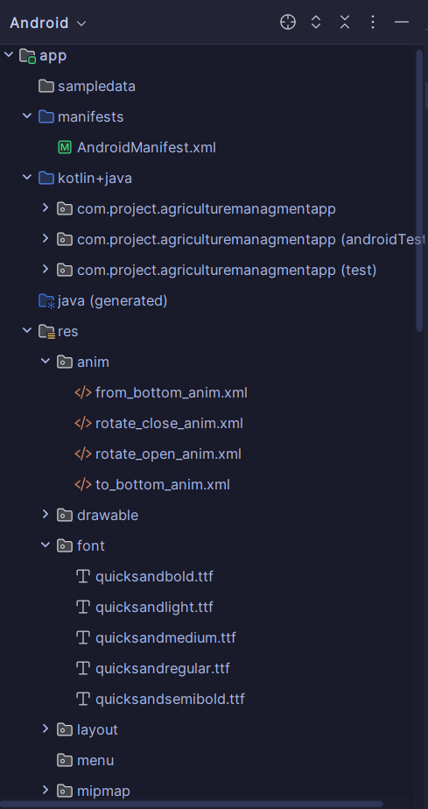

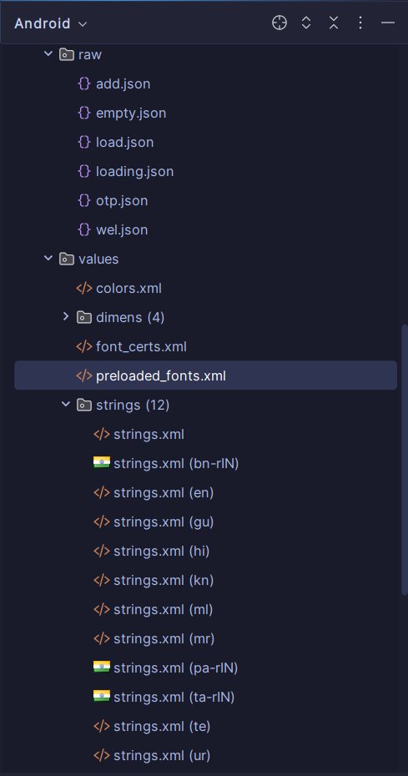

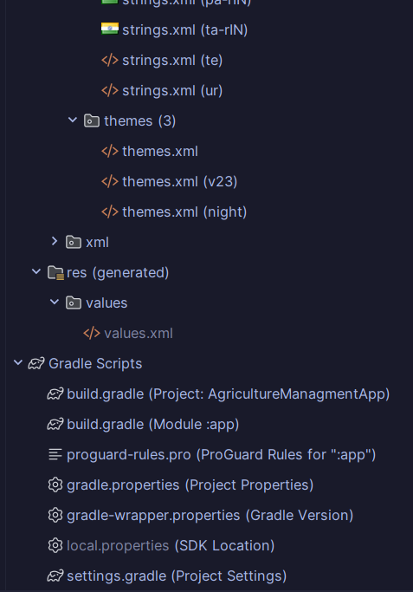

* **Activities**

|  |  |
| --- | --- |
| Java File | Xml File |
| add_admin | activity_add_admin.xml |
| add_animal | activity_add_animal.xml |
| add_cultivation_product | activity_add_cultivation_product.xml |
| add_ecomm | activity_add_ecomm.xml |
| add_feed | activity_add_feed.xml |
| add_gov_scheme | activity_add_gov_scheme.xml |
| add_labour | activity_add_labour.xml |
| add_labour_vacancy | activity_add_labour_vacancy.xml |
| add_news | activity_add_news.xml |
| add_tools_accesories | activity_add_tools_accesories.xml |
| admin_animal | activity_admin_animal.xml |
| admin_cultivation | activity_admin_cultivation.xml |
| admin_ecom | activity_admin_ecom.xml |
| admin_home | activity_admin_home.xml |
| admin_resell_category | activity_admin_resell_category.xml |
| admin_tools | activity_admin_tools.xml |
| AI | activity_ai.xml |
| animal_category_Activity | activity_animal_category.xml |
| Cart | activity_cart.xml |
| category_cultivation | activity_category_cultivation.xml |
| chat | activity_chat.xml |
| ChatList | activity_chat_list.xml |
| ConfirmOrder | activity_confirm_order.xml |
| Contact_us | activity_contact_us.xml |
| EditprofileActivity | activity_editprofile.xml |
| Explore_User | activity_explore_user.xml |
| govermentScheme | activity_goverment_scheme.xml |
| Home | activity_home.xml |
| Language | activity_language.xml |
| MainActivity | activity_main.xml |
| MyOrder | activity_my_order.xml |
| MyProfile | activity_my_profile.xml |
| Navigation | activity_navigation.xml |
| news | activity_news.xml |
| orderbydate | activity_orderbydate.xml |
| OTP | activity_otp.xml |
| Posts | activity_posts.xml |
| Resell_Category | activity_resell_category.xml |
| Saved | activity_saved.xml |
| show_CultivationProduct | activity_show_cultivation_product.xml |
| show_ecom_prdt | activity_show_ecom_prdt.xml |
| Show_Follower | activity_show_follower.xml |
| splashActivity | activity_splash.xml |
| Term_Conditions | activity_term_conditions.xml |
| User_list | activity_user_list.xml |
| User_option | activity_user_option.xml |
| User_output | activity_user_output.xml |
| Write_share | activity_write_share.xml |

* **Fragments**

|  |  |
| --- | --- |
| Java File | Xml File |
| animals | fragment_animals.xml |
| Cultivation_Product | fragment_cultivation__product.xml |
| E_commrce | fragment_e_commrce.xml |
| FollowList | fragment_follow_list.xml |
| frghome | fragment_frghome.xml |
| Labour_Management | fragment_labour__management.xml |
| MyProducts | fragment_my_products.xml |
| MyVacancy | fragment_my_vacancy.xml |
| Myfeed | fragment_myfeed.xml |
| Other_vacancy | fragment_other_vacancy.xml |
| Resell | fragment_resell.xml |
| ShowFeed | fragment_show_feed.xml |
| tools_accesories | fragment_toos_accesories.xml |
| Cancelled_order | fragment_Cancelled_order.xml |
| datewiseorder | fragment_datewiseorder.xml |

* **Layout Resource File**

|  |
| --- |
| XmlLayoutFile |
| lyt_add_feed_category.xml |
| lyt_ai_conversation_tabs.xml |
| lyt_animal_tab.xml |
| lyt_comment.xml |
| lyt_comment_sheet.xml |
| lyt_delete_dg.xml |
| lyt_dlt_msg.xml |
| lyt_ecom_filter.xml |
| lyt_ecom_tb.xml |
| lyt_edit_option_sheet.xml |
| lyt_feed.xml |
| lyt_gov_scheme.xml |
| lyt_green_toast.xml |
| lyt_img.xml |
| lyt_labor.xml |
| lyt_loading_dg.xml |
| lyt_msg_info.xml |
| lyt_news.xml |
| lyt_red_toast.xml |
| lyt_resell.xml |
| lyt_schema_feed.xml |
| lyt_user.xml |
| lyt_vacancy.xml |
| lyt_view_animal_sheet.xml |
| lyt_view_order_sheet.xml |
| lyt_view_tools_sheet.xml |

* **ModelClass**

|  |
| --- |
| JavaModelClass |
| clsaiconversation |
| clsAnimalModel |
| clsChatModel |
| clsCommentModel |
| ClsCultivationProductModel |
| clsEcommModel |
| clsFeedModel |
| clsgovmodel |
| clsLaborModel |
| clsNewsModel |
| clsOrderModel |
| clsToolsAccessoriesModel |
| clsUserModel |
| clsVacancyModel |

* **RecycleviewAdapter**

|  |
| --- |
| RecycleviewAdapter |
| RcAiConversationAdapter |
| RcAnimalAdapter |
| RcChatAdapter |
| RccommentAdapter |
| RcCultivatonPrdtAdpter |
| RcEcommAdapter |
| RcFeedAdapter |
| RcGovAdapter |
| RcImageGridAdapter |
| RcLabourAdapter |
| RcnewsAdapter |
| RcorderAdapter |
| RcToolsAccesoriesAdapter |
| RcuserAdapter |
| RcVacancyAdapter |

* **ViewPagerAdapter**

|  |
| --- |
| ViewPagerAdapter |
| VpAdapterResell |
| VpFollowerAdapter |
| VpHomeAdapter |
| VpProfileAdapter |
| VporderAdapter |

**6.3 INPUT Layouts**

* **Login (User&Admin)**

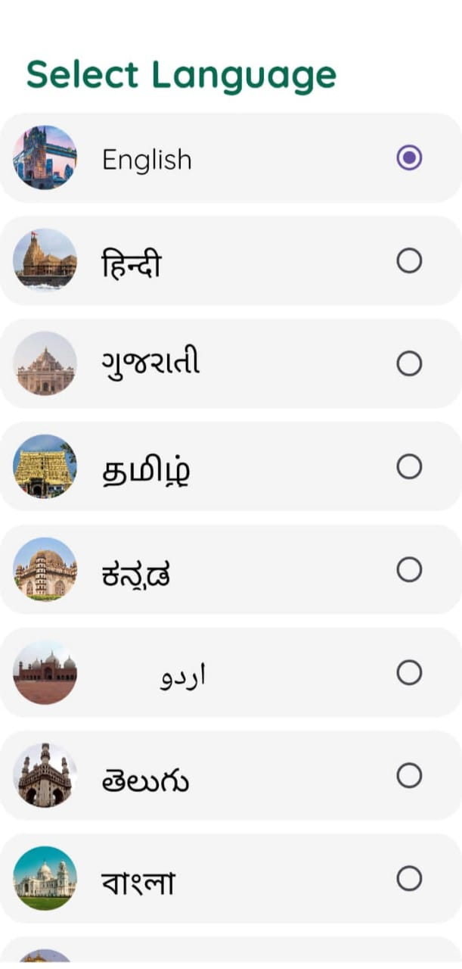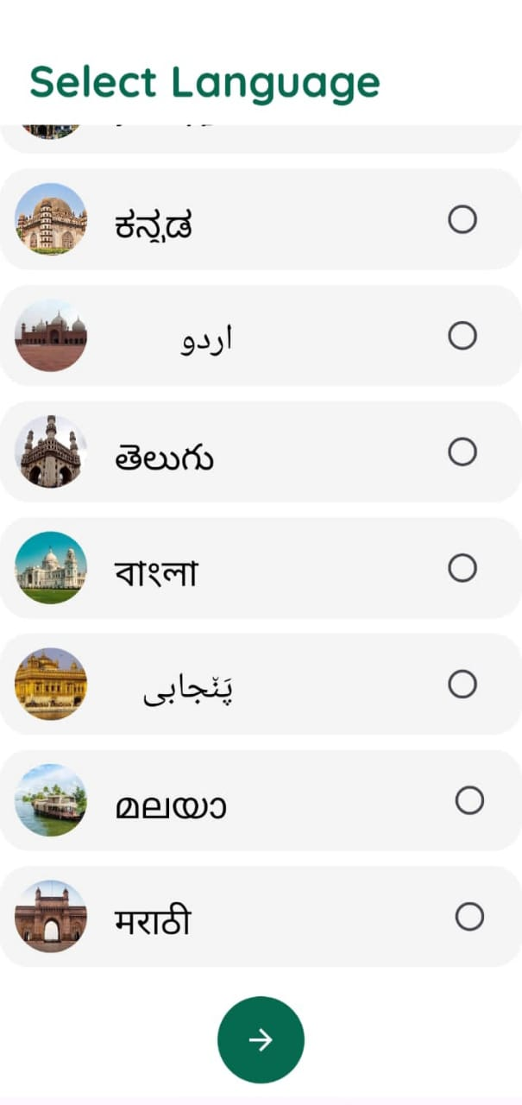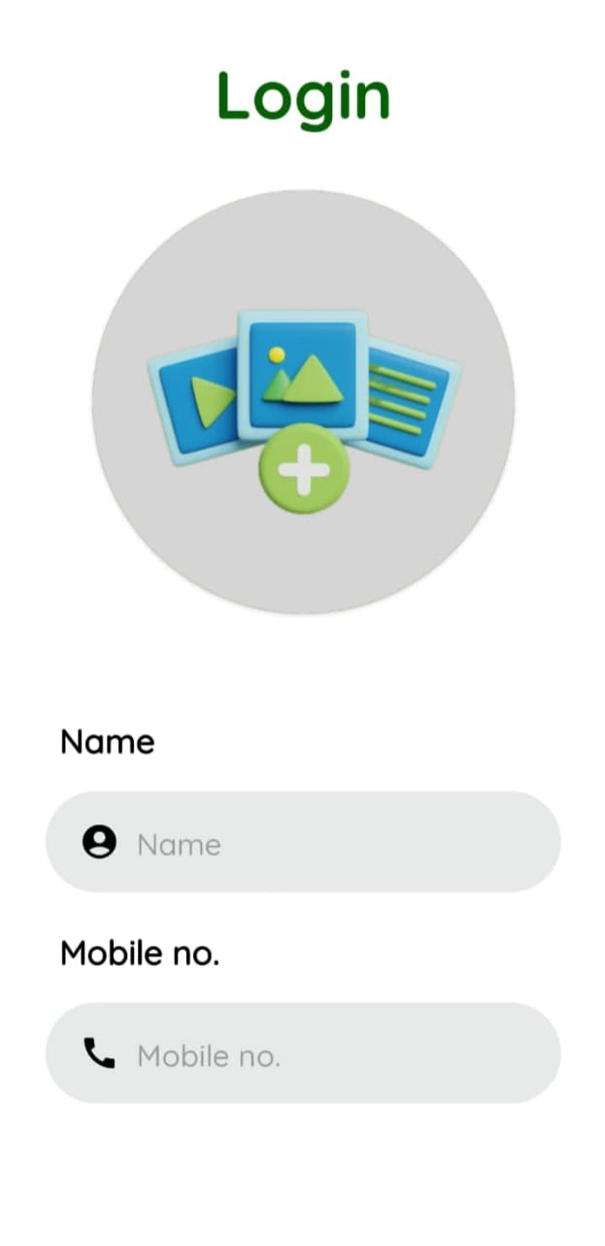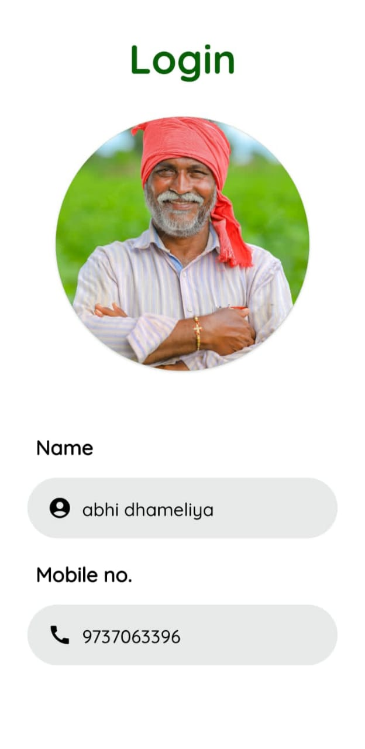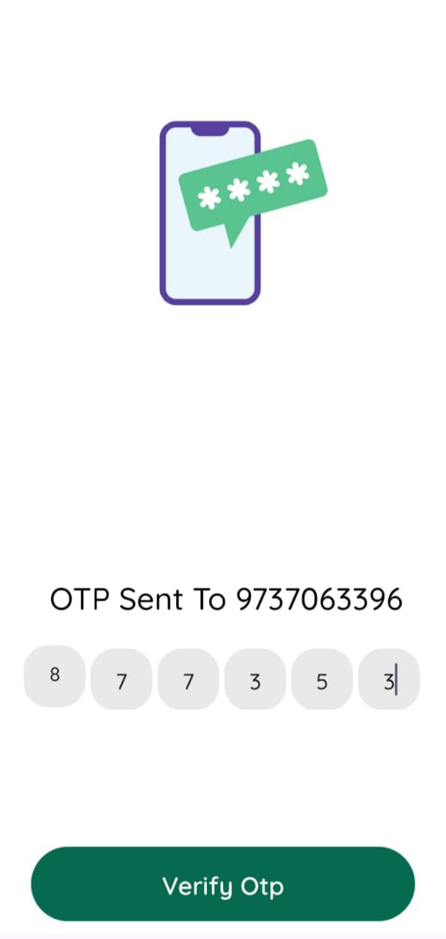

* **Feed (User)**

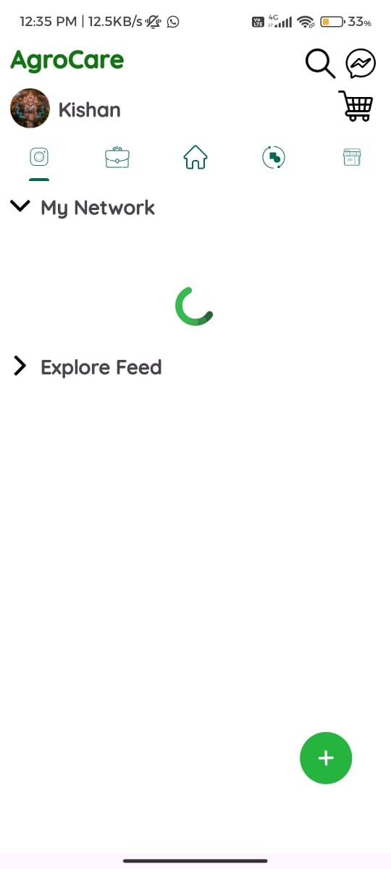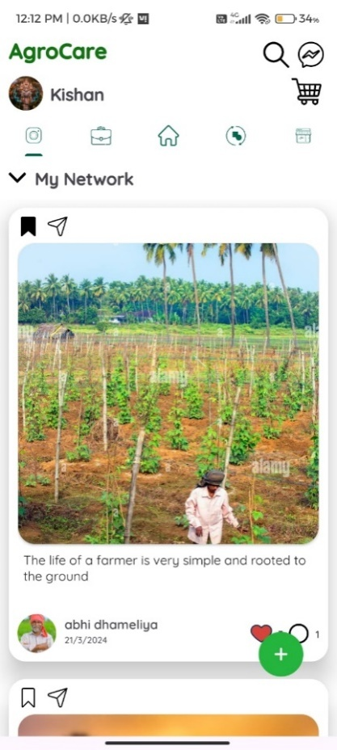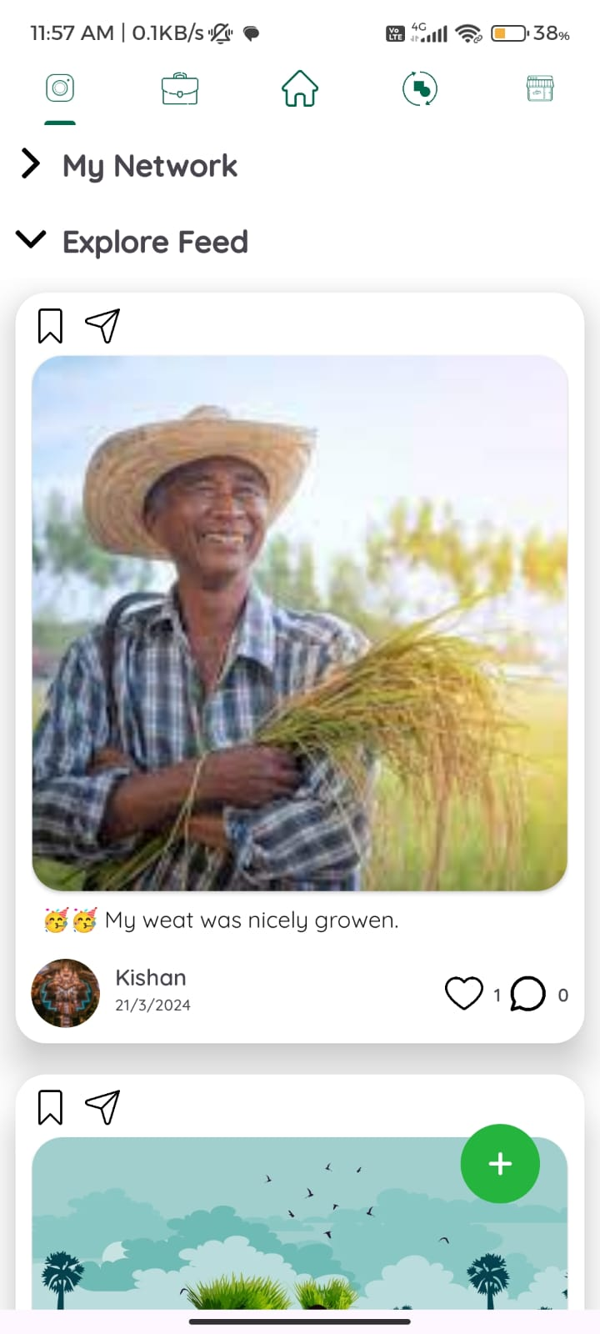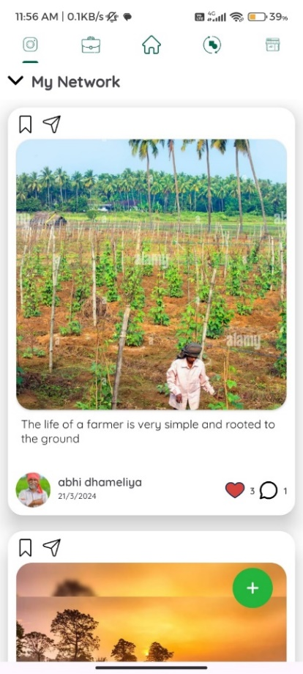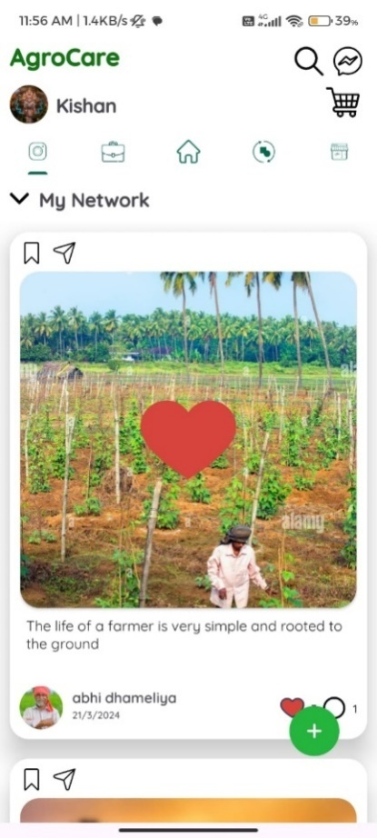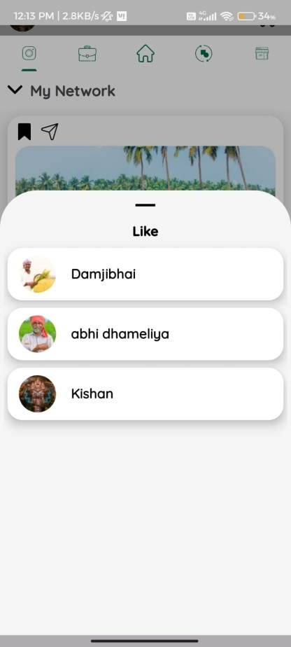

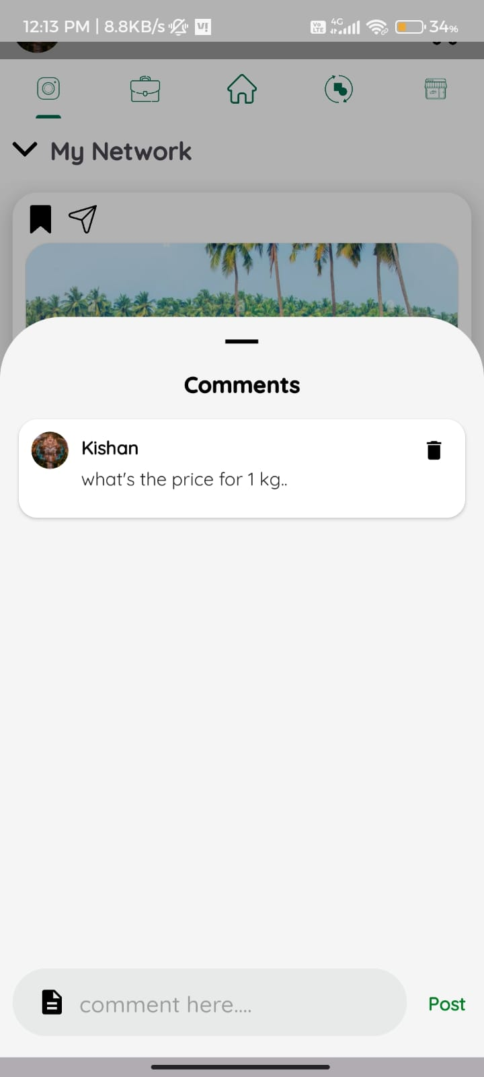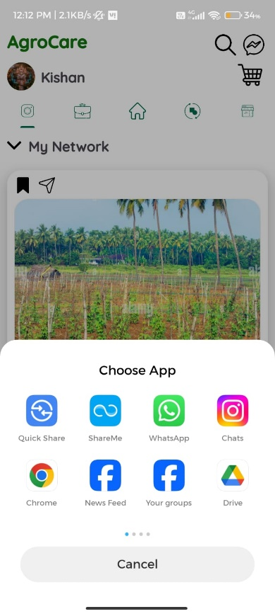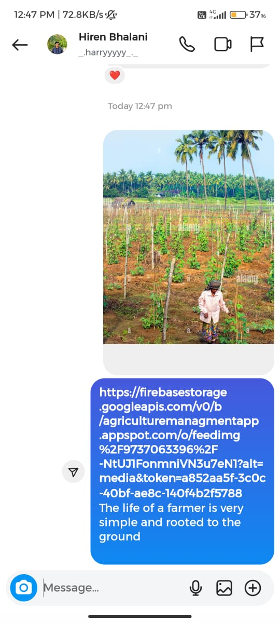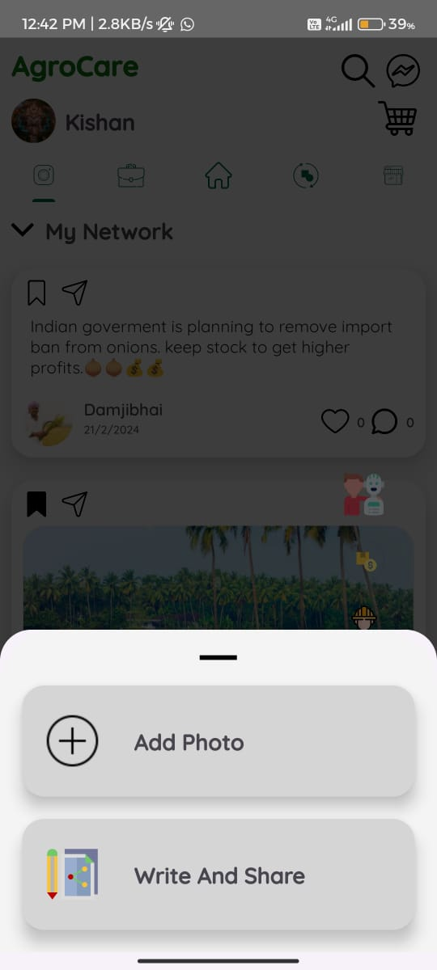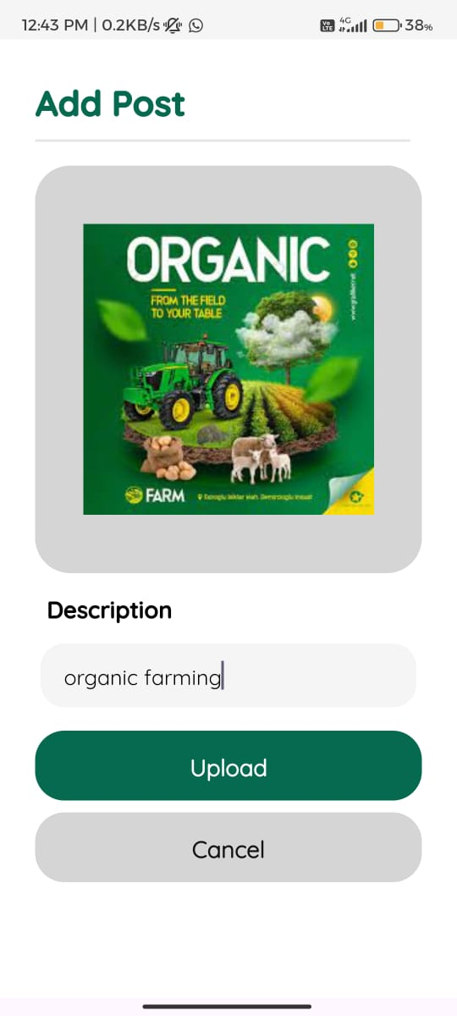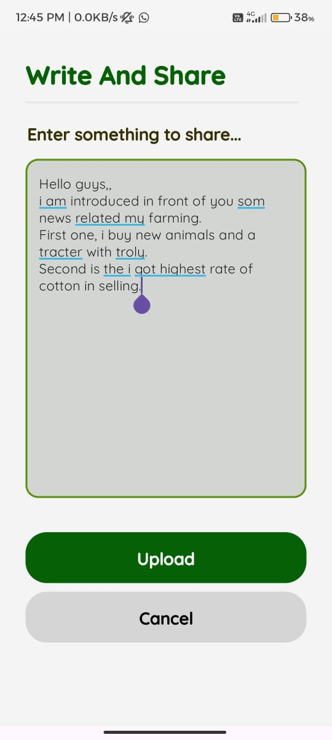

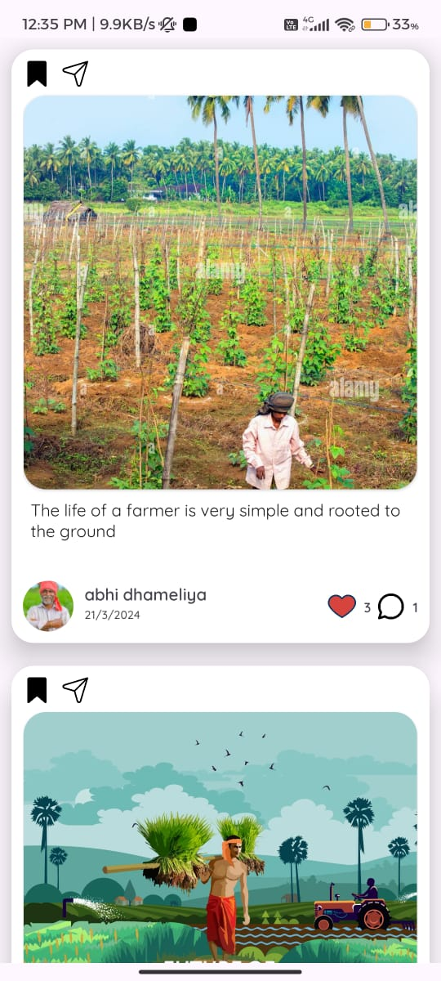

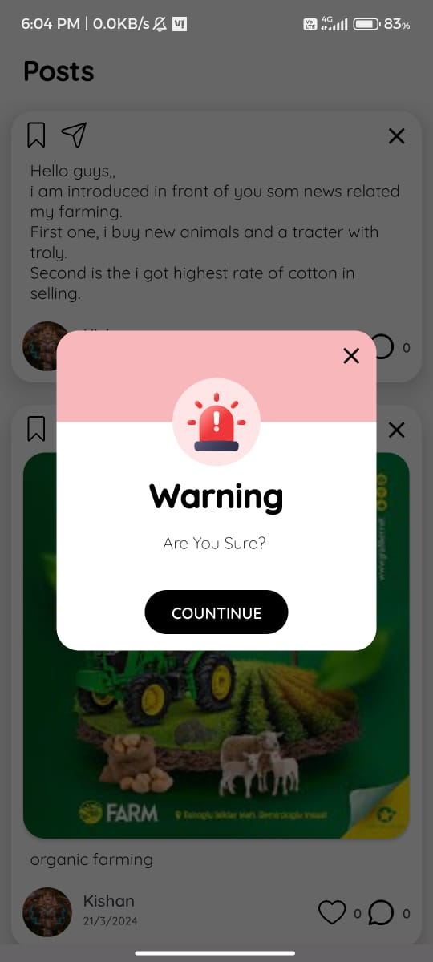

* **Chat (User)**

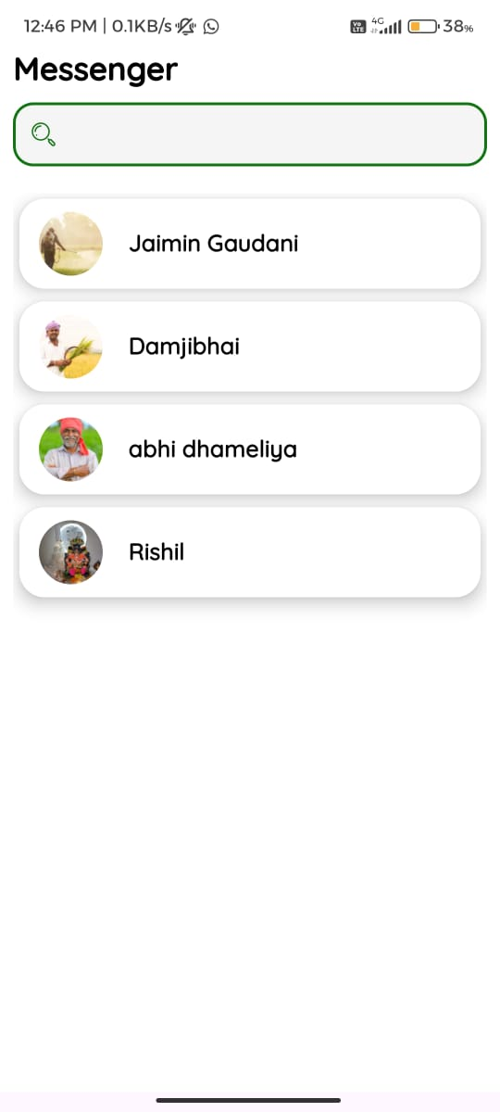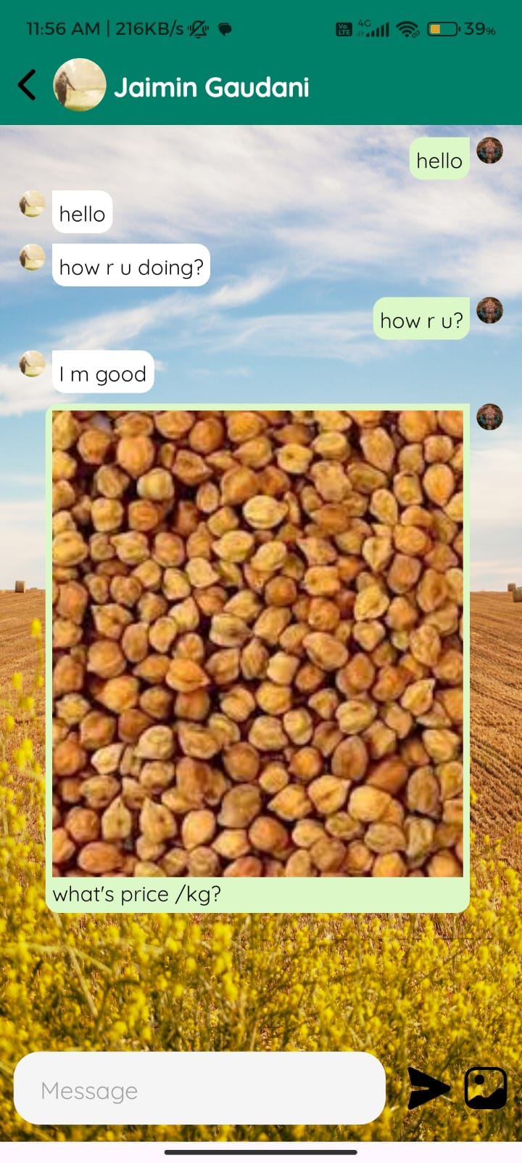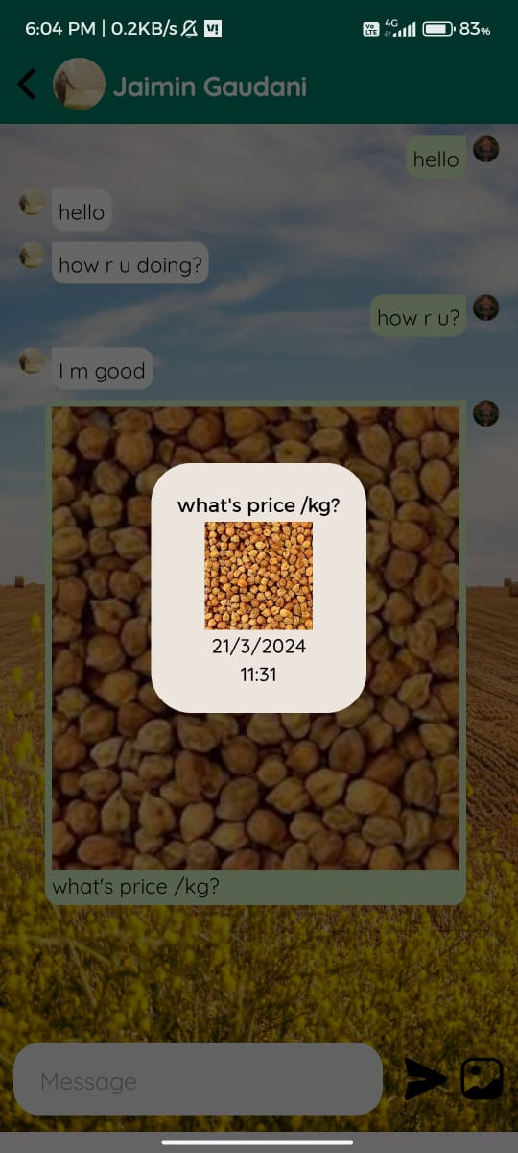

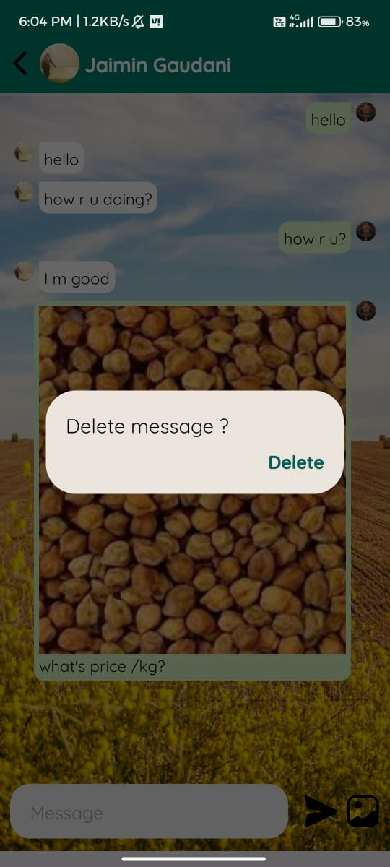

* **Vacancy (User)**

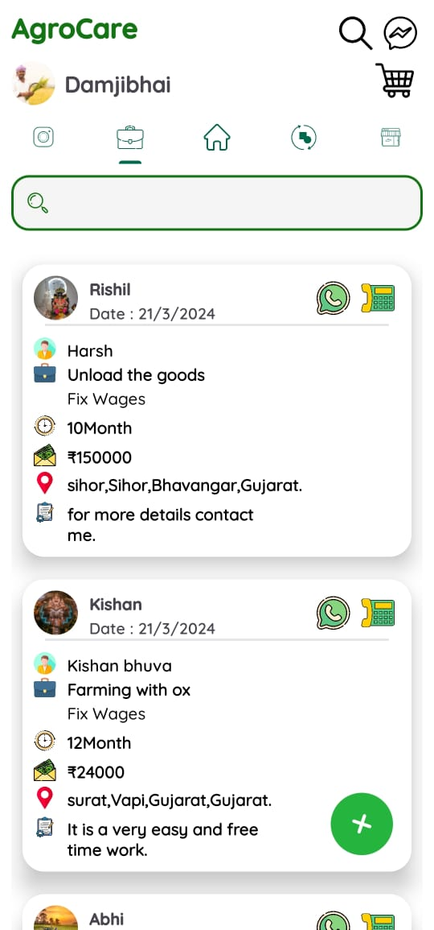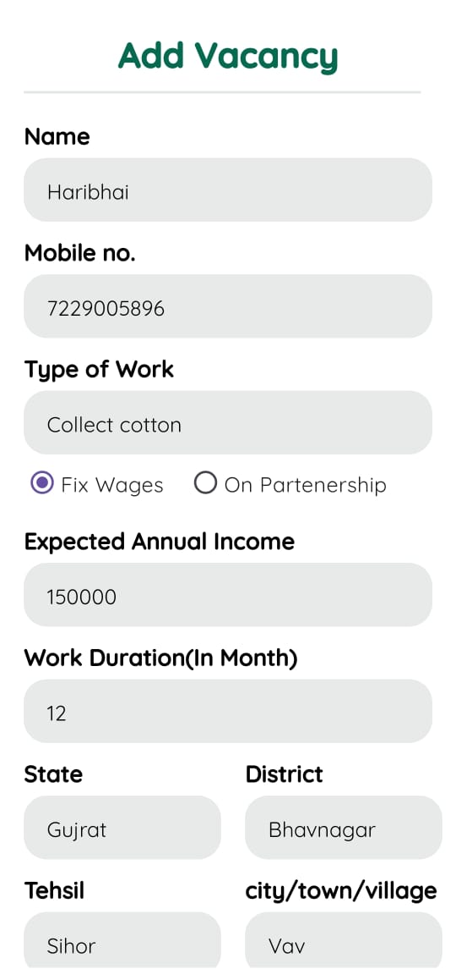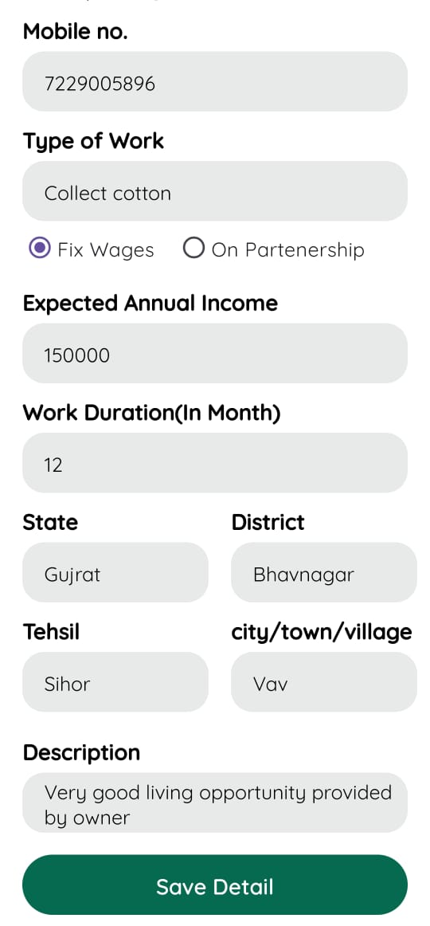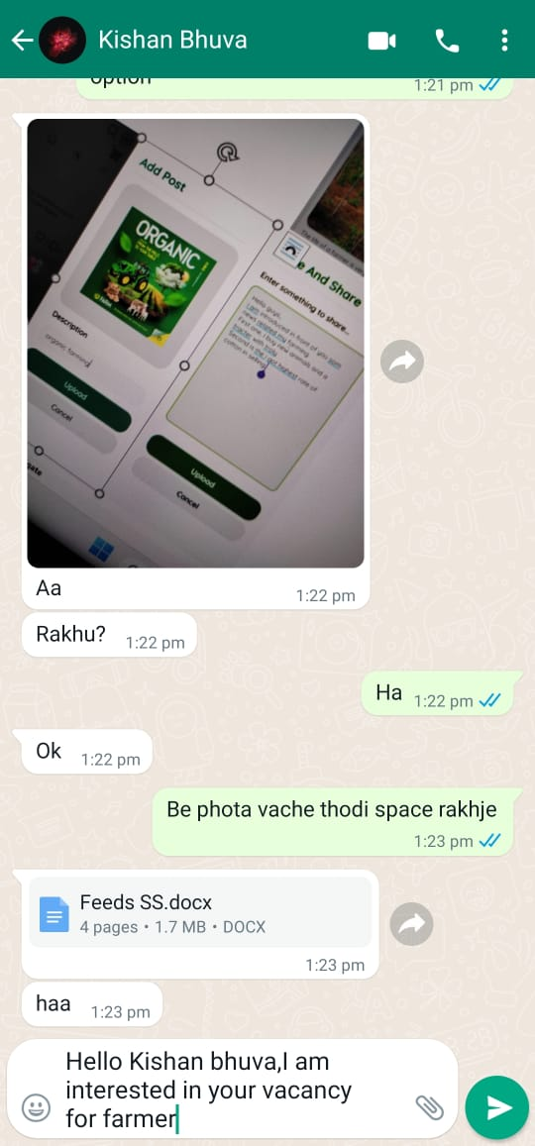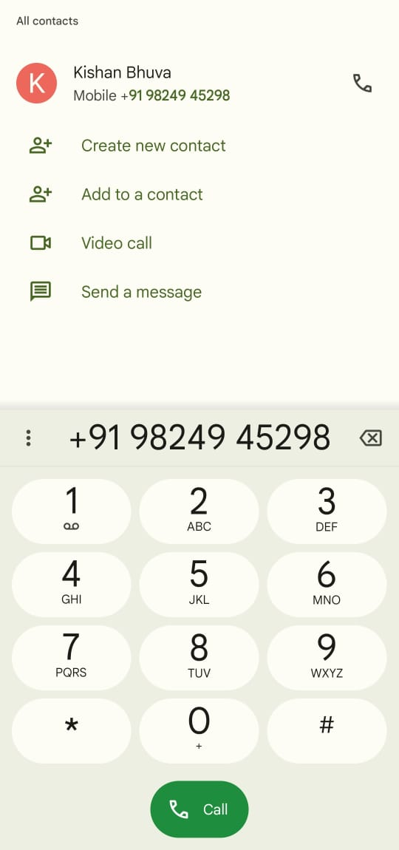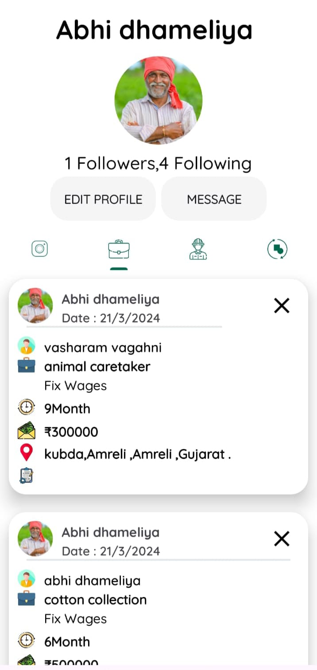

* **LabourManagment (User)**

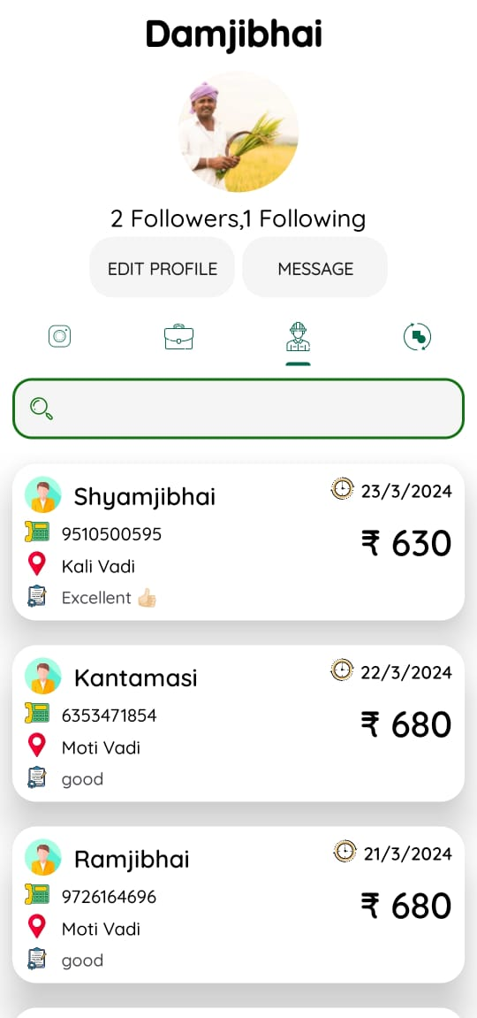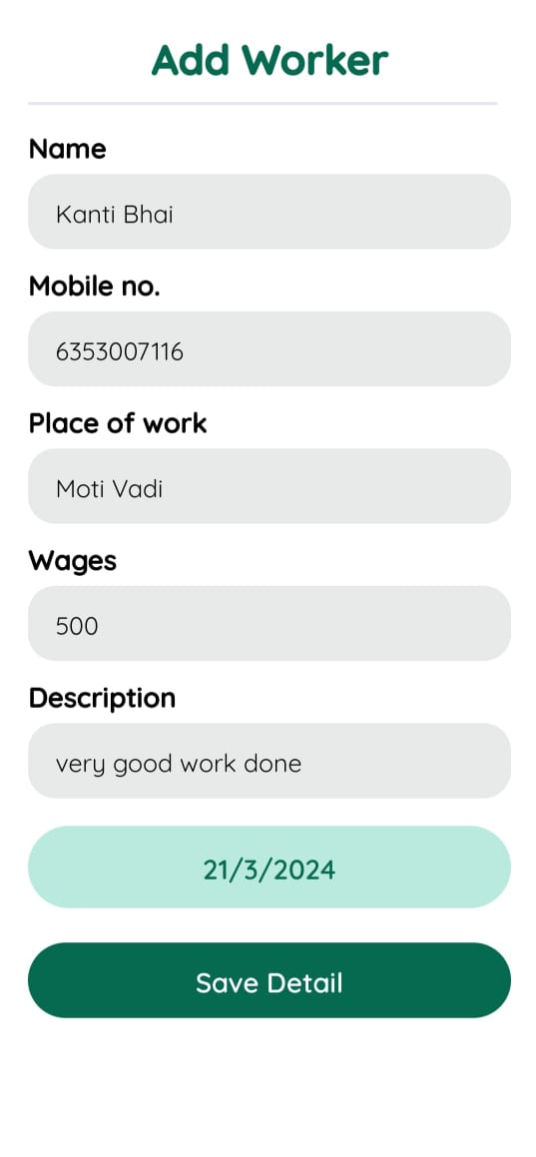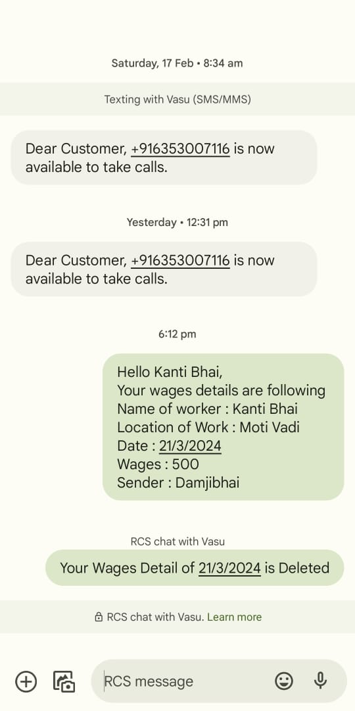

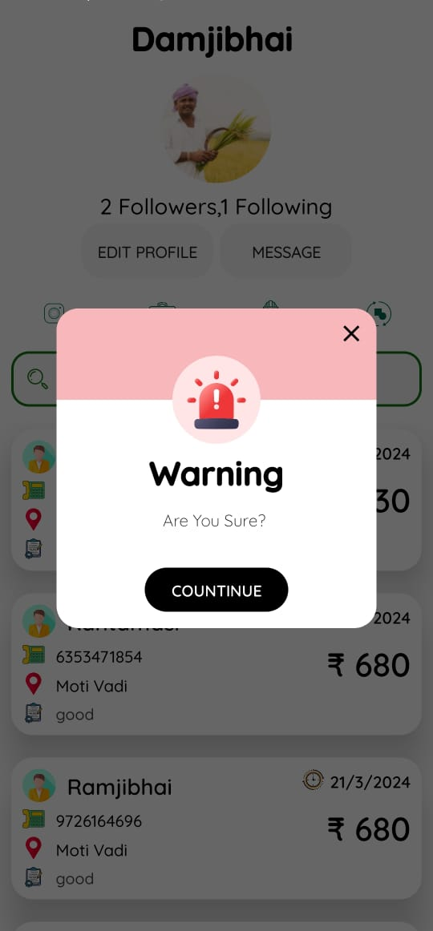

* **Resell (User)**

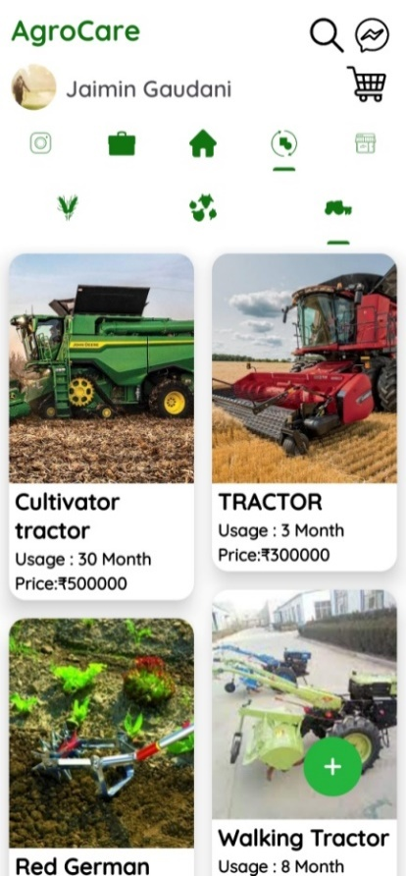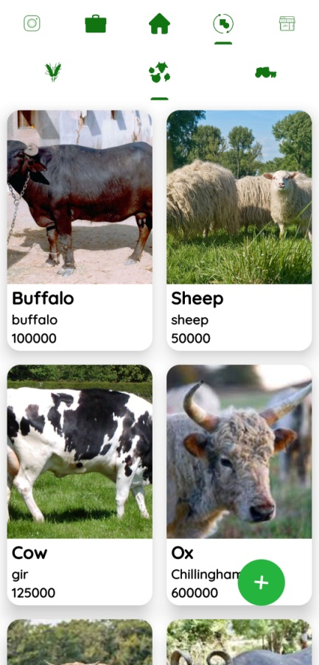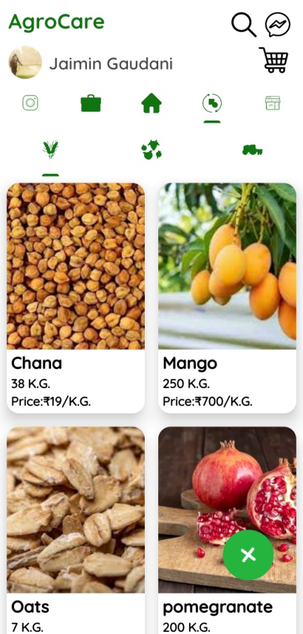

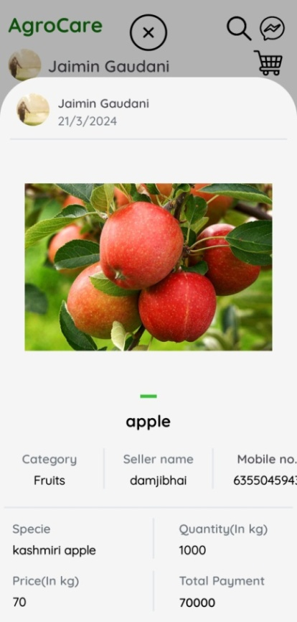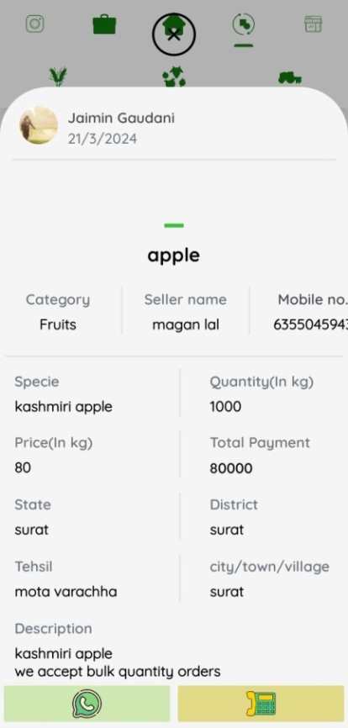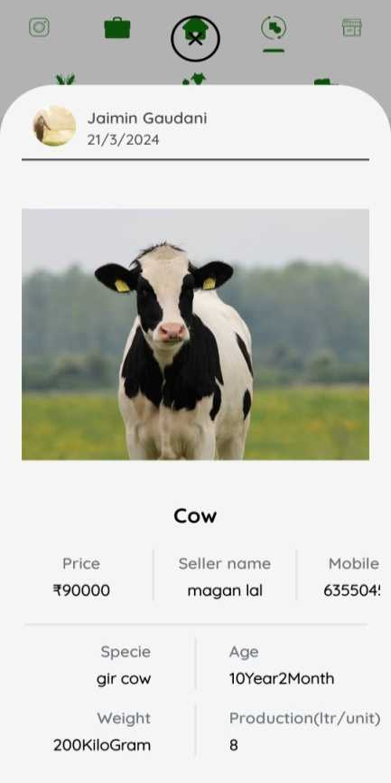

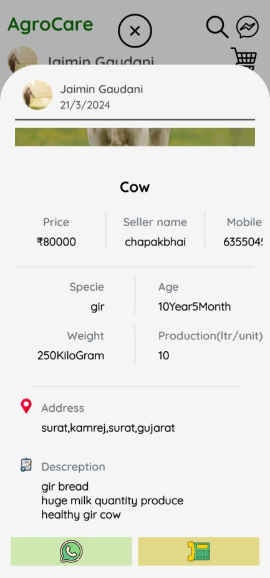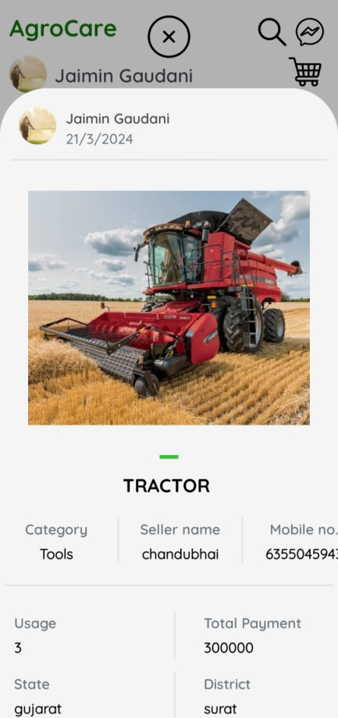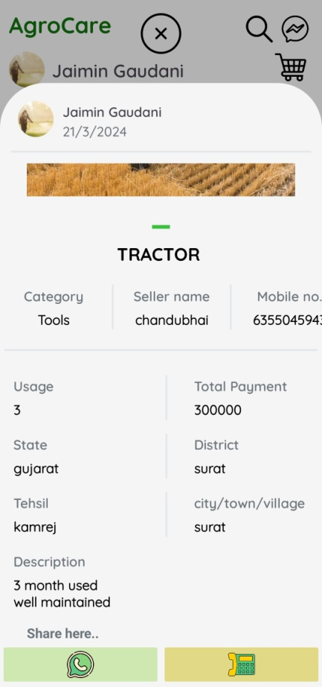

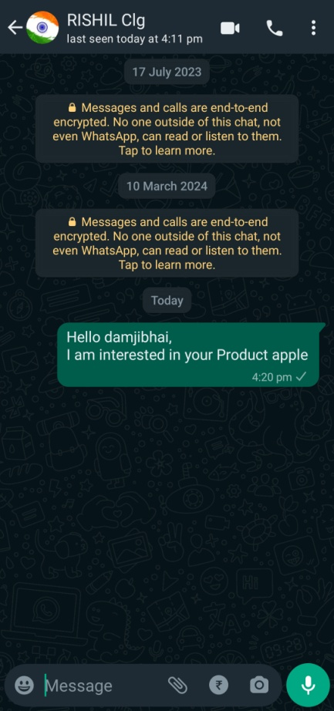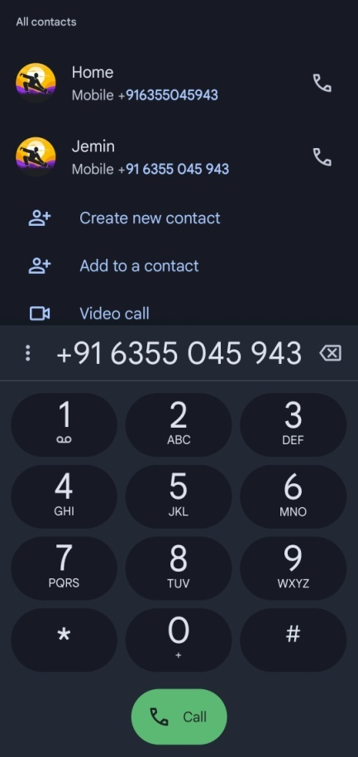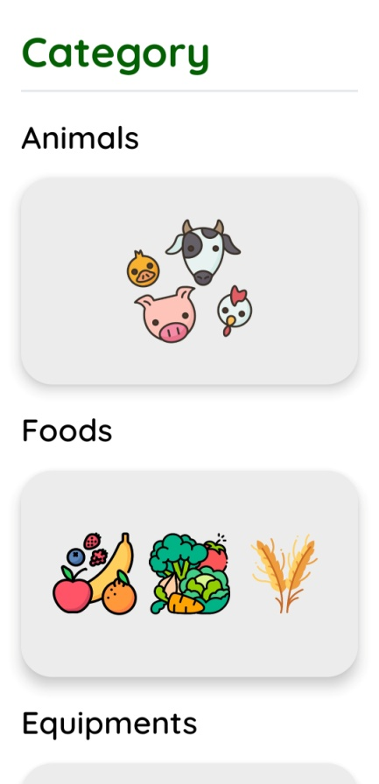

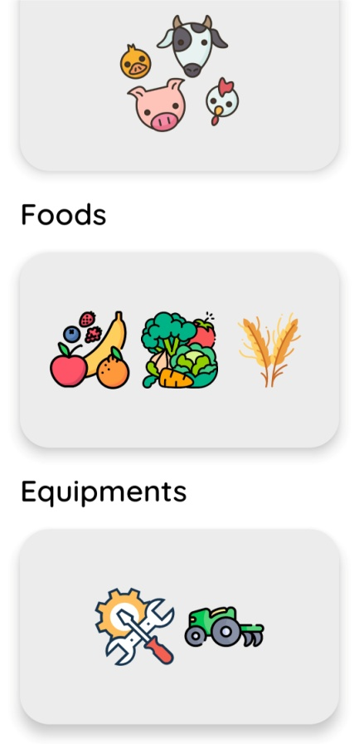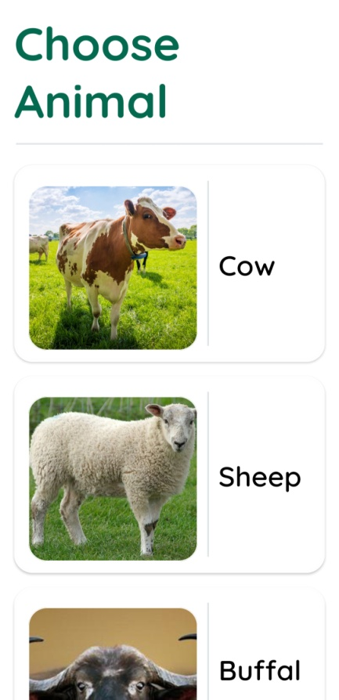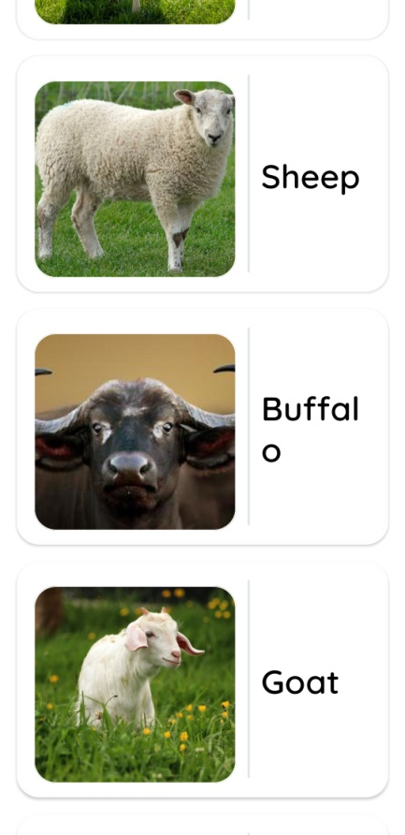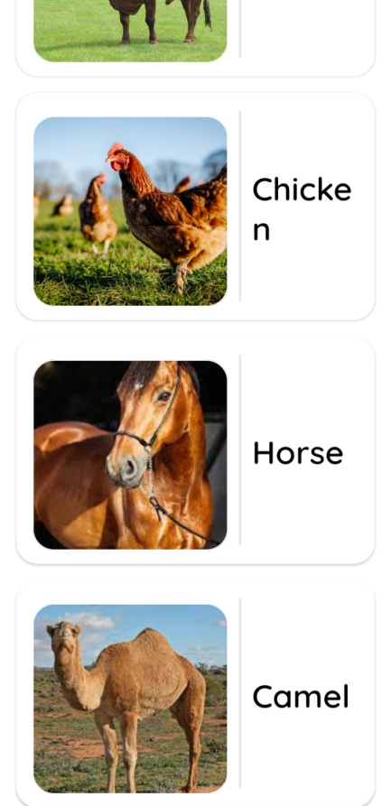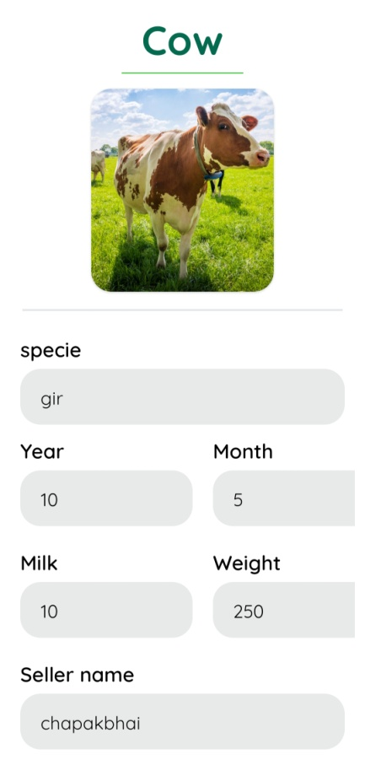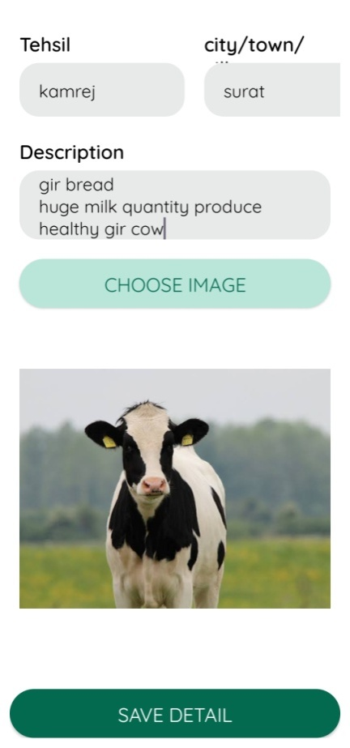

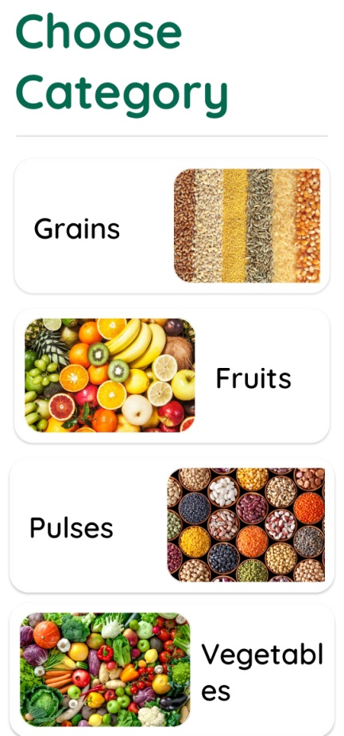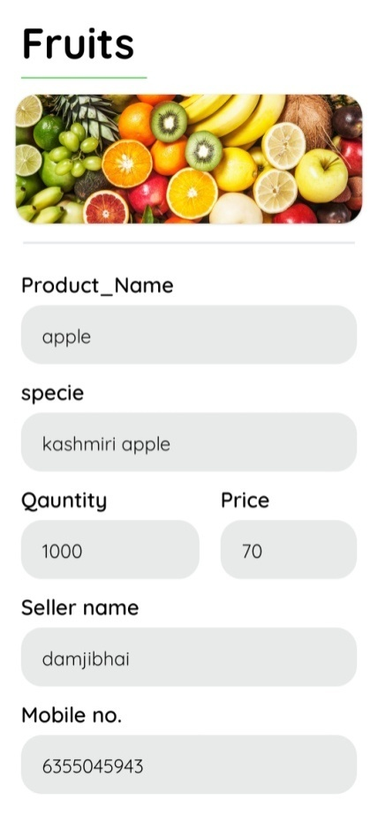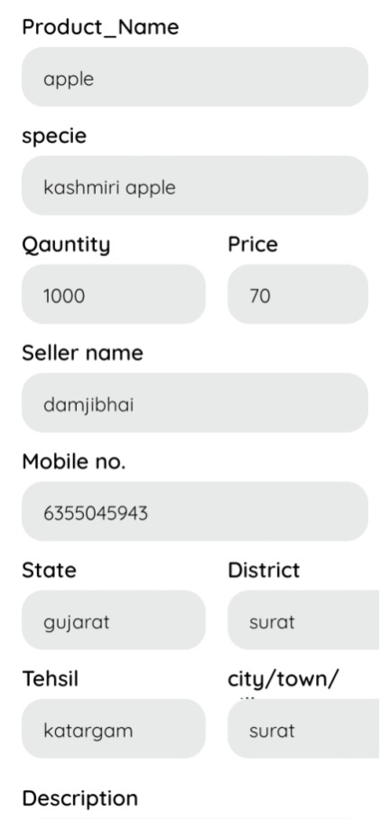

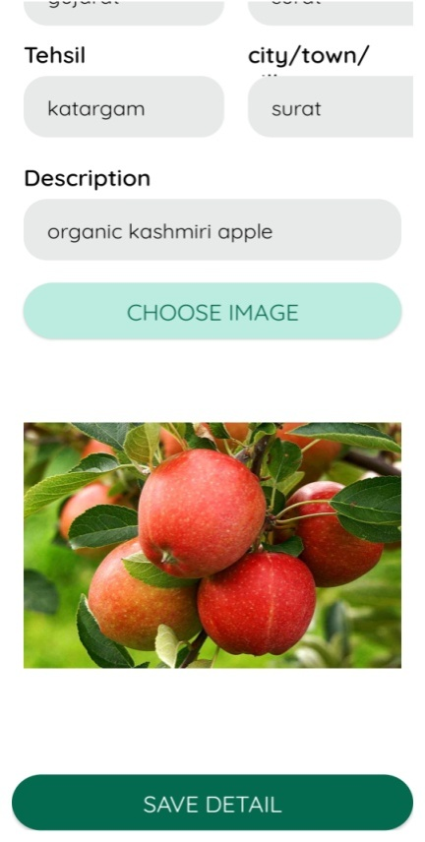

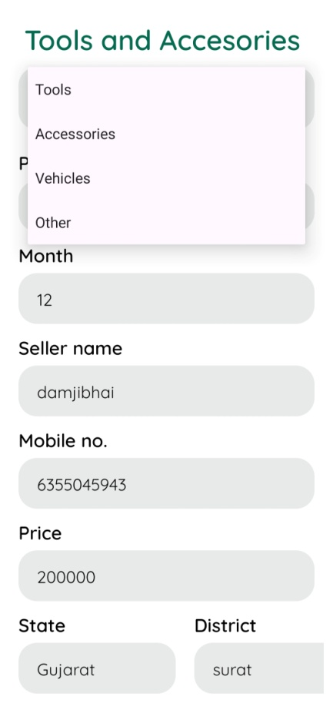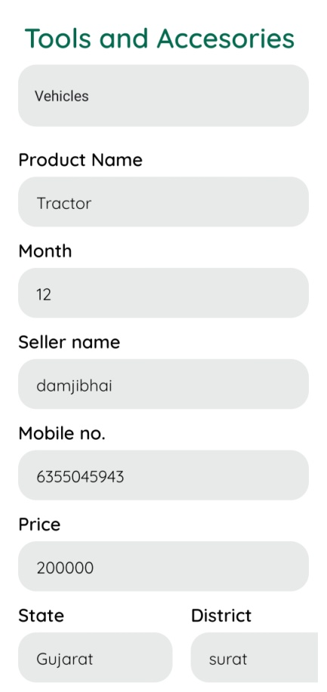

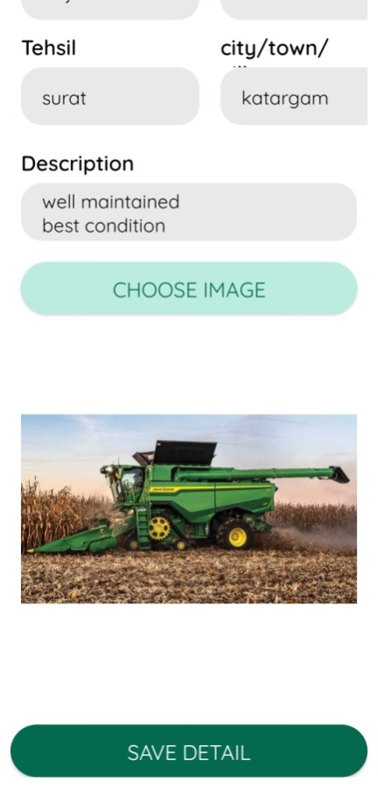

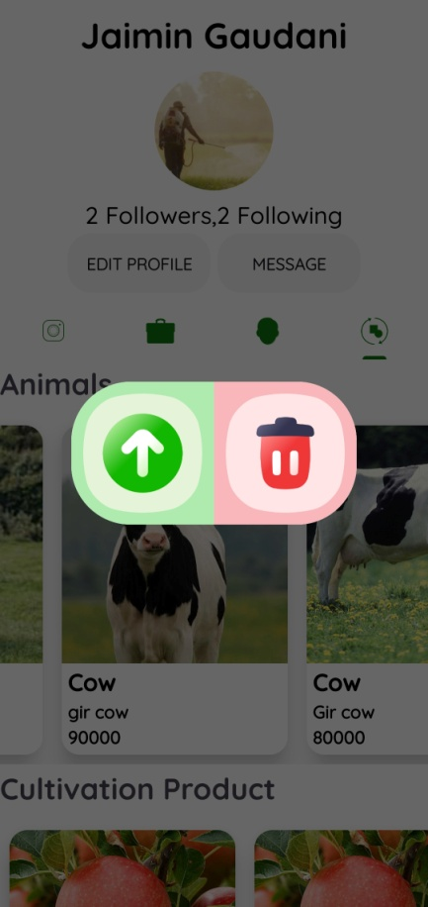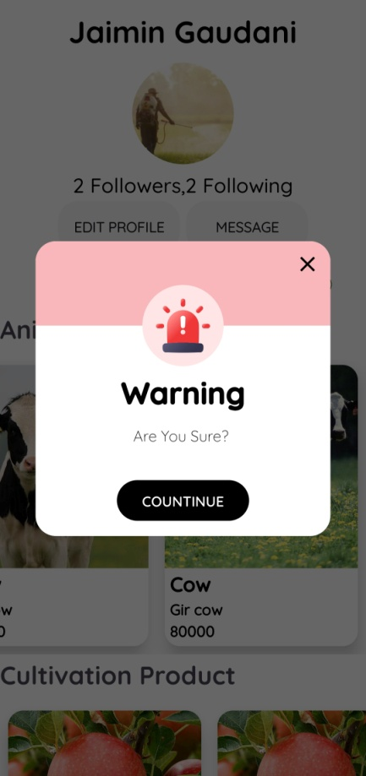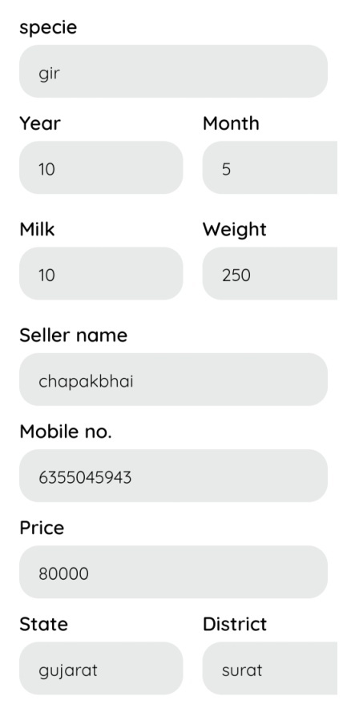

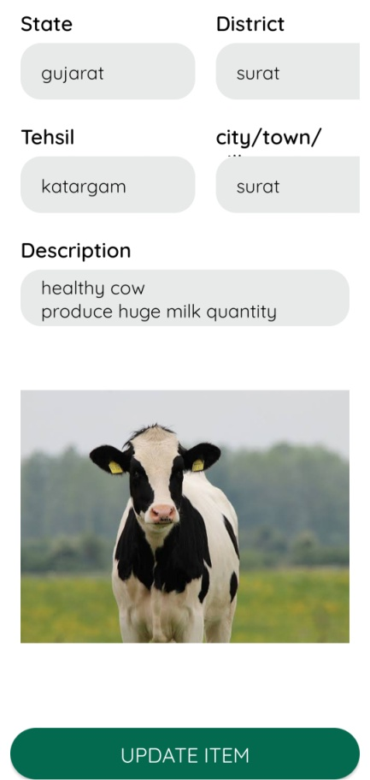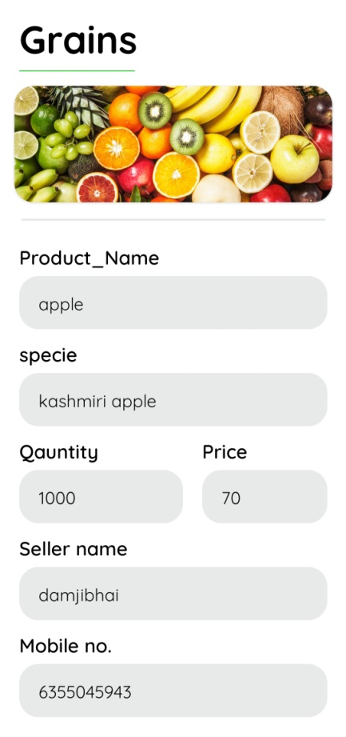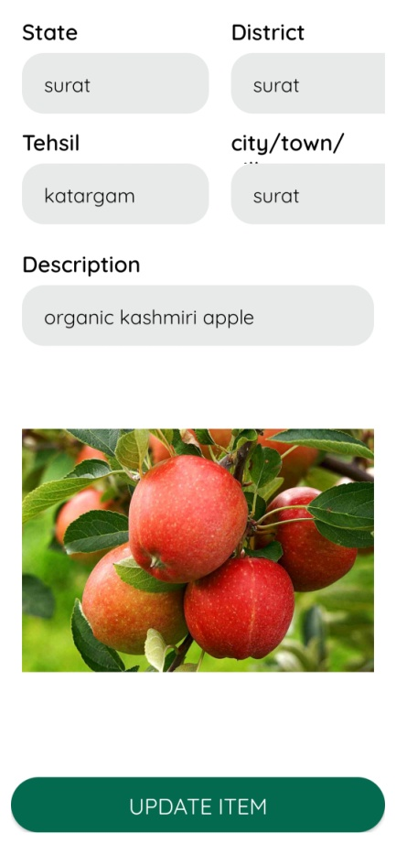

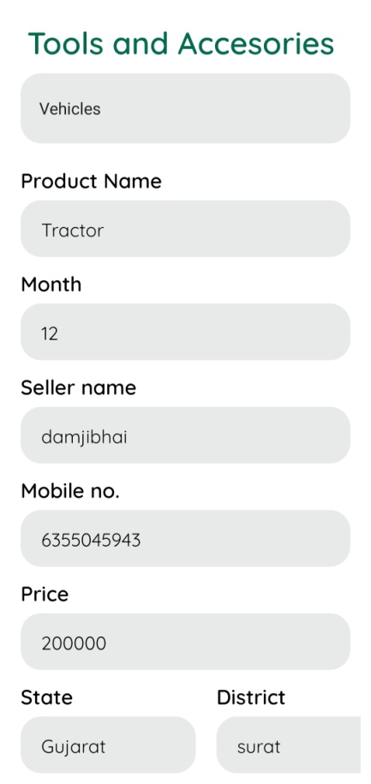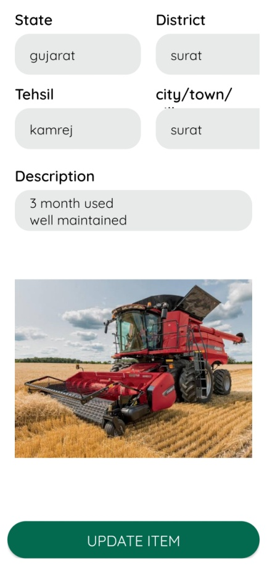

* **Ecommerce**

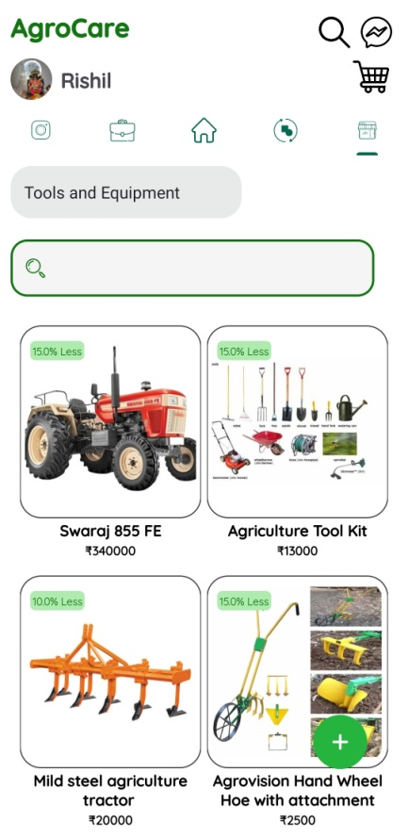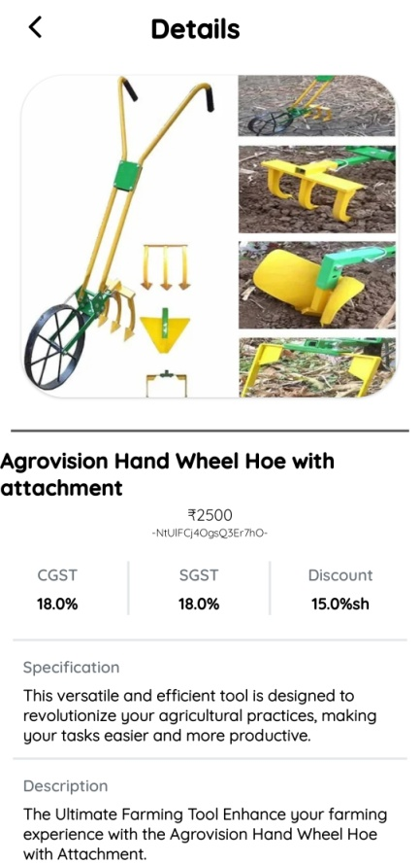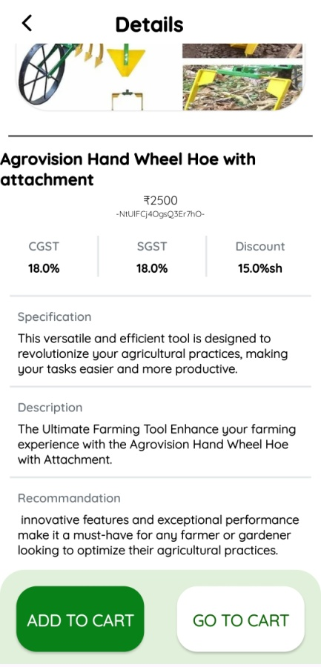

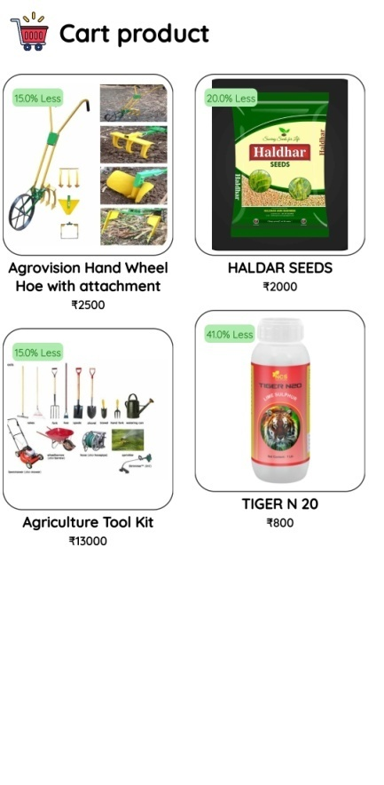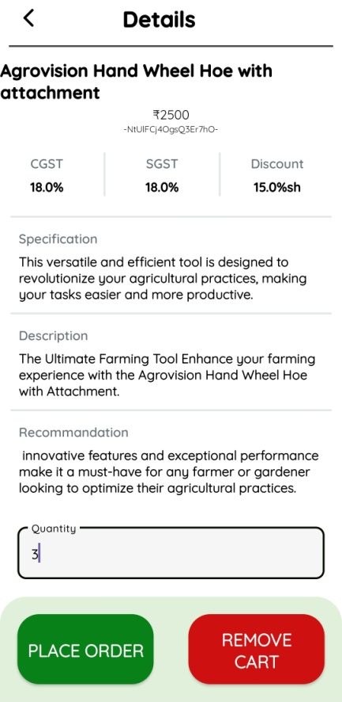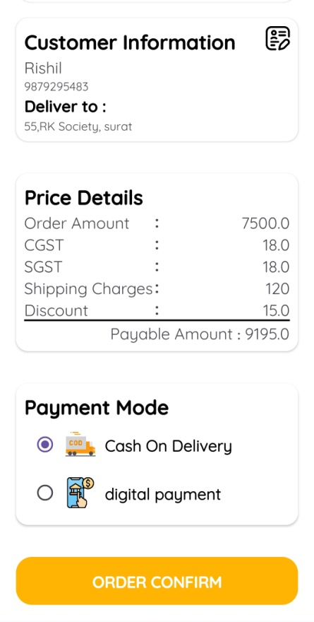

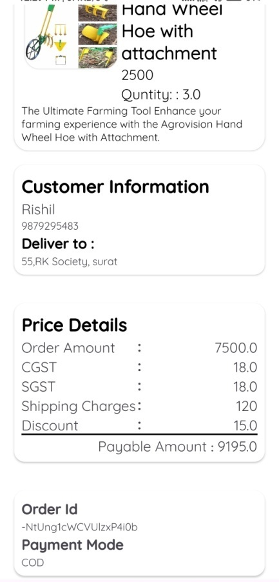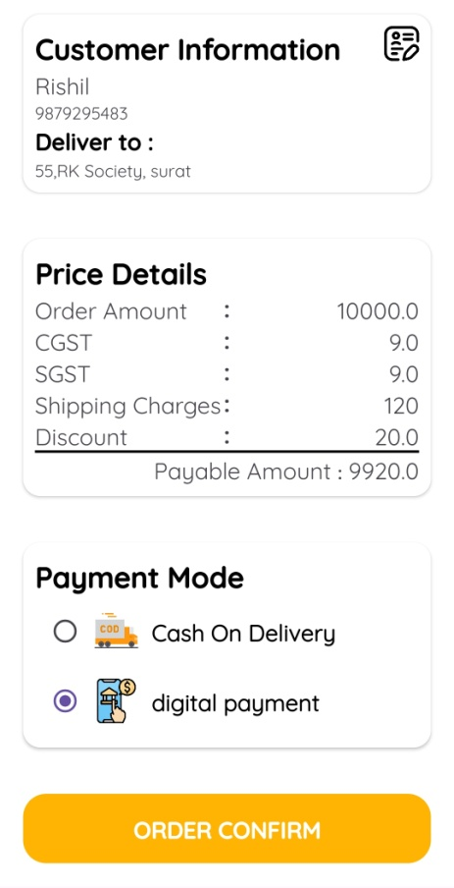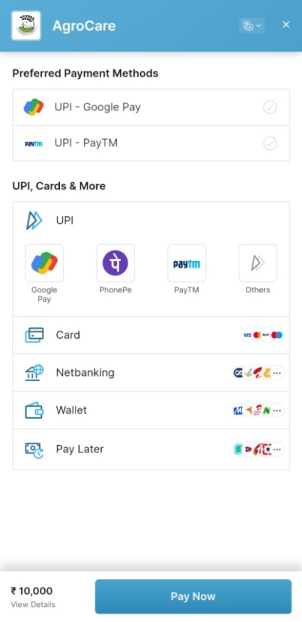

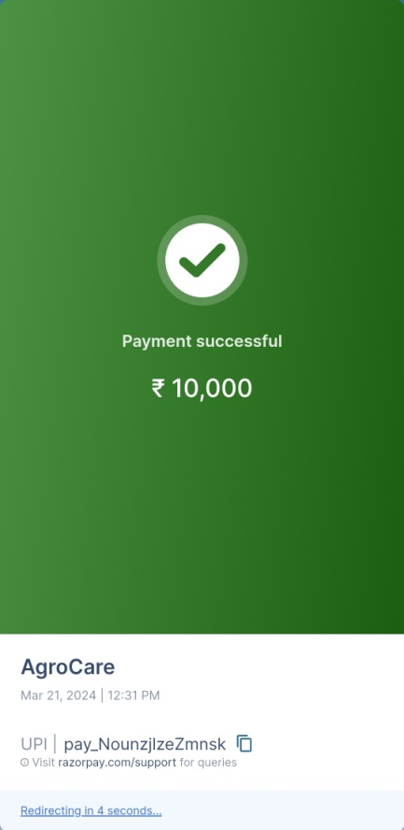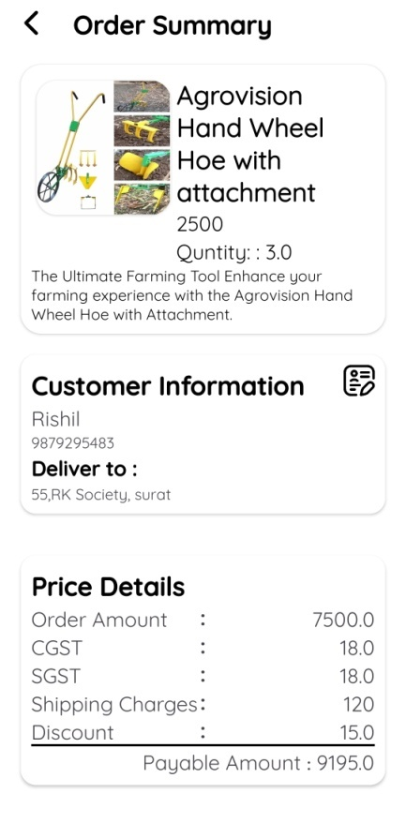

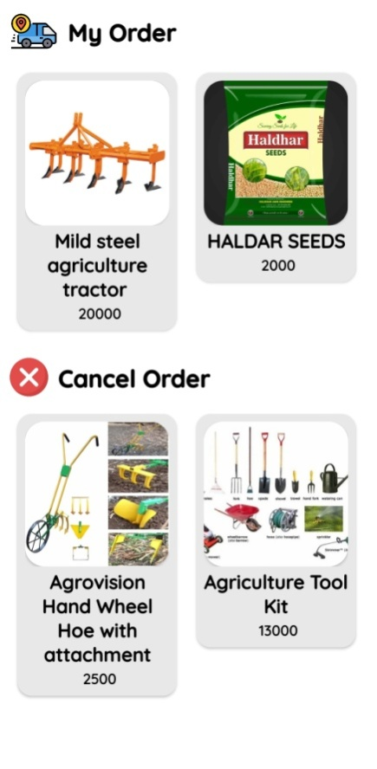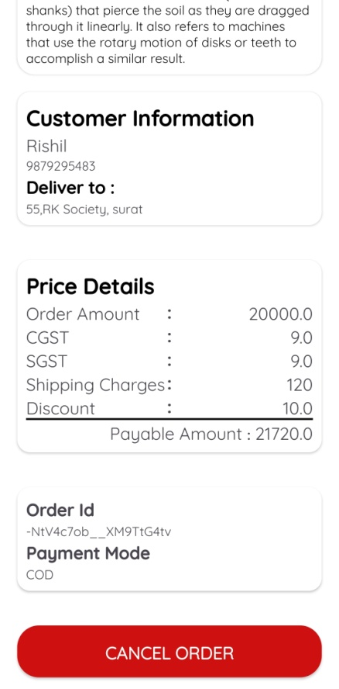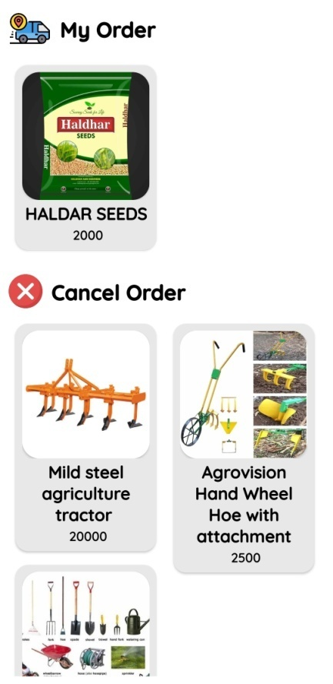

* **Home: News & Weather Detail & Search User (User)**

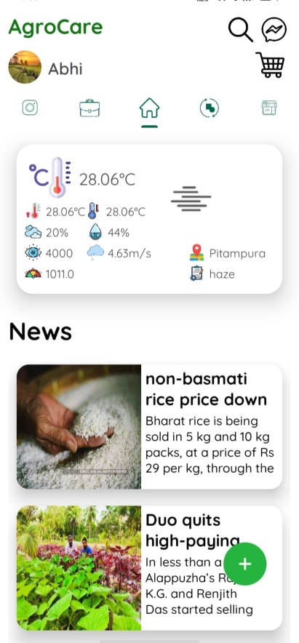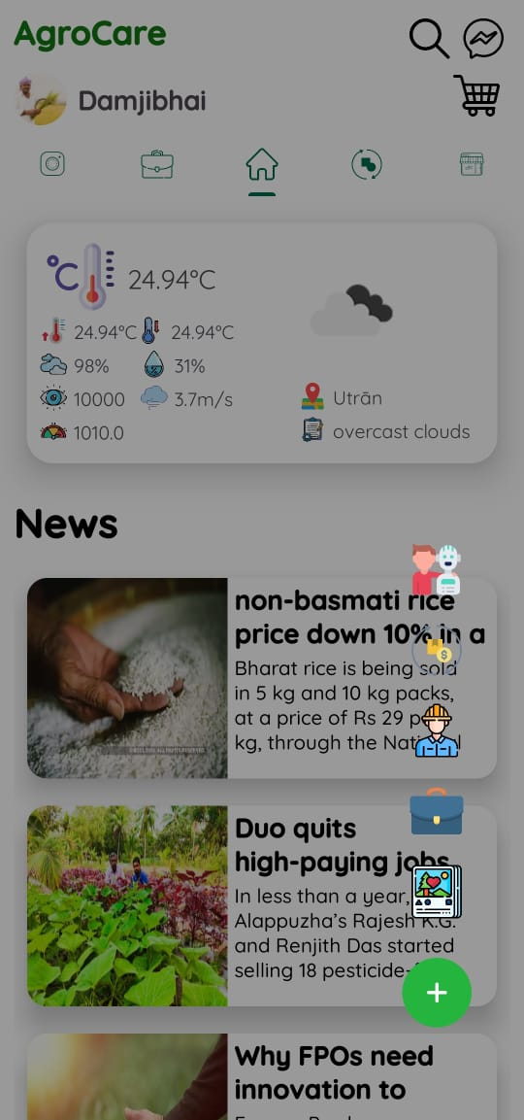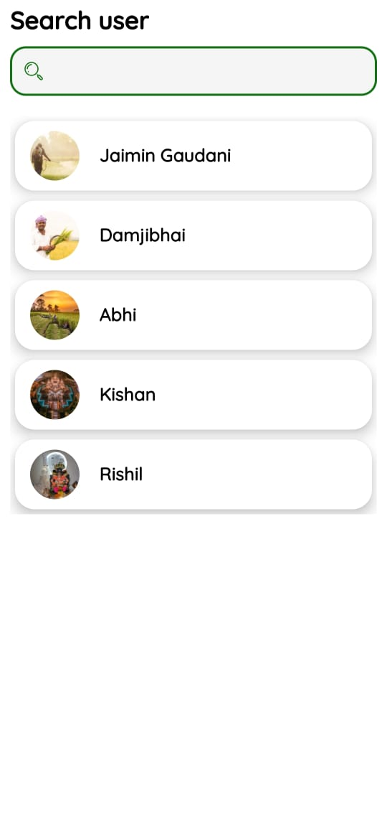

* Government Scheme

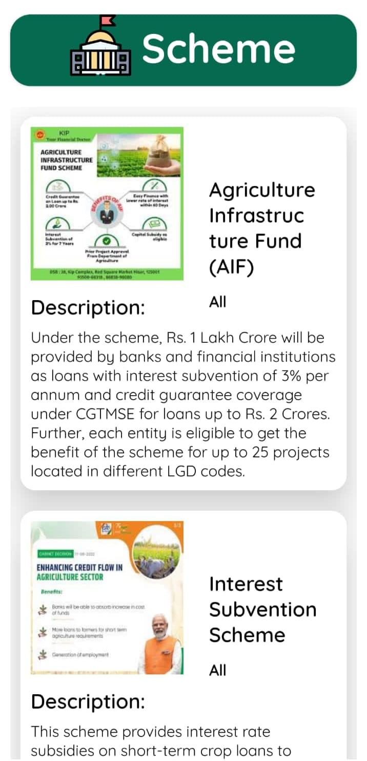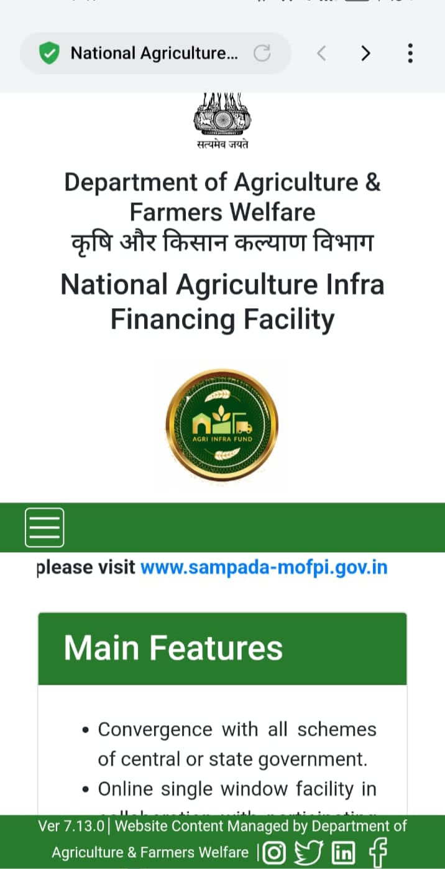

* **Farmer Friend**

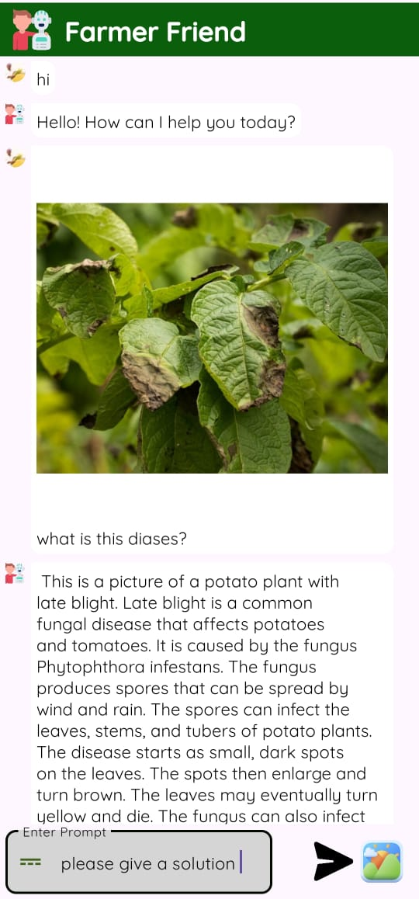

* **Navigation (User)**

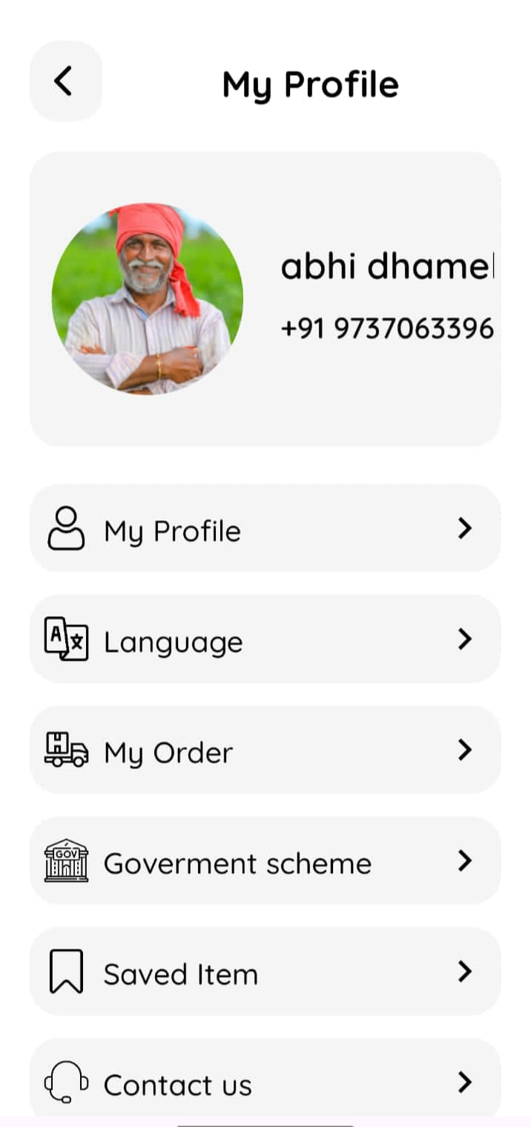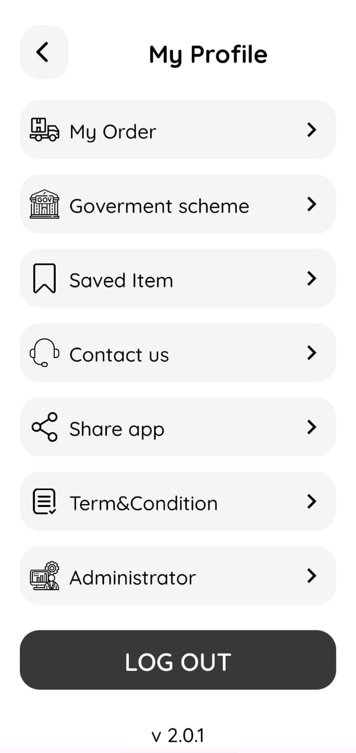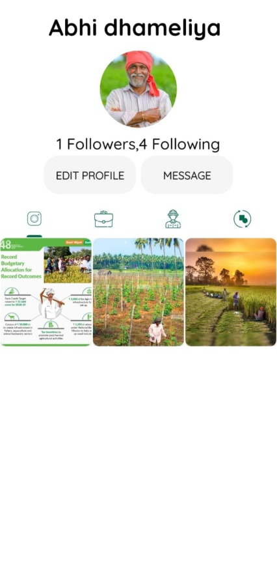

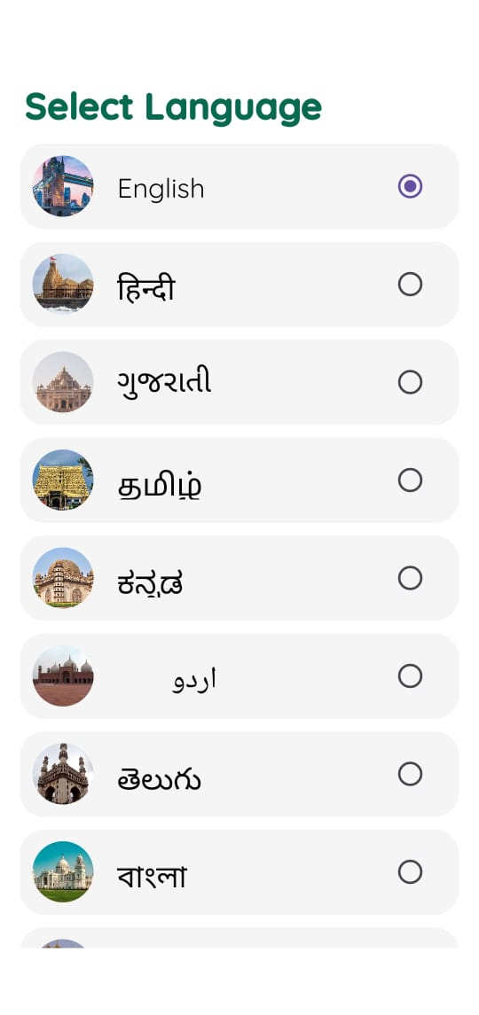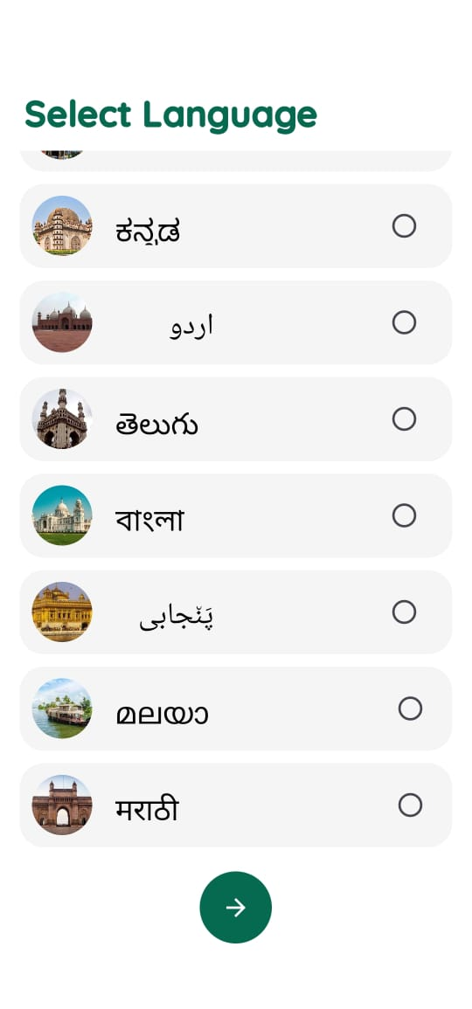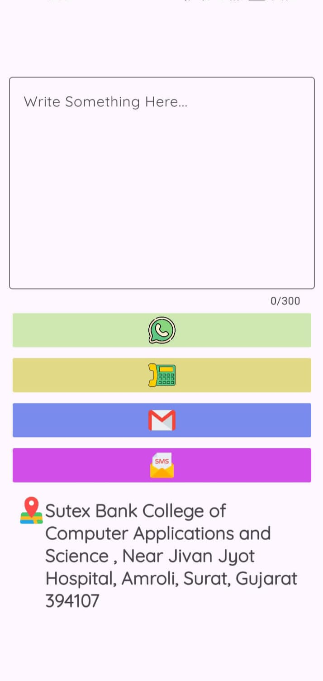

* **EditProfile (user)**

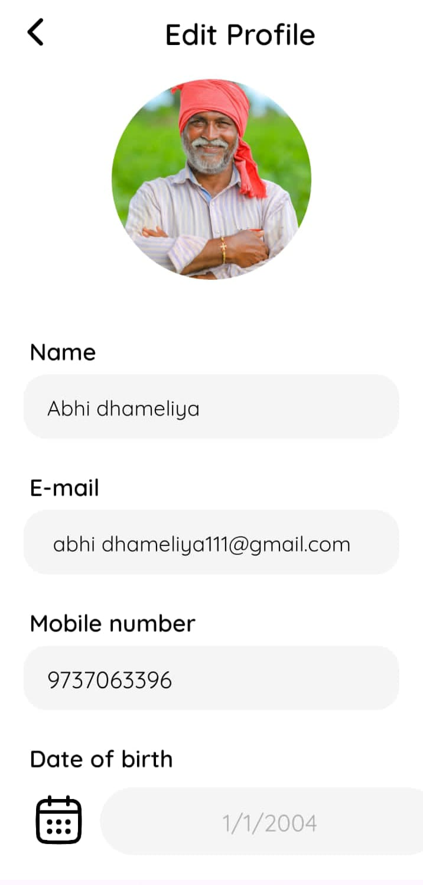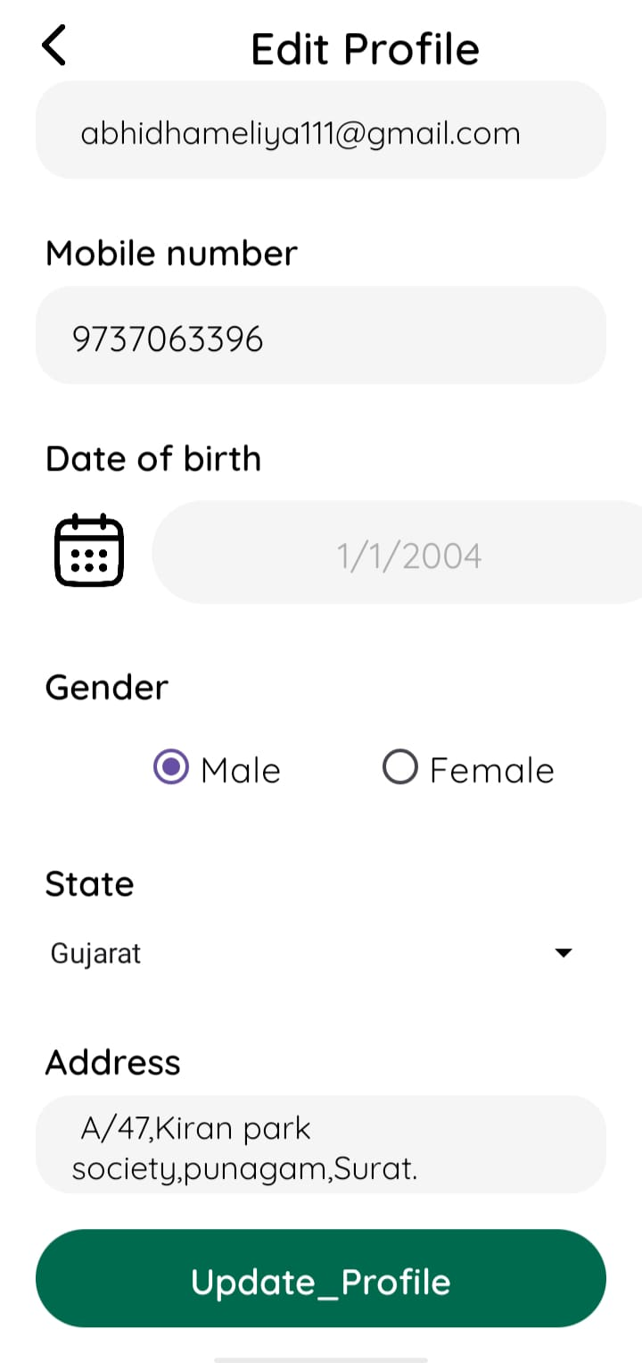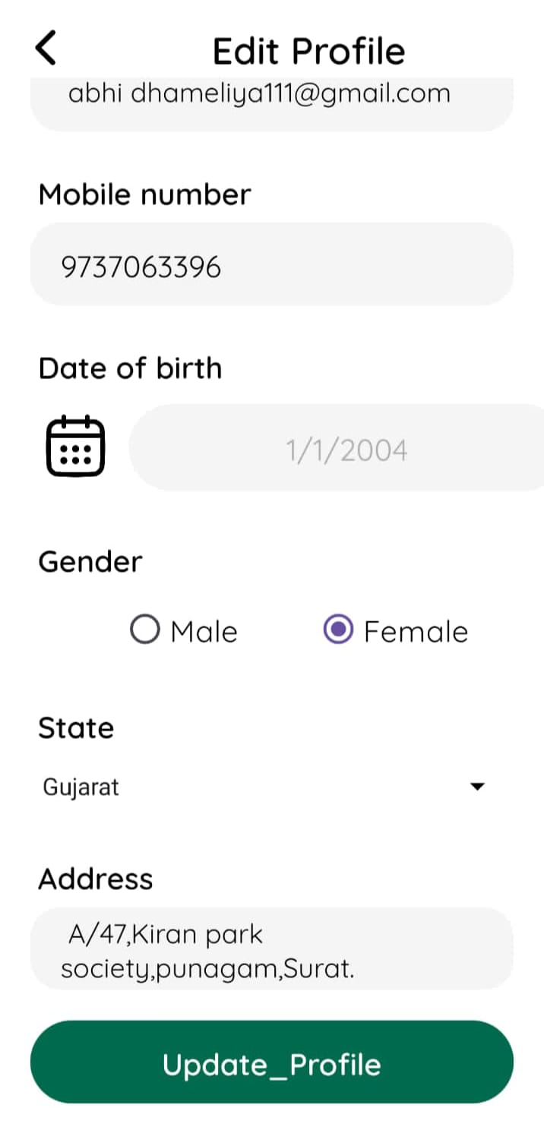

* **Home (Admin)**

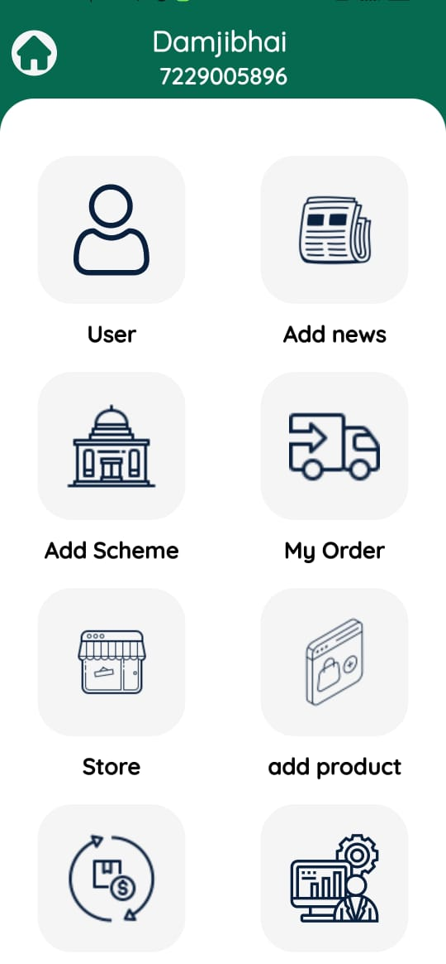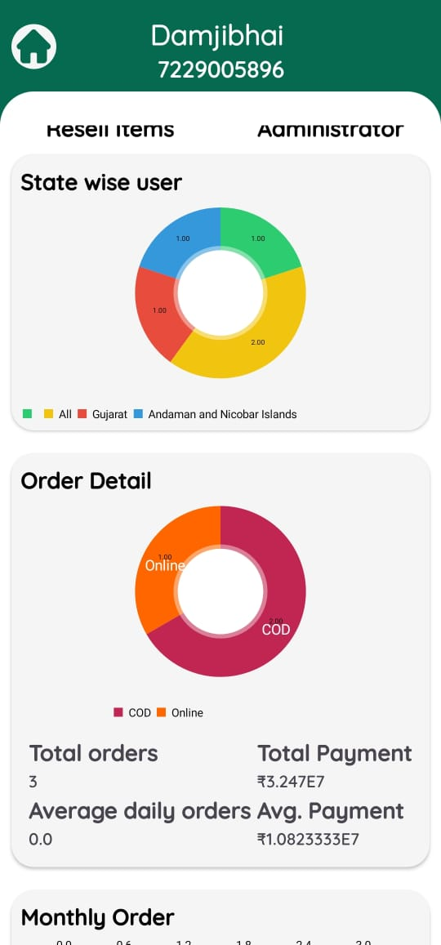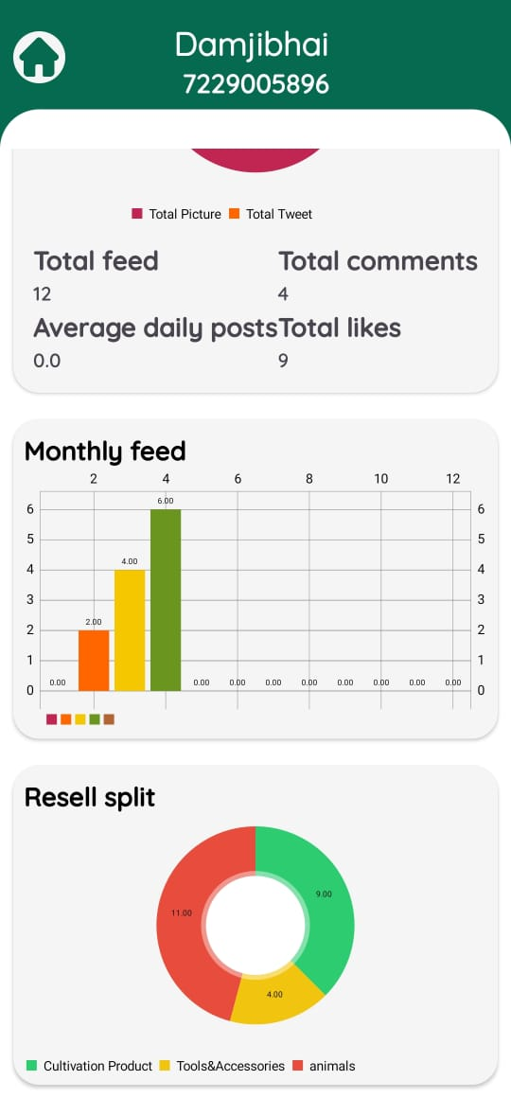

* Explore User (Admin)

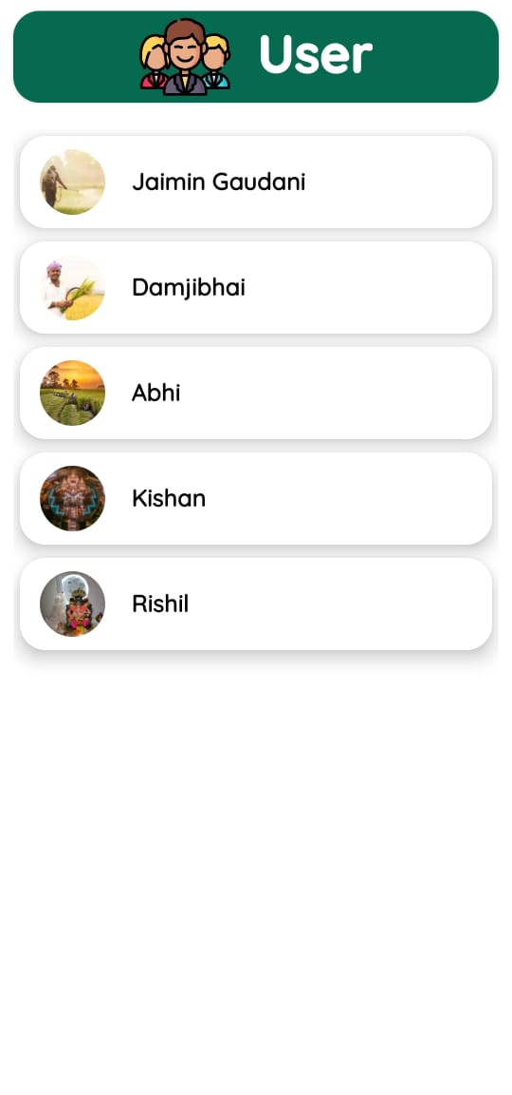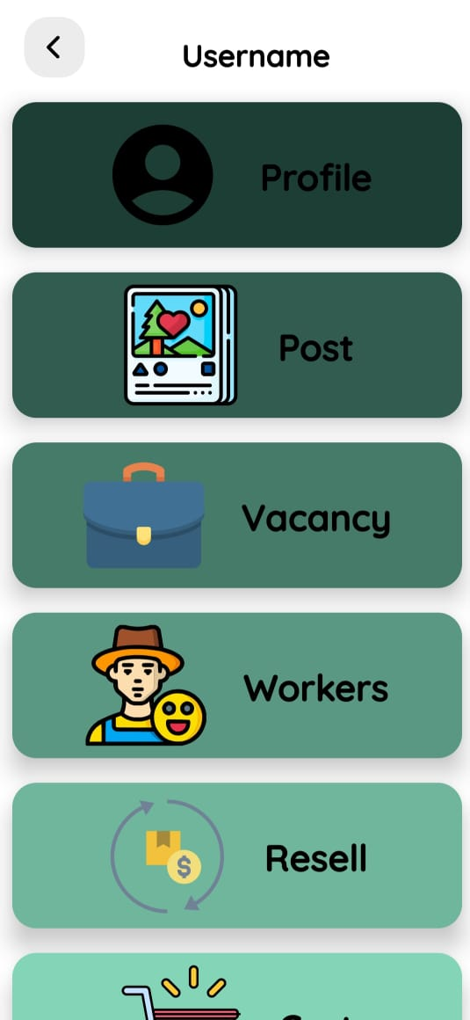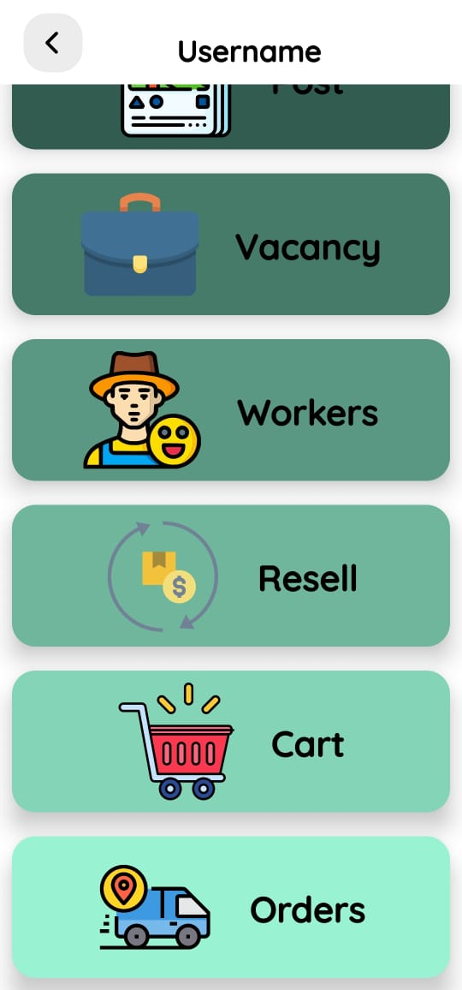

* **Add News (Admin)**

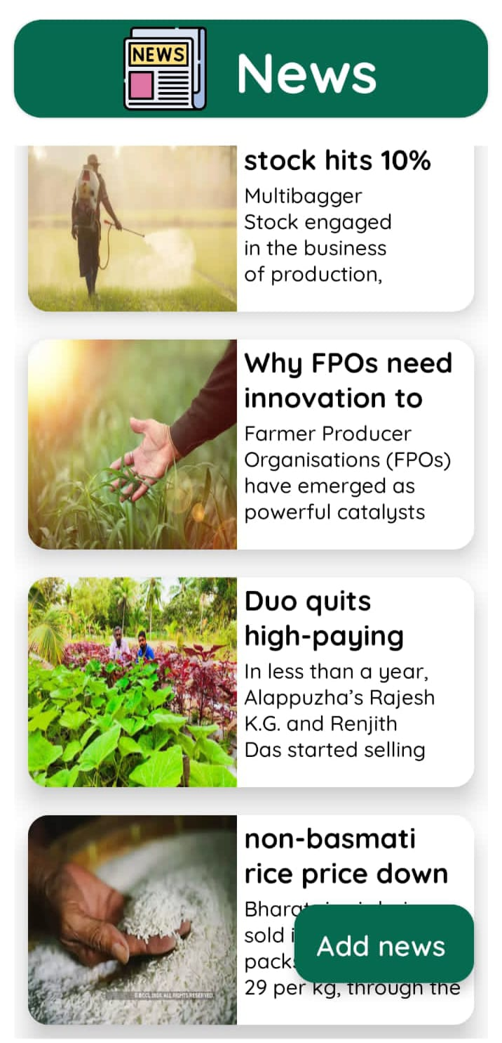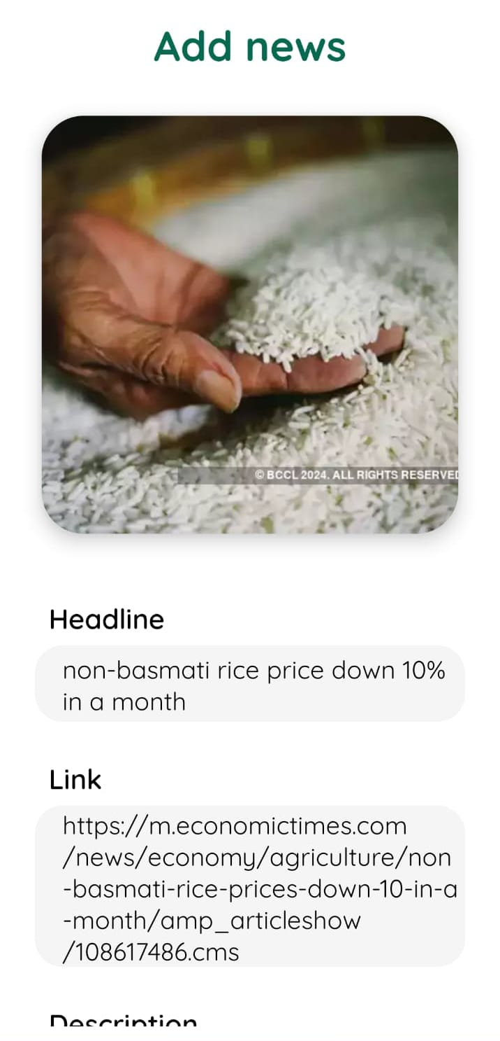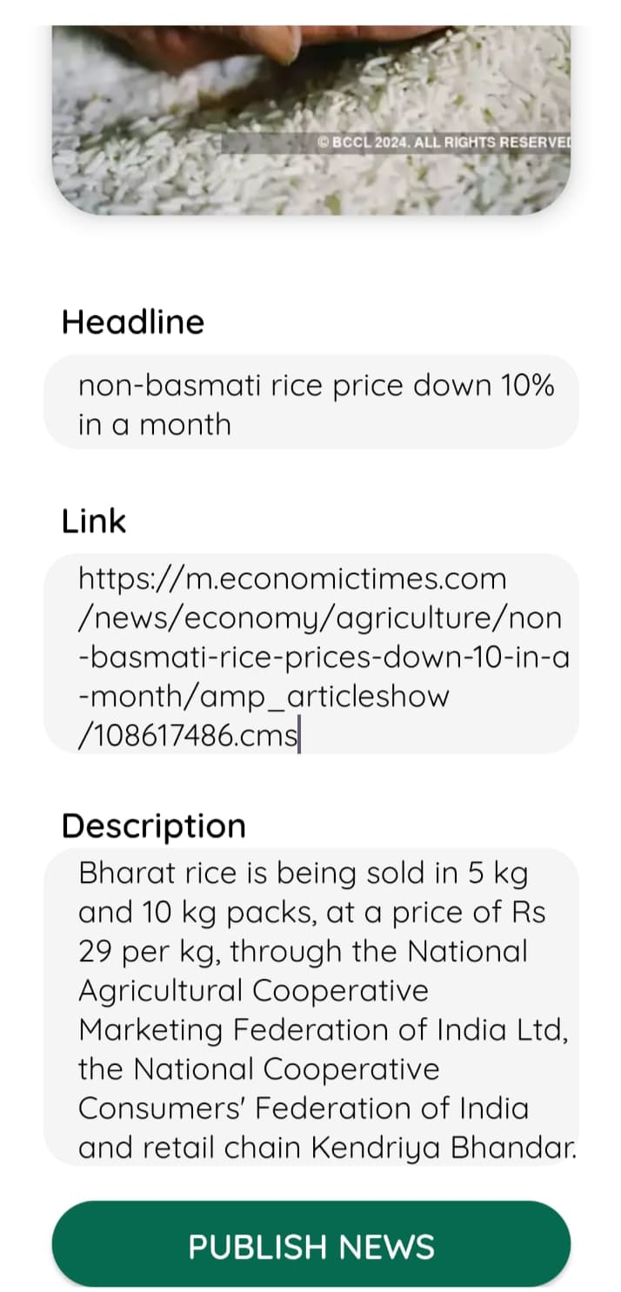

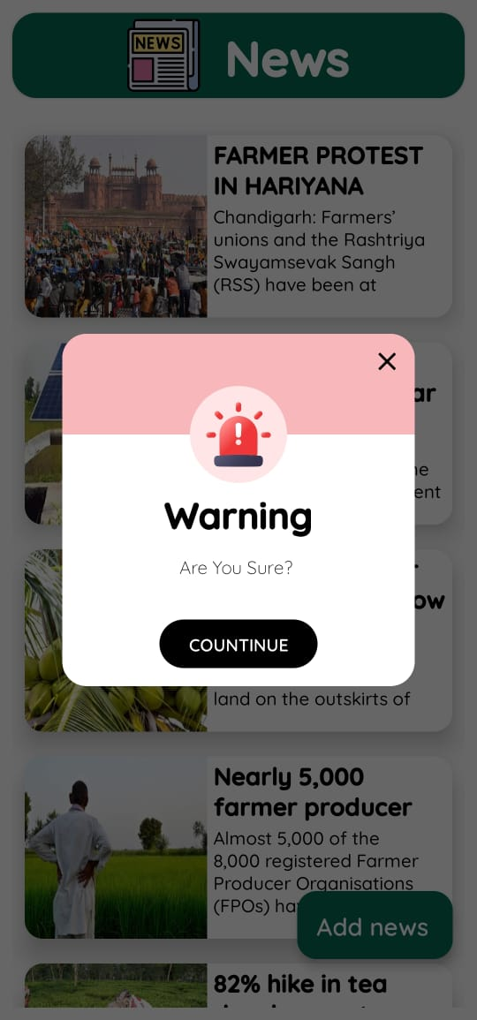

* **Add Government Scheme (Admin)**

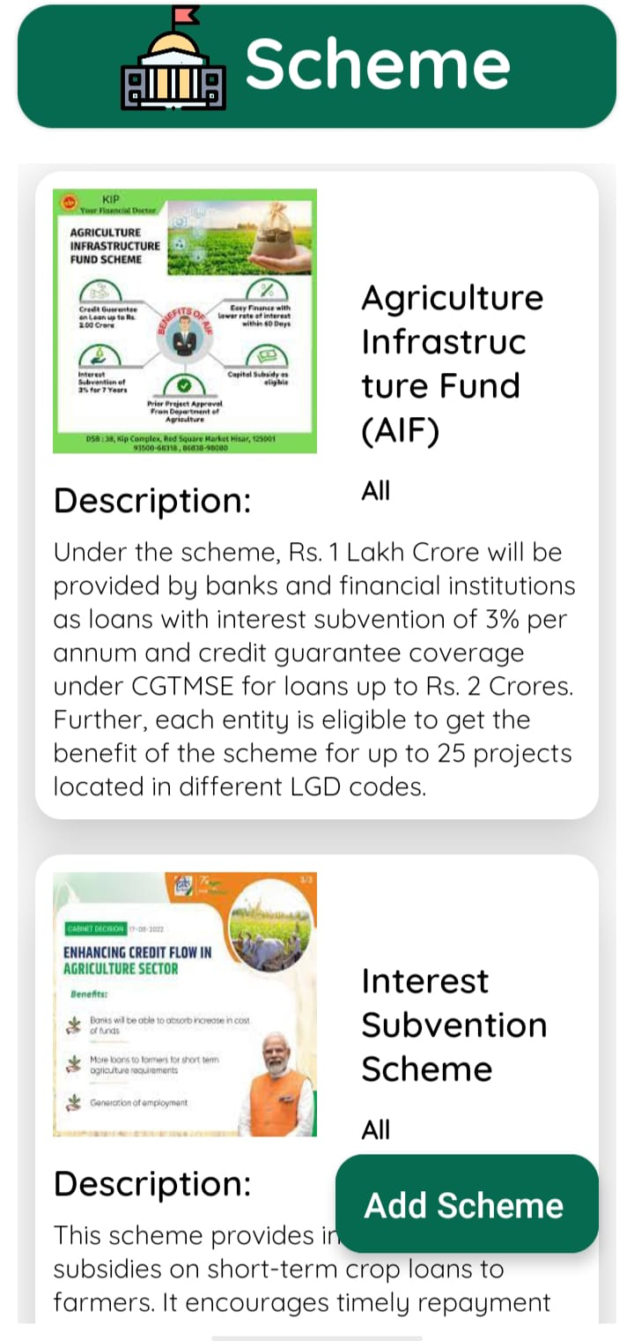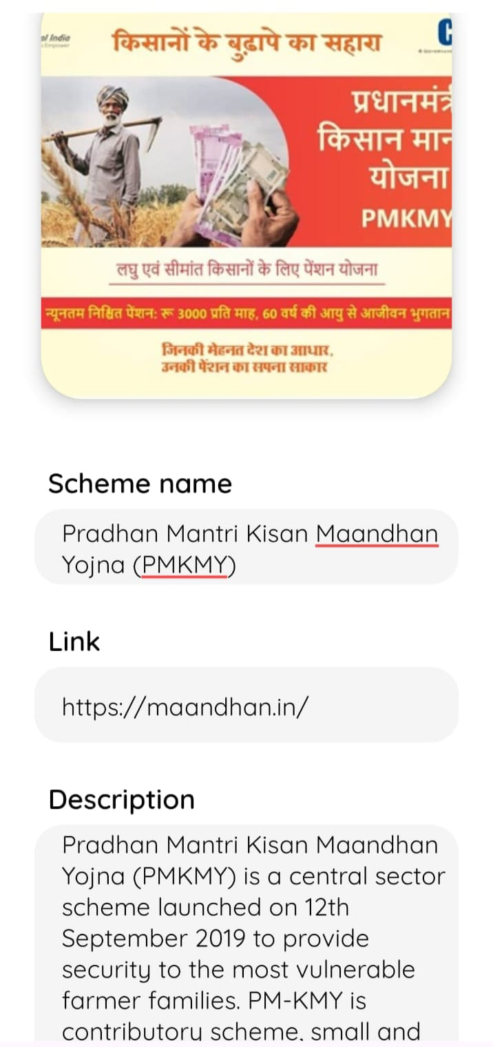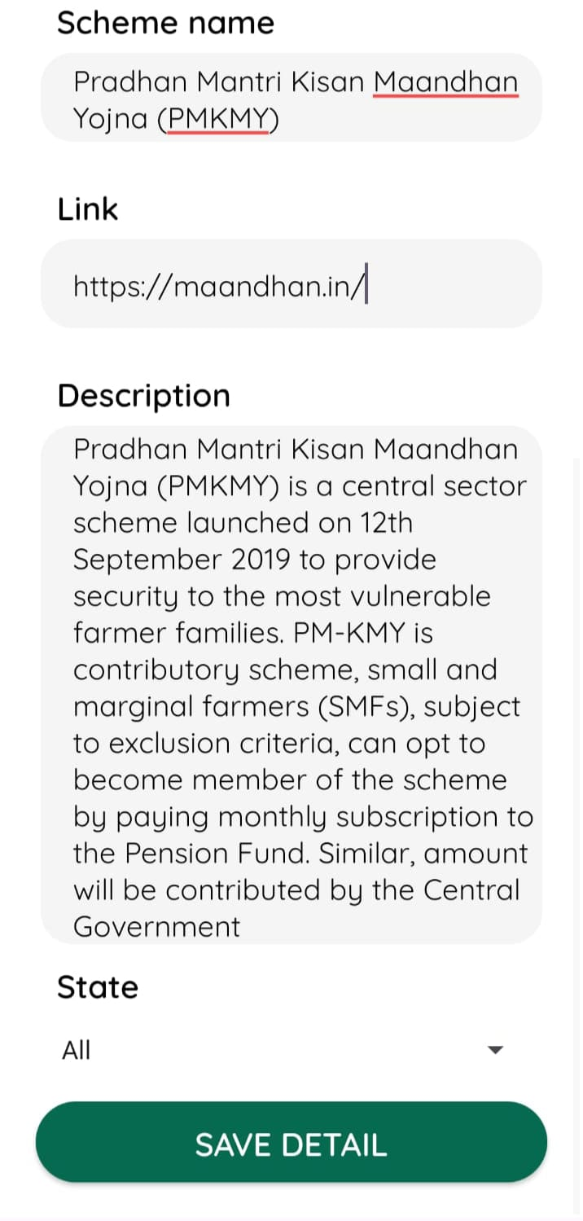

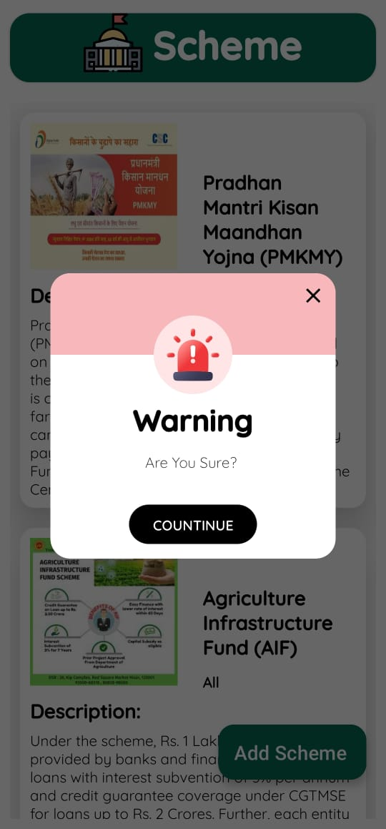

* **Manage order (Admin)**

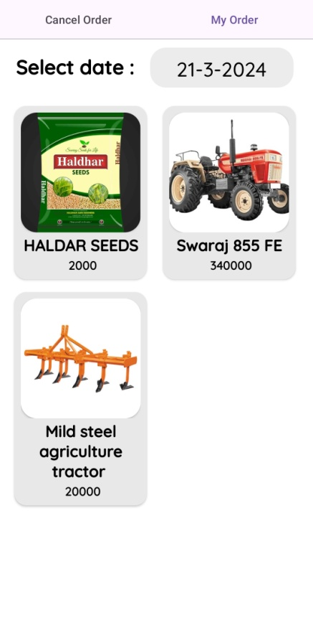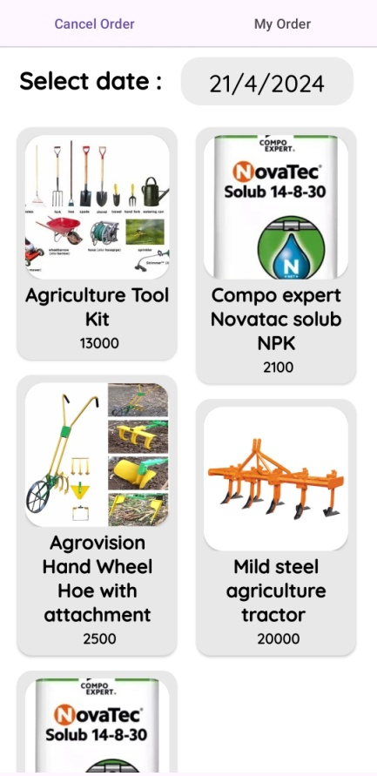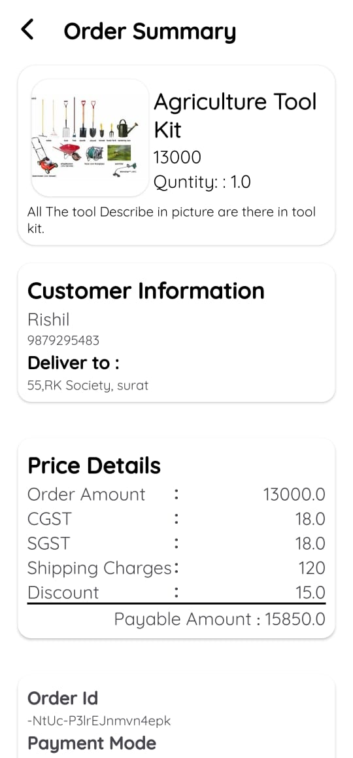

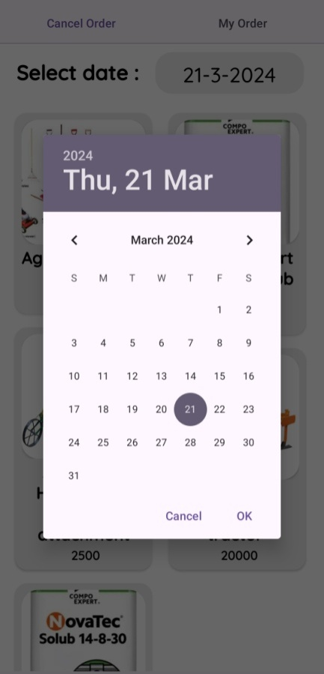

* **Manage Ecommerce Store (Admin)**

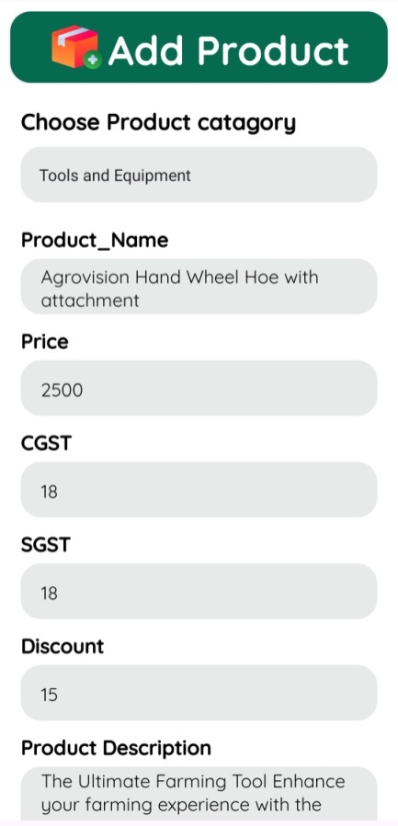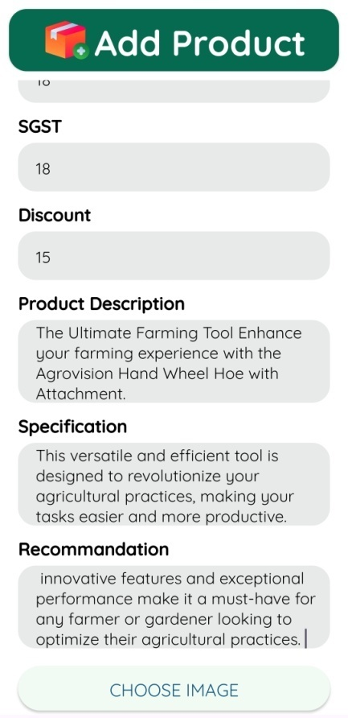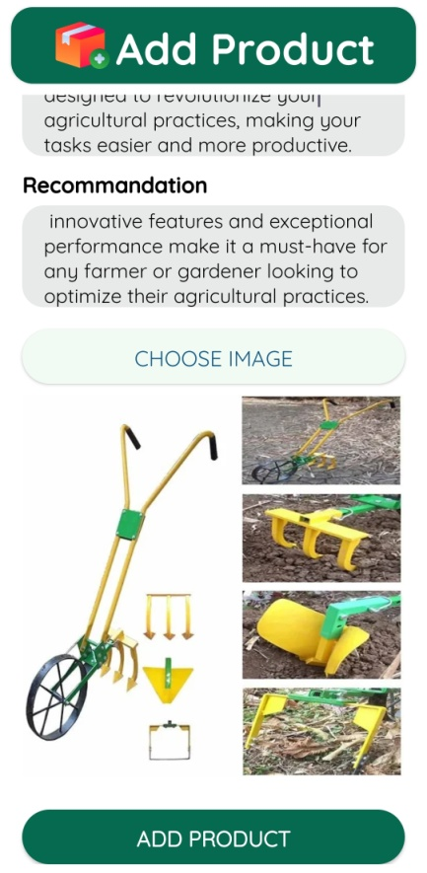

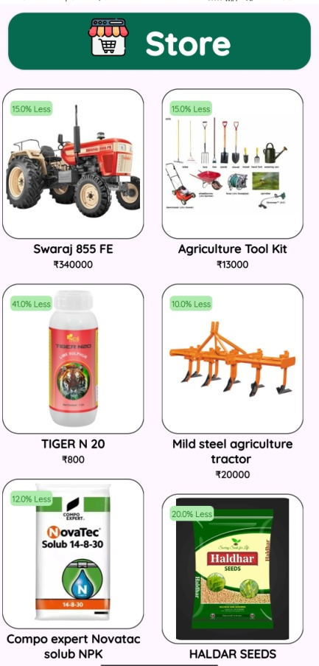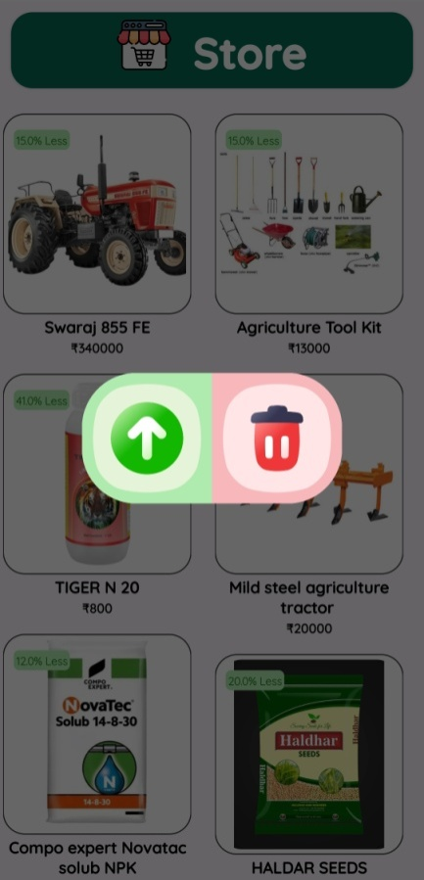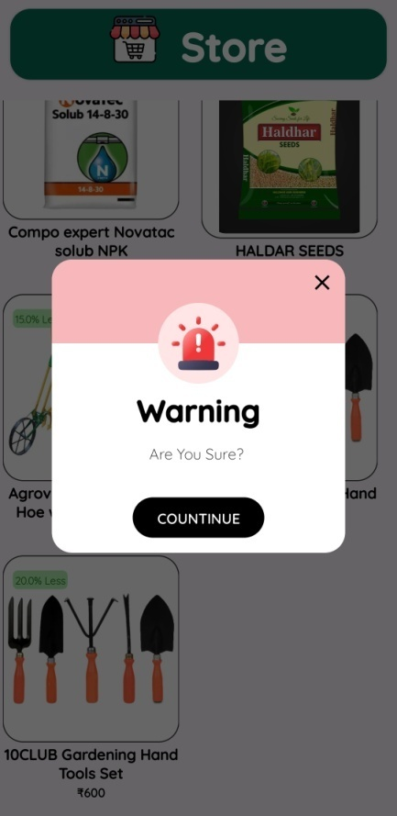

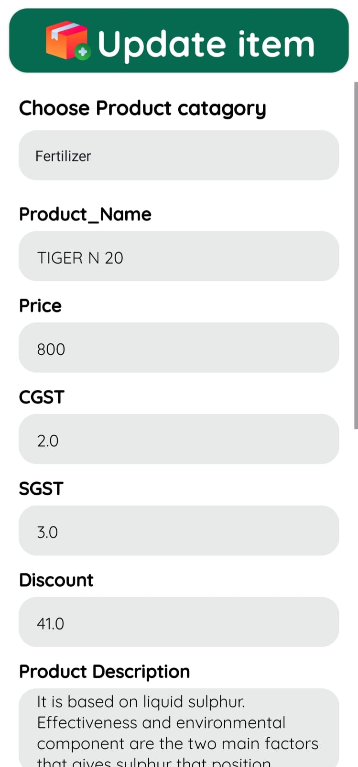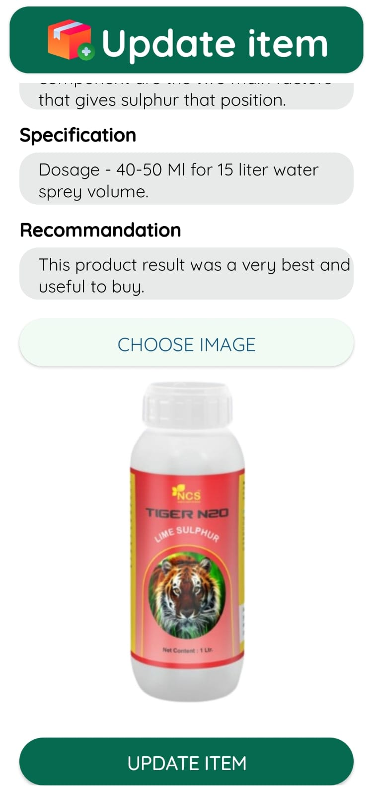

* **Resell (Admin)**

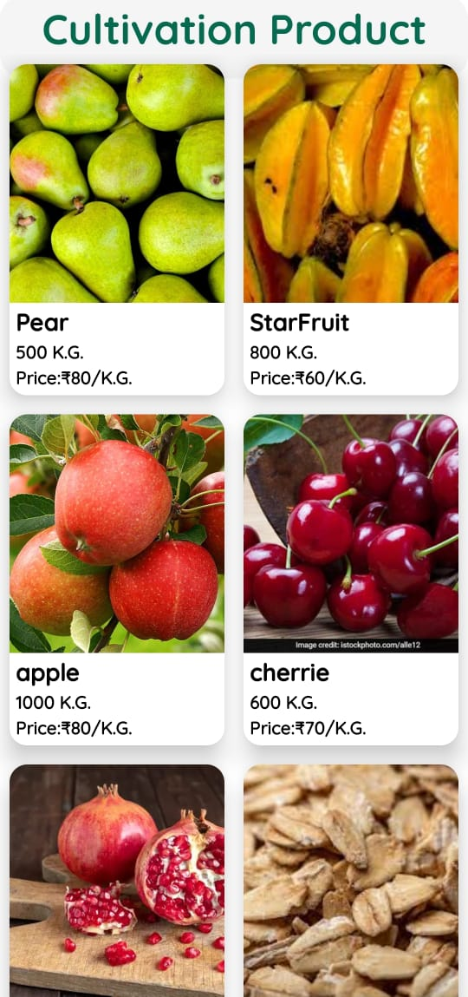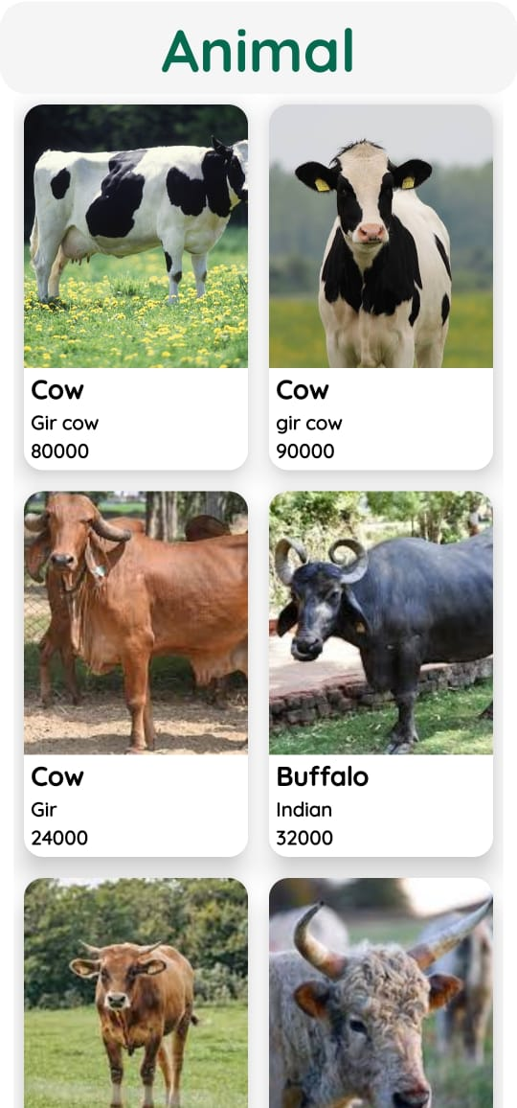

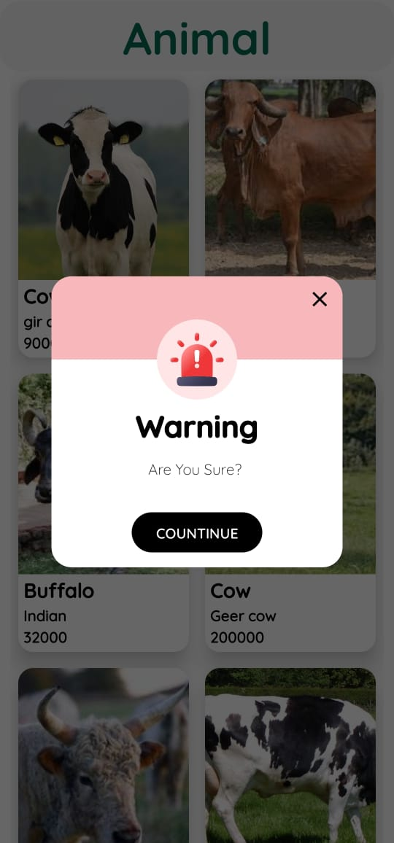

* **Add Admin (Admin)**

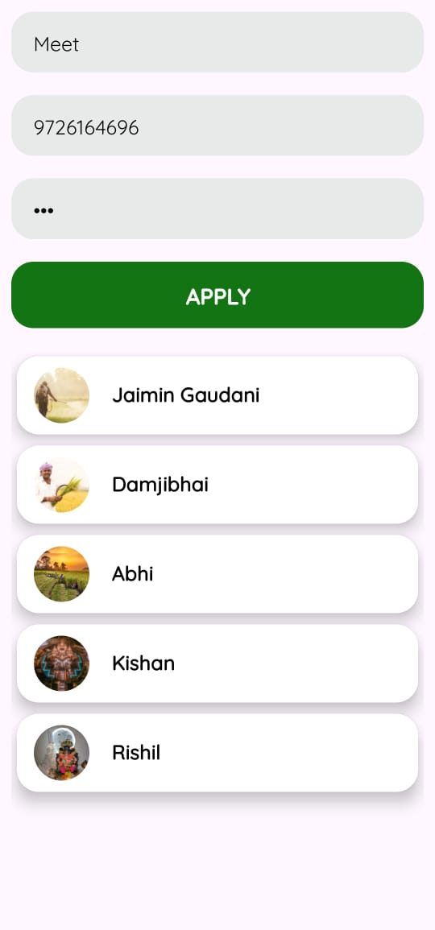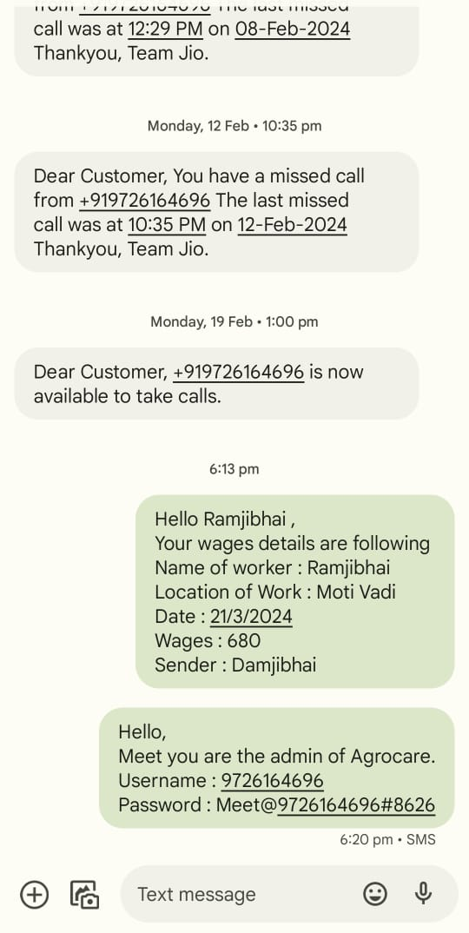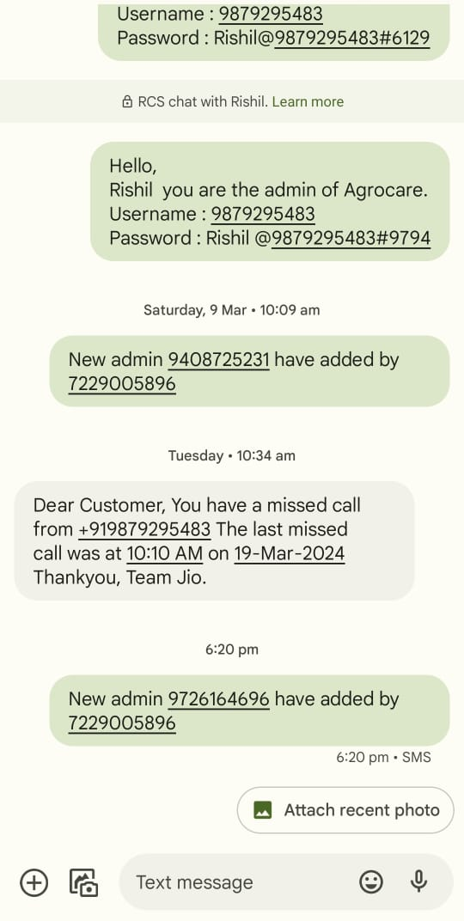

**7. System Testing [Test Cases]**

7.1 System Testing

**7.1 System Testing**

* **Login**

|  |  |  |  |
| --- | --- | --- | --- |
| Field Test | Test Data | Valid/Invalid | Test Result |
| Username | Empty | Invalid | Please Enter  Name. |
|  | Hiren Bhalani | Valid | Username is valid. |
| Mobile No. | empty | Invalid | Please Enter  Mobile No. |
|  | 12345 | Invalid | Length of mobile no. must be 10. |
|  | 123abc | Invalid | Mobile no should only contain numbers. |
| Profile Picture | Empty | invalid | Please select a image. |
|  | Image uri | Valid | Image selected and will send to database. |

* **Add Animal**

|  |  |  |  |
| --- | --- | --- | --- |
| Field Test | Test Data | Valid/Invalid | Test Result |
| specie | Empty | Invalid | Please Enter specie. |
|  | Gir | Valid | Speice is valid. |
| year | empty | Invalid | Please enter year. |
|  | 123 | Invalid | Please enter valid year. |
|  | aa | Invalid | Please enter numbers only |
|  | 11 | valid | Year is valid |
| month | empty | invalid | Please enter month. |
|  | 123 | Invalid | Please enter valid year. |
|  | aa | Invalid | Please enter numbers only |
|  | 11 | valid | year is valid |
| Milk production | empty | invalid | Please enter milk production. |
|  | aa | invalid | Please enter valid milk production. |
|  | 01 | valid | Milk production is valid. |
| Mobile no | Empty | Invalid | PleaseEnterPhone Number |
|  | 7016akash | Invalid | Phone Number field containonlynumber format. |
|  | 70166527 | Invalid | EntervalidPhone Number |
|  | 7016652775 | Valid | Inputtedtextisvalid Number |
| Price | Empty | Invalid | Please enter price. |
|  | Abc123 | Invalid | Please enter valid price. |
|  | 100 | valid | Price is valid. |
| State | Empty | Invalid | Please enter state. |
|  | Gujrat | valid | State is valid. |
| District | Empty | Invalid | Please enter district. |
|  | Surat | valid | District is valid. |
| tehsil | Empty | Invalid | Please enter tehsil. |
|  | Kamrej | valid | Tehsil is valid. |
| City/town/village | Empty | Invalid | Please enter city. |
|  | Simada gam | Valid | City is valid. |
| Image | Empty | invalid | Please select a image. |
|  | Image uri | Valid | Image is selected and will sent to database. |
| description | Empty | valid | description is not madatory. |
|  | This is desciption | valid | Description is valid. |

* **Add Cultivation Product**

|  |  |  |  |
| --- | --- | --- | --- |
| Field Test | Test Data | Valid/Invalid | Test Result |
| Product name | Empty | Invalid | Please enter product name. |
|  | wheat | valid | Product name is valid. |
| specie | Empty | Invalid | Please Enter specie. |
|  | Bhaliya | Valid | Speice is valid. |
| Quantity | empty | Invalid | Please enter quantity. |
|  | 123aa | Invalid | Quantity must have numeric value. |
|  | aa | Invalid | Quantity must have numeric value. |
|  | 11 | valid | Quantity is valid. |
| Price | Empty | Invalid | Please enter price. |
|  | Abc123 | Invalid | Please enter valid price. |
|  | 100 | valid | Price is valid. |
| Seller name | Empty | Invalid | Please enter seller name. |
|  | Hiren Bhalani | Valid | Seller name is valid. |
| Mobile no | Empty | Invalid | PleaseEnterPhone Number |
|  | 7016akash | Invalid | Phone Number field containonlynumber format. |
|  | 70166527 | Invalid | EntervalidPhone Number |
|  | 7016652775 | Valid | Inputtedtextisvalid Number |
| State | Empty | Invalid | Please enter state. |
|  | Gujrat | valid | State is valid. |
| District | Empty | Invalid | Please enter district. |
|  | Surat | valid | District is valid. |
| tehsil | Empty | Invalid | Please enter tehsil. |
|  | Kamrej | valid | Tehsil is valid. |
| City/town/village | Empty | Invalid | Please enter city. |
|  | Simada gam | Valid | City is valid. |
| Image | Empty | invalid | Please select a image. |
|  | Image uri | Valid | Image is selected and will sent to database. |
| description | Empty | valid | description is not madatory. |
|  | This is desciption | valid | Description is valid. |

* **Add Tools&Accessories**

|  |  |  |  |
| --- | --- | --- | --- |
| Field Test | Test Data | Valid/Invalid | Test Result |
| Product name | Empty | Invalid | Please enter product name |
|  | Tractor | valid | Product name is valid |
| month | empty | invalid | Please enter month. |
|  | 123 | Invalid | Please enter valid year. |
|  | aa | Invalid | Please enter numbers only |
|  | 11 | valid | year is valid |
| Seller name | Empty | Invalid | Please enter  Seller name. |
|  | Hiren Bhalani | Valid | Seller name is valid. |
| Mobile no | Empty | Invalid | PleaseEnterPhone Number |
|  | 7016akash | Invalid | Phone Number field containonlynumber format. |
|  | 70166527 | Invalid | EntervalidPhone Number |
|  | 7016652775 | Valid | Inputtedtextisvalid Number |
| Price | Empty | Invalid | Please enter price. |
|  | Abc123 | Invalid | Please enter valid price. |
|  | 100 | valid | Price is valid. |
| State | Empty | Invalid | Please enter state. |
|  | Gujrat | valid | State is valid. |
| District | Empty | Invalid | Please enter district. |
|  | Surat | valid | District is valid. |
| tehsil | Empty | Invalid | Please enter tehsil. |
|  | Kamrej | valid | Tehsil is valid. |
| City/town/village | Empty | Invalid | Please enter city. |
|  | Simada gam | Valid | City is valid. |
| Image | Empty | invalid | Please select a image. |
|  | Image uri | Valid | Image is selected and will sent to database. |
| description | Empty | valid | description is not madatory. |
|  | This is desciption | valid | Description is valid. |

* **Add Vacancy**

|  |  |  |  |
| --- | --- | --- | --- |
| Field Test | Test Data | Valid/Invalid | Test Result |
| Name | Empty | Invalid | Please enter name. |
|  | Hiren Bhalani | Valid | Name is valid. |
| Mobile no | Empty | Invalid | PleaseEnterPhone Number |
|  | 7016akash | Invalid | Phone Number field containonlynumber format. |
|  | 70166527 | Invalid | EntervalidPhone Number |
|  | 7016652775 | Valid | Inputtedtextisvalid Number |
| Work type | Empty | invalid | Please select work type. |
|  | Fix wages | valid | Work type selected. |
|  | On partnership | valid | Work type selected. |
| Annual income | Empty | Invalid | Please enter annual income. |
|  | Abc123 | Invalid | Income may only contain numbers. |
|  | 100 | valid | Income is valid. |
| Work duration | empty | invalid | Please enter work duration. |
|  | 123 | Invalid | Please enter valid work duration. |
|  | aa | Invalid | Work duration may only contain numbers. |
|  | 11 | valid | Work duration is valid. |
| State | Empty | Invalid | Please enter state. |
|  | Gujrat | valid | State is valid. |
| District | Empty | Invalid | Please enter district. |
|  | Surat | valid | District is valid. |
| tehsil | Empty | Invalid | Please enter tehsil. |
|  | Kamrej | valid | Tehsil is valid. |
| City/town/village | Empty | Invalid | Please enter city. |
|  | Simada gam | Valid | City is valid. |
| Image | Empty | invalid | Please select a image. |
|  | Image uri | Valid | Image is selected and will sent to database. |
| description | Empty | valid | description is not madatory. |
|  | This is desciption | valid | Description is valid. |

* **Add Labour**

|  |  |  |  |
| --- | --- | --- | --- |
| Field Test | Test Data | Valid/Invalid | Test Result |
| Name | Empty | Invalid | Please enter name |
|  | Hiren Bhalani | Valid | Name is valid. |
| Mobile no | Empty | Invalid | PleaseEnterPhone Number |
|  | 7016akash | Invalid | Phone Number field containonlynumber format. |
|  | 70166527 | Invalid | EntervalidPhone Number |
|  | 7016652775 | Valid | Inputtedtextisvalid Number |
| Work place | Empty | invalid | Please enter workplace. |
|  | Lemon farm | valid | Work place is valid. |
| Wages | Empty | Invalid | Please enter wages. |
|  | Abc123 | Invalid | Wages may only contain numbers. |
|  | 100 | valid | Wages are valid. |
| Work duration | empty | invalid | Please enter work duration. |
|  | 123 | Invalid | Please enter valid work duration. |
|  | aa | Invalid | Work duration may only contain numbers. |
|  | 11 | valid | Work duration is valid. |
| Date | empty | invalid | Please select date. |
|  | 18/03/2024 | Valid | Selected date is valid. |
| description | Empty | valid | description is not madatory. |
|  | This is desciption | valid | Description is valid. |

* **Add Post**

|  |  |  |  |
| --- | --- | --- | --- |
| Field Test | Test Data | Valid/Invalid | Test Result |
| Image | Empty | invalid | Please select  A image. |
|  | Image uri | Valid | Image is selected and will upload to database. |
| description | Empty | valid | description is not madatory. |
|  | This is desciption | valid | Description is valid. |

* **Write and share**

|  |  |  |  |
| --- | --- | --- | --- |
| Field Test | Test Data | Valid/Invalid | Test Result |
| Description | Empty | invalid | please enter some description. |
|  | this is description | Valid | Description is valid. |

* **Add News**

|  |  |  |  |
| --- | --- | --- | --- |
| Field Test | Test Data | Valid/Invalid | Test Result |
| Headline | Empty | invalid | Please enter headline. |
|  | this is headline | Valid | Headline is valid. |
| Link | Empty | invalid | Please enter  link. |
|  | www.google.com | Valid | Link is valid. |
| Description | Empty | invalid | Please enter Description |
|  | this is description | Valid | Description is valid. |
| Image | Empty | invalid | Please select  A image. |
|  | Image uri | Valid | Image is selected and will upload to database. |

* **Add Government scheme**

|  |  |  |  |
| --- | --- | --- | --- |
| Field Test | Test Data | Valid/Invalid | Test Result |
| Scheme name | Empty | invalid | Please enter name of scheme. |
|  | P.M.K.V. Y. | Valid | Headline is valid. |
| Link | Empty | invalid | Please enter  link. |
|  | www.google.com | Valid | Link is valid. |
| Description | Empty | invalid | Please enter Description |
|  | this is description | Valid | Description is valid. |
| Image | Empty | invalid | Please select  A image. |
|  | Image uri | Valid | Image is selected and will upload to database. |

* **Add Government scheme**

|  |  |  |  |
| --- | --- | --- | --- |
| Field Test | Test Data | Valid/Invalid | Test Result |
| Product name | Empty | Invalid | Please enter product name. |
|  | Tractor | valid | Product name is valid |
| Price | Empty | Invalid | Please enter price. |
|  | Abc123 | Invalid | Price may only contain numbers. |
|  | 100 | valid | Price is valid. |
| CGST | Empty | Invalid | Please enter cgst rate. |
|  | aa | Invalid | Rate may only contain numbers. |
|  | 1a | Invalid | Rate may only contain numbers. |
|  | 11 | valid | Cgst rate is valid. |
| SGST | Empty | Invalid | Please enter sgst rate. |
|  | aa | Invalid | Rate may only contain numbers. |
|  | 1a | Invalid | Rate may only contain numbers. |
|  | 11 | valid | sgst rate is valid. |
| Discount | Empty | Invalid | Please enter discount rate. |
|  | aa | Invalid | Rate may only contain numbers. |
|  | 1a | Invalid | Rate may only contain numbers. |
|  | 11 | valid | discount rate is valid. |
| Description | Empty | Invalid | Please enter Description |
|  | This is description. | Valid | Description is valid. |
| Specification | Empty | Invalid | Please enter Specification |
|  | This is description. | Valid | Specification is valid. |
| Recommendation | Empty | Invalid | Please enter Recommendation |
|  | This is description. | Valid | Recommendation is valid. |
| Image | Empty | invalid | Please select  A image. |
|  | Image uri | Valid | Image is selected and will upload to database. |

* **Add Admin**

|  |  |  |  |
| --- | --- | --- | --- |
| Field Test | Test Data | Valid/Invalid | Test Result |
| Name | Empty | Invalid | Please enter name. |
|  | Hiren Bhalani | Valid | Name is valid. |
| Mobile no | Empty | Invalid | PleaseEnterPhone Number |
|  | 7016akash | Invalid | Phone Number field containonlynumber format. |
|  | 70166527 | Invalid | EntervalidPhone Number |
|  | 7016652775 | Valid | Inputtedtextisvalid Number |
| Password | Empty | Invalid | Please enter password. |
|  | Hiren@7229005896#0000 | Valid | Password is valid. |

* **Chat**

|  |  |  |  |
| --- | --- | --- | --- |
| Field Test | Test Data | Valid/Invalid | Test Result |
| Message | empty | valid | text is not empty however image is compulsory. |
|  | this is message | Valid | Message is valid. |
| image | Empty | valid | Image is not selected however text is compulsory. |
|  | Image uri | valid | Image is selected and will upload to database. |

* **A.i.**

|  |  |  |  |
| --- | --- | --- | --- |
| Field Test | Test Data | Valid/Invalid | Test Result |
| query | empty | invalid | please enter some query text. |
|  | this is message | Valid | Message is valid. |
| image | Empty | valid | Image is not selected however text is compulsory. |
|  | Image uri | valid | Image is selected and will upload to database. |

* **EditProfile**

|  |  |  |  |
| --- | --- | --- | --- |
| Field Test | Test Data | Valid/Invalid | Test Result |
| Name | Empty | Invalid | Please enter name. |
|  | Hiren Bhalani | Valid | Name is valid. |
| email | Empty | valid | Email is not a compulsory field. |
|  | Hirenbhalani1910@gmail.com | valid | Email is valid. |
| Date of birth | Not selected | Valid | Dob is not compulsory field. |
|  | 19/10/2024 | valid | Date of birth is selected and is valid. |
| gender | Not selected | valid | Gender is not mandatory field. |
|  | Male/female | valid | Gender is selected and is valid. |
| state | Not selected | valid | State is not mandatory field. |
|  | Gujrat | valid | State is selected and is valid. |
| Address | empty | valid | Address is not mandatory field. |
|  | 45 apple sqaresurat | valid | Address is valid |

**8 . Limitations and Future Scope of Enhancements References**

* **Limitation**

1. Limited Image Upload: Users can upload only one image per post, potentially hindering comprehensive product or activity representation.

2. Language Support: While the UI is available in 12 Indian rural languages, user-generated content remains untranslated, posing a barrier to communication for non-English speakers.

3. Data Security: Concerns exist regarding the handling and protection of sensitive user information, highlighting the need for robust security measures.

4. Payment Options: The application offers only cash on delivery or online payment methods, limiting user convenience and flexibility in completing transactions.

5. Admin Notification System: Notifications for adding new admins are indiscriminately sent to all existing admins, potentially causing information overload.

6. Personalized Data Filtering: The absence of personalized data filtering may lead to information overload and hinder user engagement.

7. E-commerce Store Functionality: The e-commerce store is partially implemented, resulting in limitations such as a restricted product catalog and incomplete order management features.

8. Report Generation for Admin: The application provides limited functionality for generating reports and accessing comprehensive data analytics for administrators.

9. Trust and Security in C-to-C Transactions: Insufficient measures to ensure trust and security in customer-to-customer transactions may deter users from engaging in peer-to-peer transactions.

Enhanced Image Upload: Implement functionality for users to upload multiple images per post, enriching visual content and improving product representation.

* **Future Enhancements**

1. Expanded Language Support: Introduce automatic translation features for user-generated content to break language barriers and promote inclusivity.
2. Improved Data Security Measures: Strengthen encryption protocols and implement advanced security measures to safeguard user data from unauthorized access.
3. Refined Admin Notification System: Implement a targeted notification system for admin activities to streamline communication and reduce unnecessary notifications.
4. Personalized Data Filtering: Introduce personalized data filtering features to prioritize content based on user preferences and interests, enhancing user engagement.
5. Enhanced E-commerce Store Functionality: Focus on expanding the product catalog, integrating additional payment gateways, and optimizing order management features to enhance the e-commerce experience for users.
6. Advanced Reporting and Analytics Features: Implement customizable reporting tools and analytics features for administrators to gain valuable insights and facilitate data-driven decision-making.
7. Trust and Security Mechanisms in C-to-C Transactions: Enhance trust and security in customer-to-customer transactions by implementing identity verification, user rating systems, secure payment solutions, and dispute resolution mechanisms.